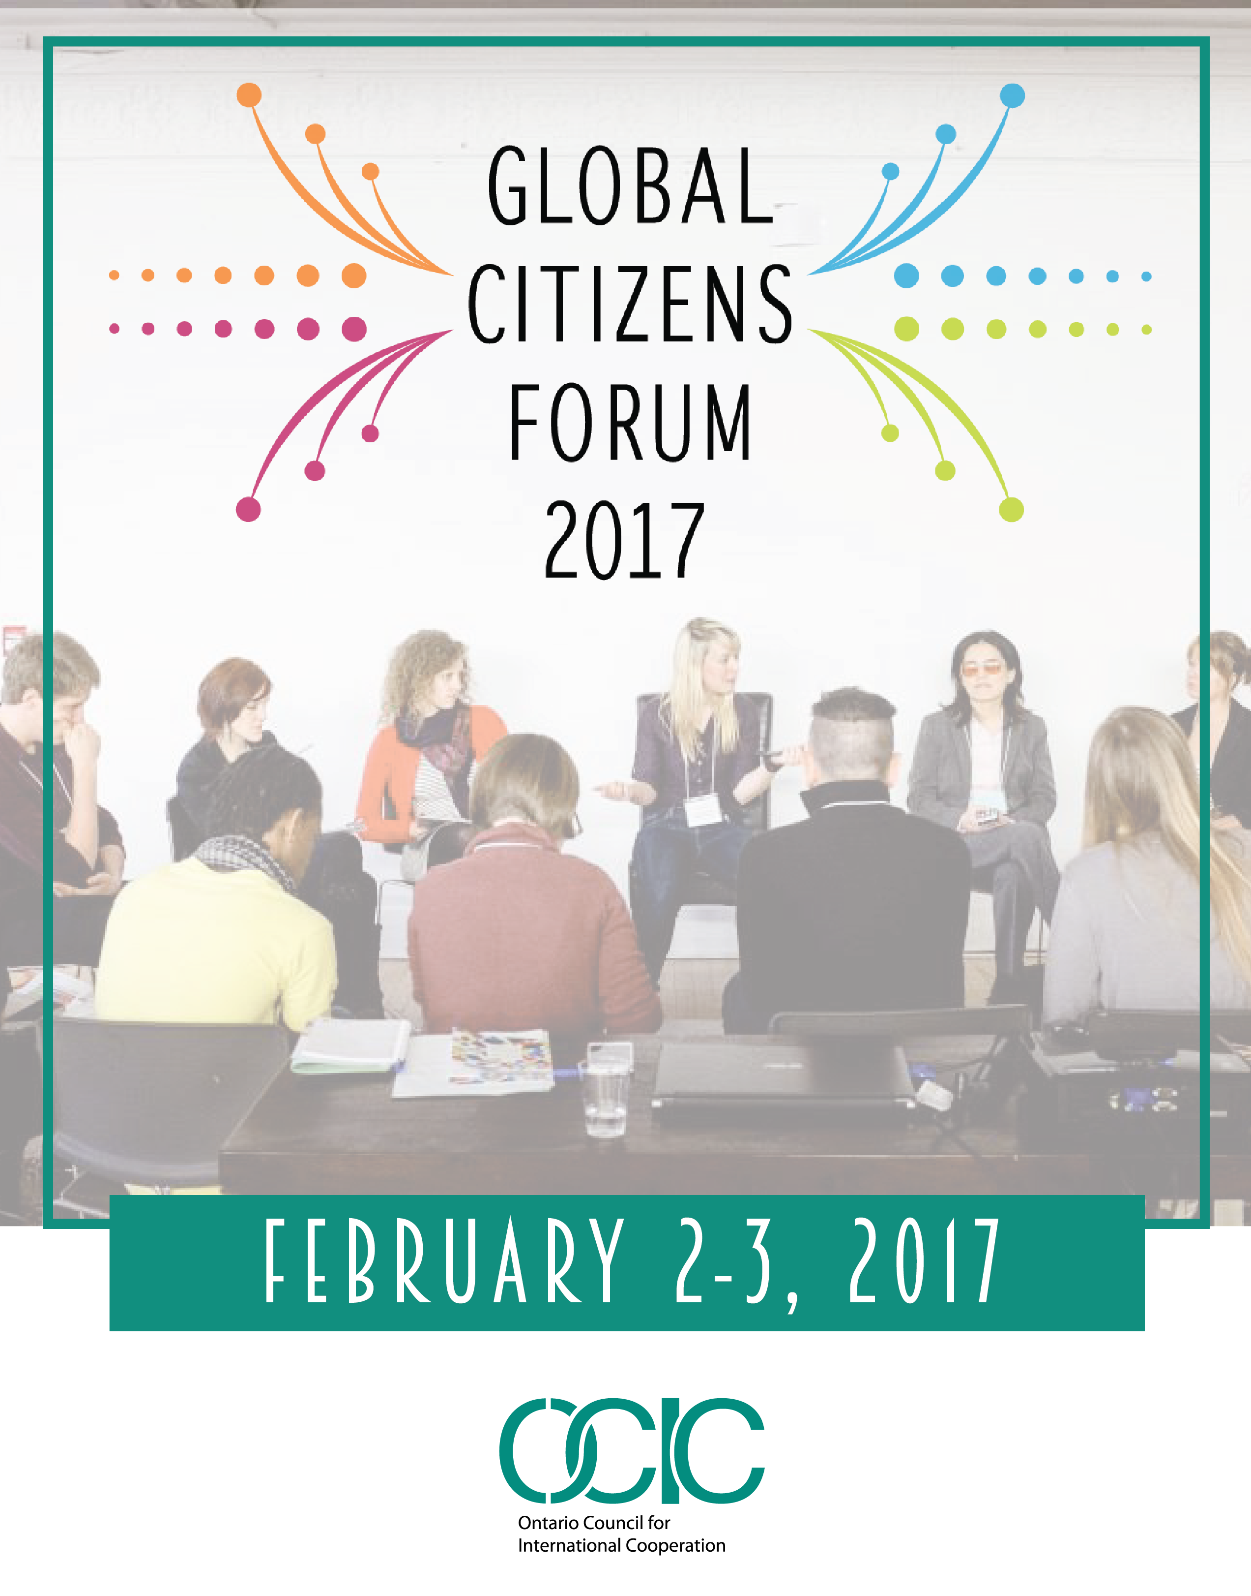

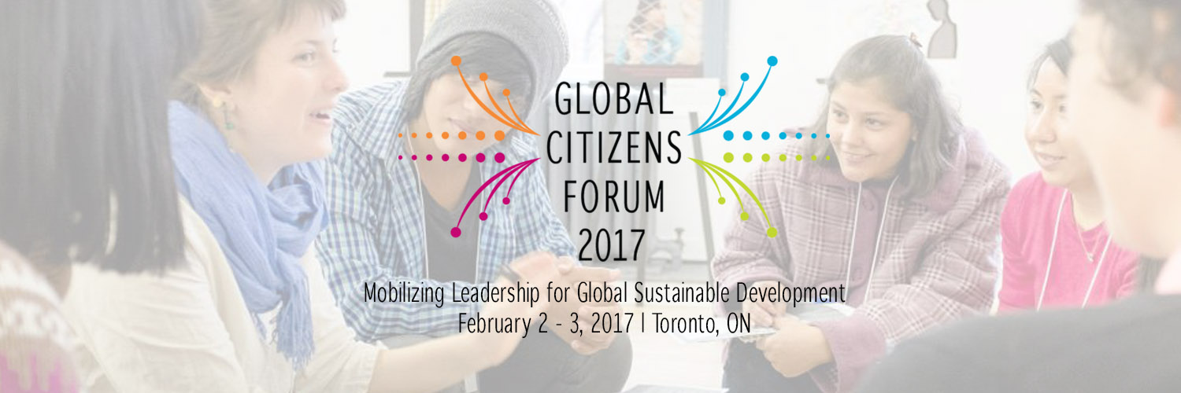

February 2, 2017
9:45-10:30 | Registration / Fair Trade Café
10:30-11:00 | Welcome & Introductions  “According to the teachings of the Midewewin faith keepers, the language of the Ojibway Anishinabe people is written on the land. All of the plants and the waters have names that reflect our human relationship to creation. Before every ceremony or gathering we send out our songs that carry our prayers of thanksgiving for our first mother, the Earth”.  - Shelley Charles Elder Advisor on Aboriginal Relations, Humber College  - Kimberly Gibbons Executive Director, OCIC
11:00-12:15 | Contextualizing Global Sustainable Development Panel  - Helle Bank Jorgensen President, Global Compact Network Canada  - Deirdre Kent Director General of Development Policy, Global Affairs Canada  - Dr. Nenad Rava Strategic Development, Policy Design, Social Impact Consultant  - Fraser Reilly-King Senior Policy Analyst, Canadian Council for International Co-operation  - Mike Simpson Executive Director, British Columbia Council for International Cooperation
12:30-1:30 | Lunch / Poster Session
1:30-3:00 | Parallel Agora Sessions  Collaborating with Public and Private Partners to Promote Food Security for Women Subsistence Farmers and Children in Rural Vietnam  - Melody Mendonca Project Coordinator, Ryerson University  Memory and social action as a mechanism to achieve Peace and Reconciliation  - Julián Marin Social Worker, and Mónica Aguirre Coordinator of Youth Initiatives, YMCA of Medellin, Colombia  Generating Social Innovation in your Workplace  - Dr. Keita Demming Executive Director, The Agency, University of Toronto  - Geraldine Cahill Manager, Programs and Partnerships, Social Innovation Generation
3:00-3:30 | Break
3:30-5:00 | Parallel Agora Sessions  Global to Local: Strategic Diaspora Mobilization Towards a Just Society  - Marine Adamyan Director, New Business and Partnerships, World Vision International Sustainable Health  - Isabel Perez-Doherty Development Consultant  - Dr. Suzanne L. Stewart Canada Research Chair in Aboriginal Homelessness & Life Transitions  - Uju Umenyi Youth and Outreach Coordinator, Canadian Jesuits International  - Najia Zewari Instructor, Centre for Community Learning and Development, and Coordinator, Global Citizen Network  Making the SDGs Famous: Movement Building & Mainstream Conversation  - Chelsey Smith Canada Communications Manager, Global Citizen  Unleashing the Potential of Social Enterprise: Understanding the Social Stakeholder  - Niduk Wijayasingha Serendip International  Self Identity in a Changing World  - Mike Simpson Executive Director, British Columbia Council for International Cooperation
5:00-5:45 | Closing Plenary
5:45-8:00 | Reception, OCIC Global Changemaker Youth Ambassador 2017 Awards and If Women Mattered: Stories of Resistance, Stories of Allyship, presented in collaboration with the Canadian Partnership for Women and Children’s Health  - James Madhier OCIC Global Changemaker Youth Ambassador 2017  - Neesa Medina Centro de Derechos de Mujeres, Honduras  - Nice Nailantei Leng’ete Amref Health Africa in Kenya  - Judith Odhiambo PhD Candidate, Dalla Lana School of Public Health, University of Toronto

February 3, 2017
8:00-8:45 | Registration / Fair Trade Café
8:45-9:30 | Transformations: Stories of Partnership, Resilience & Positive Change Virtual Exhibition Launch  - Kimberly Gibbons Executive Director, OCIC  - Allan Lissner Photojournalism, Praxis Pictures  - Delfina Edward Country Manager, CPAR Tanzania  - Dusanka Pavlica Executive Director, CPAR Canada
9:30-10:30 | International Partners Panel  - Mónica Aguirre Coordinator of Youth Initiatives, YMCA of Medellin, Colombia  - Innocent Leoni Mlay Project Officer, CPAR Tanzania, Tanzania  - Neesa Medina Security & Gender Analyst, Centro de Derechos de Mujeres, Honduras  - Leonora Obara Co-Founder, Kijiji Cha Upendo Children's Project, Kenya
10:30-11:00 | Break
11:00-12:30 | Parallel Agora Sessions  Empowering Masaai Girls through Alternative Rites of Passage  - Nice Nailantei Leng’ete Project Officer, Amref Health Africa in Kenya  - Kevin O’Neill Director of Programs, Amref Health Africa in Canada  Innovating in Finance for Change  - Majid Mirza Senior Program Manager-Global Programs, Mennonite Economic Development Associates  - Abhishek Bhasin Vice Chair, Oikocredit Canada Board of Directors  Digital Technology for Social Impact  - Manu Kabahizi CTO and Co-Founder, Vera Belazelkoska Impact Measurement and Analyst, Arisa Goldstone Corporate Strategist and Analyst, Ulula  How the UN Addresses the SDGs? A Case for Peace and Biodiversity Dialogue Initiative  - Dr. Alexander Belyakov Certified Sustainability Professional
12:30-1:30 | Lunch / Poster Session Awards
1:30-2:30 | Localizing the Sustainable Development Goals in Thought and Practice: University of Waterloo, School of Environment, Enterprise and Development (SEED) Panel  - Dr. Larry Swatuk Associate Professor, International Development  - Dr. Bruce Frayne Associate Professor and Program Director, International Development  - Dr. Jennifer Lynes Associate Professor and Director, Environment and Business Undergraduate Program  - Dr. Prateep Nayak Associate Professor, International Development
2:30-3:30 | Closing Ceremony

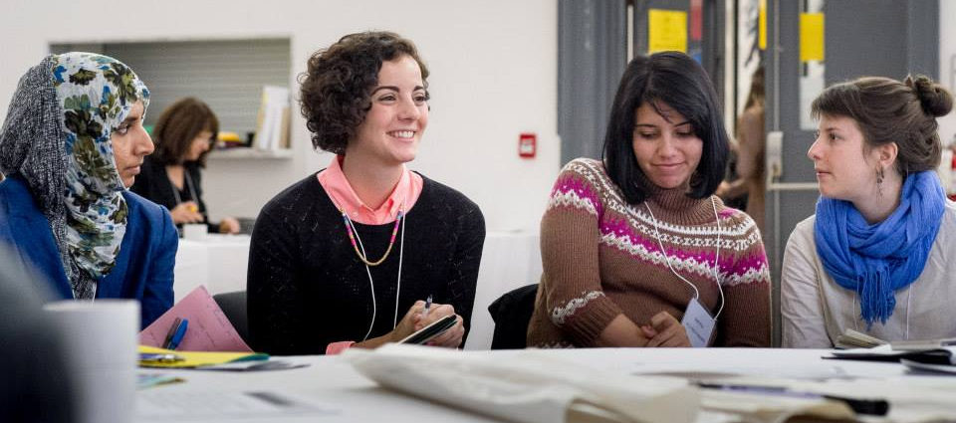

Collaborating with Public and Private Partners to Promote Food Security for Women Subsistence Farmers and Children in Rural Vietnam
Melody Mendonca

Collaborating with the private sector does not always mean crossing over to the dark side. Private sector partners come in a variety of forms and such collaborations can contribute to meaningful impacts in development. This session and its interactive role play components walk participants through a case study based on the Ecosun collaboration in Northern Vietnam. Through the Ecosun project, the National Institute of Nutrition in Vietnam (NIN) and Ryerson University have developed a food systems model and market driven approach to scale up successful initiatives by NINFOOD (a business subsidiary of NIN) using locally grown crops for the development and production of fortified foods for children (instant pabulums and instant flours).
Nearly one-third of children under the age of two are malnourished in northern Vietnam, and food security is highly prevalent. The project aims to increase food and nutrition security by building the capacity of women farmers to increase crop productivity, income and integration into food value chains while also supporting access to culturally acceptable fortified foods and increase in knowledge of complementary foods during weaning. By means of this case study on the food systems model and market-driven approach, this session will demonstrate: 1) NINFOOD's partnering strategy with local businesses to scale-up production of fortified foods in local small-scale food processing facilities; 2) The involvement of stakeholders to train farmers in sustainable agricultural practices; and 3) NIN's social franchising approach through nutrition counselling centers to promote uptake of the complementary fortified foods to improve child nutrition and feeding practices.

Memory and social action as a mechanism to achieve Peace and Reconciliation
Julián Marin, Mónica Aguirre

What are the challenges and opportunities for the work on Truth and Reconciliation? The YMCA of Medellin has vindicated Memory, Non-Violence and Peace building as fundamental principles to understand a troubling past, to strengthen the initiatives of resistance to violence, and to work for the future we envision for our communities. This workshop will present some of the elements of the political and cultural context Colombia is facing and the concepts of Memory and Peace that support the work of the Medellin YMCA on this topic. It will also present ideas, challenges and opportunities that civil society organizations in Canada can draw from to support our own process of Truth and Reconciliation and effective practices to support community mobilization. The workshop includes a hands-on exercise called cartographies of Memory and Peace.

Generating Social Innovation in your workplace
Dr. Keita Demming, Geraldine Cahill
How do we learn to generate strategic social innovation? One of the promises of university is to prepare students for the workplace. We are starting to help students to think in systems and address the root cause of problems. In this session, we work together to see how university preparation of students can support strategic social innovation in your organization. First, we will share examples of how the university is preparing students to address some of the world's most complex problems. Next, we will provide a framework for social innovation, using examples to demonstrate how it works. Then together we will apply the framework to your workplace context.

Global to Local: Strategic Diaspora Mobilization Towards a Just Society
Marine Adamyan, Isabel Perez-Doherty, Dr. Suzanne L. Stewart, Uju Umenyi, Najia Zewari

This two-part session explores key priority areas for diaspora communities to mobilize for change, with a focus on strategic actions individuals or groups can take to scale up their impact. The session begins with a panel featuring four speakers who will share insights on best practices for diaspora engagement with international development; diaspora youth as agents of change for their communities; using the SDGs as a framework for strategic diaspora engagement; and aboriginal community mobilization for international development and social justice.
After the panel, participants will break into groups for a workshop to learn collaborative strategies for advancing the 2030 Agenda. During the workshop the group will learn about working together on a strategic plan, the possibilities and limitations of building a network, and ways to build solidarity with aboriginal communities, NGOs and other organizations. Participants will leave the session with a deepened awareness of how diaspora communities are working for social justice; an understanding of how the SDGs can be used as a framework for mobilization; a new network to engage with for collective impact; and concrete tools for movement-building.

Making the SDGs Famous, Movement Building, and Mainstream Conversation with Global Citizen
Chelsey Smith
Making the SDGs Famous, Movement Building, and Mainstream Conversation with Global Citizen is an interactive multi-media presentation that unpacks the policies and delves into the international development discourse with the objective of broadening the conversation to be more inclusive and more effective for engaging the population at large.

Unleashing the Potential of Social Enterprise: Understanding the Social Stakeholder
Niduk Wijayasingha, Brooke Gordon

This session will equip Civil Society and Non-Governmental Organizations (CSOs and NGOs) as well as donors from government and private sectors with a deeper understanding of how to develop programs within their organization that support social enterprises. Be it the creation of (or partnership with) a new social enterprise through to establishing new policies for Corporate Social Responsibility (CSR), we will explore best practices that cross silos and boundaries of social issues targeting water, agriculture and forestry, for example, that impact poverty, inclusion and gender equity, decent work and economic growth. This session will specifically provide context for program managers who are engaged with social enterprises and accountable to diverse social stakeholders within the value chain. Attendees will participate in discussion around due diligence criteria and evaluating the value chain, establishing KPIs, models for transformational leadership and centralized/collective decision making.

Self-Identity in a Changing World
Mike Simpson

At the heart of any change agent lies a unique sense of self; a self under pressure in a changing world that faces the daunting task of the Sustainable Development Goals in the next fifteen years. We face psychologically challenging issues like "dangerous" climate change, increasing contraction in a violent world and a trend away from global thinking at the very time we need it most. Working in the context of global poverty, violence, conflict, migration, gender violence or inequality can take a toll on the strongest of us. This hands-on workshop is for those interested in the Socratic question "Who am I?" and is most suitable for those interested in a genuine inquiry into the self and the necessary skills to navigate with a sense of inquiry; not for the faint of heart or those that prefer presentations over participation. This workshop trades power points for powerful questions. Participant registration is limited and absolutely no answers are guaranteed nor offered.

Empowering Masaai Girls Through Alternative Rites of Passage
Nice Nailantei Leng’ete, Kevin O’Neill
This session will highlight the change that is taking place among Maasai communities in Kenya and Tanzania to replace the traditional practice of female genital mutilation/cutting (FGM/C) with Alternative Rites of Passage (ARP), focusing on the community-led nature of Amref Health Africa’s ARP initiative and on how youth are being empowered to take on leadership roles in global sustainable development efforts. Nice Nailantei Leng’ete, a 26-year-old Maasai woman from Kenya, is a true agent of change in opening up the discussion on FGM/C, both in her community, and around the world.

Born in a remote village on the slopes of Kilimanjaro, eight-year-old Nice ran away from home to escape FGM/C as a key aspect of the traditional Maasai passage to womanhood. Ms. Nailantei’s experience explores the sexual and reproductive health rights of girls and women through the lens of FGM/C. It shows how working with communities to empower women and girls can lead to positive, community-led change that results in greater equality for women and girls. It highlights the health consequences of FGM and how community conversations around the health of women and girls can provide a doorway into working with whole communities to empower women and girls. Ms. Nailantei’s experience also focuses on youth as leaders in sustainable development through profiling ARP - which place girls, young women and Morans (young Maasai men) at the centre of community and cultural change.

Between 2009 and 2015, Amref Health Africa successfully graduated over 10,500 girls into womanhood through its long-running, community-led ARP initiative in Kenya and Tanzania. In addition to sharing Ms. Nailantei’s experience, this session will explore the ARP initiative, through which Amref Health Africa is working towards eradicating FGM/C in the countries where it works by 2030; contributing towards Sustainable Development Goal 5.3: “Eliminate all harmful practices, such as forced early child marriage and female genital mutilation”.

Innovating in Finance for Change
Majid Mirza, Abhishek Bhasin, Clara Yoon Wilson

This session provides two models of innovative finance which are creating development outcomes. It will be held in conjunction with Oikocredit Canada and Mennonite Economic Development Associates (MEDA), with Oikocredit focusing on micro-finance tools, while MEDA will be focusing on blended finance. Through the international development activities of Oikocredit, the session will educate and enlighten audience on the role played by microfinance and impact investing on the lives of marginalized populations. Oikocredit is one of the largest sources of microfinance in the world with over $1 billion in assets.
We will share case studies of pioneering work done across the developing world in the field of impact investment and social justice through innovative funding mechanisms and capacity building work. The blended finance session by MEDA will showcase the INFRONT project, a 5-year partnership between Global Affairs Canada, MEDA, Sarona Asset Management, and MaRS Centre for Impact Investing, leveraging $15 million in first lost capital from the Government of Canada to crowd in an additional $150 million from external investors for investing in over 20 countries. It aims to show how blended capital invested into strongly governed, socially-conscious companies in the developing world impacts lives at the rural and household level and at the employee and client/customer level.

Digital Technology for Social Impact
Manu Kabahizi, Vera Belazelkoska, Arisa Goldstone

Digital technologies provide governments, companies and civil society organizations the opportunity to connect with some of the world's hardest to reach stakeholders to source invaluable insights. This session will outline the history and evolution of Information and Communication Technologies for Development (ICT4D), pulling from best practices, sector trends and our own experience creating technology for impact measurement. We will explore case studies of how simple mobile phones can change the way development agencies connect with beneficiaries to measure project success, and how companies and brands can source insights on real working conditions in the factories that make their products to create more sustainable international operations worldwide.

How the UN Addresses the SDGs? A Case for Peace and Biodiversity Dialogue Initiative
Dr. Alexander Belyakov

Management thinker Peter Drucker is often quoted as saying that “The best way to predict your future is to create it.” Are we sure what direction of creation we are taking? The 2030 Agenda for Sustainable Development will help us to leverage insights about the 17 Sustainable Development Goals, 169 targets, and 241 proposed indicators. Let us reflect how these metrics help facilitate change and embrace it. The United Nations Secretary-General António Guterres pledged to make 2017 a year for peace. How are we going to ensure positive changes are happening? Solutions will likely require drawing on a variety of disciplines, approaches and case studies.

During the 12th meeting of the Conference of the Parties to the Convention on Biological Diversity, the Republic of Korea launched the Peace and Biodiversity Dialogue Initiative, as a potential solution to global concern about conflict areas. The Korean Demilitarized Zone Ecology and Peace Park is targeted for strengthening international cooperation for protected border areas. Peace Parks' creation is a form of environmental diplomacy that is gaining prominence. Peace Parks allow shared sovereignty of the environment because it is based on science and can be de-politicized, can set the scene for other forms of cooperation in trickier areas such as competition for natural resources, environmental security or tackling environmental crime. Environmental diplomacy is drawing together agencies from the environmental, human rights and peacebuilding spheres of the UN. At the same time, there is so much to be done on the interpretation, promotion, and application of the Peace Parks’ concept as a part of these peacebuilding processes that it would be difficult for institutions working in isolation to succeed.

The PBDI is committed to broadening the range of collaborating organizations in support of Peace Parks' creation and develop a strong potential for conflict resolutions. Let us also hope that environmental diplomacy and similar projects could contribute to a peaceful development between Russia and Ukraine, other conflicts worldwide. Get inspirational messages capturing your Aha! Moment in this session.

Localizing the Sustainable Development Goals in Thought and Practice
Dr. Larry Swatuk, Dr. Bruce Frayne, Dr. Jennifer Lynes, Dr. Prateep Nayak

Students in international development studies programs yearn for hands-on skills training and different ways to anchor their passions and practical actions. Often times the ‘big concepts’ and ‘big issues’ appear beyond their reach. They are either too abstract (SDGs, MDGs) or too overwhelming (global poverty; global inequality; migration crises) for the student to come to grips with, and to find a way to contribute meaningfully to global development. In this session, five educators of international development – each with long experience in development practice – unpack different elements of the SDGs related to their own expertise (water and sanitation; cities; energy; social justice) and illustrate how the average person as well as the engaged student or development practitioner can engage meaningfully in their everyday lives with the SDGs. Each presenter will spend 5 minutes speaking to a particular SDG and then 2 minutes illustrating ways and means of giving them ‘life’ in everyday practice.

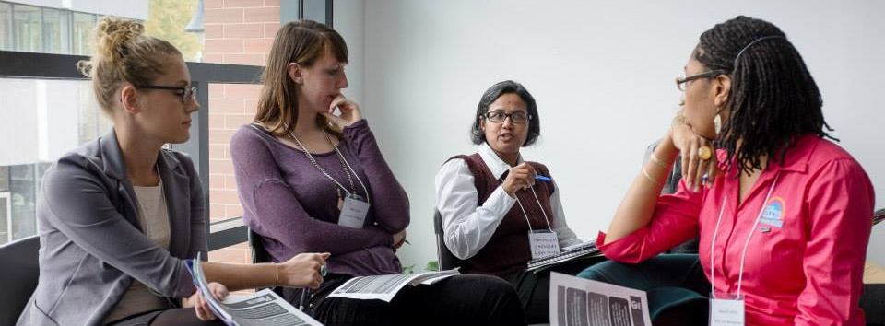

Marine Adamyan
Marine Adamyan (MPH, MBA) is a global health expert with 20 years of experience in sustainable development, having various technical, strategic and operational leadership roles in Middle East, East and Southern Africa, Central and South Asia, Eastern Europe. Marine is known as a "health in all" planner, multi-stakeholder partnership broker, experienced global health diplomat, and believes that Agenda 2030 for Sustainable Development requires strong inter-organizational and cross-sectoral collaboration, across the world. Her targeted effort in facilitating cross-sector integration; fostering multi-stakeholder partnerships; guiding and coordinating global community of practices for knowledge exchange and cross-regional / cross-country learning around various dimensions of sustainable development continue to add value to SDGs.
During her career journey, Marine exercised her technical and political savvy influencing policies, leading strategies, designing and implementing projects in technical domains of Health Systems Strengthening; Maternal, Newborn, Child Health and Nutrition; Sexual and Reproductive Health; HIV and AIDS; Behavior Change Communication; Health in All Policies. Marine was a post-graduate fellow at the department of International Health of Johns Hopkins University, Bloomberg School of Public Health (JHU-BSPH), USA in 1999. She was also a visiting scholar at Child Survival Collaboration and Resources (CORE) Group, USA in 2004. She previously worked with Catholic Relief Services (CRS), Médecins Sans Frontières/Doctors Without Borders (MSF), American University of Armenia (AUA). Marine has MPH (1997) from JHU BSPH affiliated AUA in Armenia and an executive MBA (2014) from Innovative Management Center of Athabasca University in Canada.

Mónica Aguirre
Mónica Aguirre is a professional in Planning and Social Development with 20 years of experience in working with youth. She designed “Laboratorios Creativos”, a model of the YMCA of Medellin that seeks to develop the values ​​of citizens from centers of interest in training such as video, photography, dance, theater, plastic arts, sports and music. As a social entrepreneur and a passionate activist, Mónica is the founder of two companies: one of community communications (Newspaper “La Pupila”) and another one (Humanizar el Desarrollo) that defends Human Rights, both of which currently work with the local government and carry out actions to reduce social inequities. Mónica was a Municipal Youth Councillor from 2007 to 2010 and won the Young Woman Talent Award presented by the city of Medellin in 2010. She has participated in numerous national and international events where she has shared her experiences and knowledge of working with youth.

Dr. Alexander Belyakov, PhD
Dr. Alexander Belyakov works with international, private and public sector organizations. He is recently consulting the Peace and Biodiversity Dialogue Initiative at the Secretariat of the Convention on Biological Diversity administered by the United Nations Environment Programme in Montreal. Alexander taught Sustainability Management at Ryerson University, and Media Studies at the Humber Institute of Technology and Advanced Learning. He further successfully completed many professional development programs in sustainability, including a course on the 2030 Agenda for Sustainable Development at United Nations System Staff College; Certificate in Sustainability Management at Ryerson University; International Program on the Management of Sustainability, Sustainability Challenge Foundation and TiasNimbas Business School, The Netherlands; Sustainable Environmental Management, Beahrs Environmental Leadership Program, University of California, Berkeley, USA. Alexander has extensive international experience from projects in Ukraine with United Nations Development Program; USAID; German governmental institutions; visiting scholarships in the USA and Germany (Beahrs Environmental Leadership Program and Environmental Journalism Program at the Graduate School of Journalism, University of California, Berkeley; Institute for Environmental and Sustainability Communication, University of Lüneburg, Germany). He is also a member of the board of directors of Science for Peace and a founding member of The Roots Collaborative.

Vera Belazelkoska
Vera Belazelkoska has 7+ years’ experience in field research, community engagement, and monitoring and evaluation across 6 continents. A past Rotary International Ambassadorial Scholar, Vera is passionate about developing transformative partnerships at company, grassroots and system level. At Ulula, Vera manages projects that give a voice to workers and communities impacted by business operations worldwide to create more transparent and ethical global supply chains. She holds a Master’s degree in Political Economy of International Development from the University of Toronto.

Abhishek Bhasin
Abhishek Bhasin has over a decade of international experience in financial services, commercial lending, not-for-profit and brand management fields. He is currently serving as Vice Chair on the Board of Oikocredit Canada, a support association of Oikocredit International. His experience in both developing and developed economies serves him well as a Chair of the Strategic Initiatives committee where he is leading the brand awareness and education efforts for Oikocredit. Prior to this, Abhishek served as a Director and Treasurer for Common Ground Co-operative, an award winning not-for-profit organization supporting individuals with developmental disabilities. Abhishek has a double-masters' including an MBA in Business Sustainability and Finance from Schulich School of Business at York University. Prior to his MBA, Abhishek worked on the World Economic Forum’s private-public partnership health initiative to reduce the incidence of tuberculosis (TB) in India and experienced first-hand the challenges and complexities of running such initiatives.

Geraldine Cahill
Geraldine Cahill is the Manager, Programs and Partnerships for Social Innovation Generation - a collaborative partnership working to create a culture of social innovation in Canada. She works closely with SiG's 4 partners: MaRS Discovery District, the McConnell Foundation, PLAN Institute, and the University of Waterloo's Institute for Social Innovation and Resilience.

Shelley Charles, MandawKwe
Shelley Charles is a member of the Chippewas of Georgina Island First Nation. She has worked extensively in First Nation communities across Canada and the US. She works with youth, teachers and aboriginal artists with a commitment to preserving cultural knowledge and language. Shelley is the Elder Advisor on Aboriginal Relations at Humber College. Her passion is to provide Aboriginal students with the support and guidance through their educational journey in a post-secondary environment. She has her Master’s Degree in Indigenous Philosophy.

Dr. Keita Demming, PhD
Dr. Keita Demming works in a space that merges theory, and practice related to business and social innovation. He is a social entrepreneur and PhD from OISE, University of Toronto. His thesis draws on the midwifery movement as case study for exploring the conditions for social innovation. He hosts a community of practice, called the SIDELab, where they explore System Thinking, Integrative Thinking, Design Thinking and Evaluative Thinking. He also teaches Design Thinking, System Thinking and Integrative Thinking through B Studio.

Delfina Edward
Delfina Edward is the Country Manager of the CPAR Tanzania office, where she oversees projects in a variety of sectors, including food security, water, sanitation and hygiene, and maternal and child health. Prior to joining CPAR, Delfina spent three years with WEPMO (Water and Environmental Projects Maintenance Organization) and Wellshare International, as well as one-and- a-half years as a researcher with Ifakara Health Institute, where she studied the socio-cultural factors that influence the implementation of malaria prevention, diagnosis and treatment interventions. Delfina holds an honors BA in Culture and Heritage from the University of Dar es Salaam, has completed courses in Social Accountability, project planning, management course and specialized training in Results Based Management. Delfina is fluent in English, Swahili and Sukuma.

Dr. Bruce Frayne, PhD
Dr. Bruce Frayne is Director of the International Development program and Associate Professor in the School of Environment, Enterprise and Development (SEED), Faculty of Environment, University of Waterloo. Bruce is an Urban Planner and Geographer, with research interests that fall within the broad ambit of sustainable cities, which encompass the three related areas of human migration, urbanization and food security. Bruce draws on more than 25 years’ experience in international development and his regional focus is Sub-Saharan Africa.

Kimberly Gibbons
Kimberly Gibbons has been the Executive Director of the Ontario Council for International Cooperation (OCIC) since 2005. During this time, she has helped to lead OCIC through a period of expansion and growth in its sector-representation, networking, capacity building and public engagement roles in Ontario and Canada. As a Council, OCIC’s priorities are to strengthen members’ capacity in being leaders of good development and adapting to change; to increase multi-stakeholder dialogue to better understand and leverage perspectives, expertise and resources; and to influence by informing, amplifying the voice of Council members.
Kimberly has worked in many formal and non-formal education settings with youth and adults of diverse backgrounds in Asia, Central America, Europe and Canada and cares deeply about increasing collaborative spaces and cooperation as a means to end global poverty and inequality. She holds a Masters of Education in Adult Education and Transformative Learning from OISE, University of Toronto, and studied human rights at the graduate level at the Commonwealth Institute, University of London, England. Kimberly also has a Bachelor of Arts in International Development and Rural Extension Studies from the University of Guelph and completed her final undergraduate year of study at SNDT Women’s University, Mumbai, India. She currently serves on the Humber College International Development Program Advisory Committee, and the Canadian Council for International Co-operation Board of Directors.

Arisa Goldstone
Arisa Goldstone leads strategy and business development at Ulula where she translates client needs into a business strategy and requirements for tailoring the technology and its implementation. Previously, she worked at the Rotman Centre for Global Health and then at St. Michael's Hospital with a team providing community engagement advisory services to global health projects funded by The Bill and Melinda Gates Foundation. Arisa completed her MBA at the Schulich School of Business in sustainability and entrepreneurship.

Brooke Gordon
Brooke Gordon is a Principal at Serendip International, where she leads capacity building, strategic planning, and organizational development projects for clients. She was engaged in multiple projects at McMaster University in Hamilton, Ontario for over 13 years in Research Administration and Graduate Studies related to financial and operations management, human resources, government reporting and due diligence. As a Certified Nutrition Practitioner, Brooke's approach to project implementation is focused on supporting the business' strategic vision for growth while sustaining a healthy work- life balance for the whole team. Brooke holds a Master's in commercialization (MEEi), as well as both a Bachelor's and Master's in Engineering Physics from McMaster University. She currently lectures for McMaster's Engineering & Management program.

Helle Bank Jorgensen
The Global Compact Network Canada is led by Helle Bank Jorgensen who was appointed as the UN Special Advisor to the Global Compact in 2013. She was most recently invited by HRH Prince of Wales to serve at his A4S Expert Panel. Ms. Jorgensen brings over 25 years of experience advising leading global companies, investors, and governmental and non-governmental institutions, such as the Danish Government and the EU on reporting. She has also advised the IFC, the World Bank Group, and SIDA on Responsible Global Supply Chains. Ms. Jorgensen has also served at the Council of DANIDA, while she was based in Denmark. Prior to living in Canada, she lived in Denmark and the US, where for 11 years she was a partner with PwC, leading the sustainability and climate change practice. Ms. Jorgensen has authored several books, penned numerous articles and is a recognized speaker at events. Ms. Jorgensen holds a degree as Business Lawyer (1989), Master of Science in Business Administration and Auditing (1994), and is a State Authorized Public Accountant (1998). She has also been interviewed by Forbes on how to Leverage Gender Diversity To Yield High Financial - And Human - Returns and is a frequent contributing author for GreenBiz. Her most recent article is on how women-owned businesses can be a vehicle for change. As well, Ms. Jorgensen was invited to speak at the UN HLP on Women Economic Empowerment and is the CEO of a certified Woman-Owned business.

Manu Kabahizi
Manu Kabahizi is a computer scientist focused on creating technological solutions to complex societal challenges. Before creating the Ulula platform, Manu worked as a strategist for UNICEF's DevInfo, and his work in mobile was nominated 2013's Most Inspiring Social Innovations. He studies Computer Science at the University of Cape Town, and furthered his studies in Human Geography at the University of British Columbia.

Deirdre Kent
Deirdre Kent is the Director General for Development Policy within Global Affairs Canada responsible for the advancement of strategic development policy and emerging issues, including the 2030 Agenda for Sustainable Development. Since joining the Foreign Service in 1994, Ms. Kent’s career has focused on multilateral diplomacy including international development policy, peace and security issues and human rights. From 2012-2015, she was responsible for operational responses to complex crises, police and civilian deployments and program finances with the Stabilization and Reconstruction Task Force (START) which coordinated Canada’s whole-of-government engagement for stabilization and reconstruction in fragile and conflict-affected states. Her last overseas assignment was as Human Rights Counsellor at the Canadian Permanent Mission to the United Nations in Geneva, Switzerland from 2002 to 2006, where she was elected Rapporteur for the United Nations Human Rights Commission in 2005. She has also served abroad in Israel and the West Bank/Gaza. Deirdre Kent holds a Bachelor of Science and an International Masters of Business Administration (MBA).

Nice Nailantei Leng’ete
Nice Nailantei Leng’ete is a powerful advocate for Alternative Rites of Passage (ARP) for girls in Kenya’s pastoralist communities, having herself escaped forceful female genital mutilation/cutting (FGM/C) at the age of eight. Ms. Nailantei is currently a Project Officer for Amref Health Africa in Kenya, which has to date helped to prevent more than 10,500 girls from being subjected to FGM/C in Kenya and Tanzania. Ms. Nailantei continues to play a key role in the fight against FGM/C, ensuring that girls and women transition to womanhood without undergoing the cut. She educates her community, including Maasai cultural elders, traditional birth attendants (TBAs), mothers and girls, chiefs and church leaders on the negative effects of FGM/C. She has even overcome the challenge of convincing young Maasai men ('morans') to abandon the practice. In 2016, Ms. Nailantei was selected for the Mandela Washington Fellowship for Young African Leaders hosted by President Obama. She has spoken at events in Italy, the Netherlands and the US.

Innocent Leoni Mlay
Innocent Leoni Mlay is a current Project Officer with CPAR Tanzania, where he focuses on Food Security projects using the Farmer Field Schools approach. Prior to joining CPAR, Innocent spent three years working in Food Security and sustainable agriculture programming with BRAC Tanzania. He spent a year as a teacher in Msufini See School in his home region of Kilimajaro, where he specialized in chemistry, biology, and agriculture. Innocent holds a BSc in Agriculture from the Sokoine University of Agriculture and is fluent in English, Swahili and Chagga.

Allan Lissner
Allan Lissner is an award-winning photographer, writer and filmmaker who was raised in in Ethiopia, Liberia, USA, Nepal, Lithuania, Denmark, Jordan, Bangladesh and Canada. For the past ten years Allan has been working on collaborative multimedia projects with indigenous communities, documenting their efforts to protect their ancestral lands and preserve their ways of life. This ongoing work includes projects with over a dozen communities in the Philippines, Guatemala, Tanzania, Papua New Guinea, Australia, Chile and Canada. Some of the organizations Allan has done work with include 350.org, Amnesty International, GlobalAware, Idle No More, the Indigenous Environmental Network, KAIROS, Oxfam, Make Poverty History, the Norwegian Church Aid, the Ontario Council for International Cooperation, the United Nations Development Program, and the United Nations Women's Association in Bangladesh.

Dr. Jennifer Lynes, PhD
Dr. Jennifer Lynes is associate professor and director of the University of Waterloo’s environment and business program. She is Chair of the non-profit organization Residential Energy Efficiency Program (REEP Green Solutions) and co-founder of the North American Sustainable Concerts Working Group. With an educational background in both marketing and environmental studies, her expertise intersects business and the environment, where she focuses on investigating the marketing of sustainability. Prof. Lynes is co-founder of the Sustainable Concert Working Group whose mandate is to encourage music industry stakeholders to integrate sustainability initiatives into live music concerts.

Majid Mirza
Majid Mirza has been working in international development and impact investing since he completed his Masters from the University of Waterloo in 2009. As Senior Project Manager, Global Programs, Majid's primary responsibility has been leading MEDA's INFRONT (Impact Investing in Frontier Markets) project since August 2016. Majid is also a member of MEDA's Investment Technical Team and represents MEDA in CAFIID (Canadian Forum for Impact Investing and Development). Majid has a Bachelors in Arts & Business from the University of Waterloo along with a Master in Business Entrepreneurship & Technology. Since 2009 Majid has been working with various impact investing and international development organizations including Acumen, Engro Foundation and The Aman Foundation. Through these assignments he has been exposed to various value chains related within the economic empowerment mandate including Agriculture, SME Development and Vocational Training. Through his career he has also had a chance to work closely with various donor agencies including USAID, DFID, GIZ, World Bank and the Japan Government. Majid is fluent in Urdu, and has basic Mandarin and Arabic skills.

James Thuch Madhier
James Thuch Madhier studies Peace, Conflict and Justice at the Trudeau Centre for Peace, Conflict and Justice Studies at the Munk School of Global Affairs, University of Toronto. James has been at the forefront of social change. He served as a Community mobilizer for the Girl Child Education Program at Kakuma Refugee Camp in Kenya from 2012-2013. In November 2015, he won the Nudge Global Leadership challenge in Amsterdam, Netherlands and went on a mission to Ghana and Cote d’Ivoire to investigate child slavery/hazardous child and poverty in cocoa farming. In April 2015, he was selected as a ‘Future Leader’ by the European Commission to contribute to policymaking processes alongside other world leaders in Brussels. He later got invited to the UN General Assembly Summit for the adoption of Sustainable Development Goals by the President of the UN General Assembly. James is currently working on a social venture called the Rainmaker Enterprise which is aimed at installing solar powered irrigation systems in South Sudan to enable sustainable agriculture to reduce poverty, hunger, malnourishment and resolve inter-communal conflicts over limited water and pasture resources. James is one of six recipients of the OCIC Global Changemaker Youth Ambassador 2017 Awards.

Julián Marin
Julián Marin is Social Worker with several years’ experience with community programs. He has developed an expertise in context analysis and in identifying the community impact of different stakeholders’ actions. Julián has a wealth of experience working with youth issues, local development, public policies and social research, and has been a researcher with the Observatory of Human Security in Medellin, Colombia. He is currently coordinating the Memory and Peace Area of the YMCA Medellin, which has promoted the creation of Commune 13’s Memory Committee, the implementation of the project “Memories in Dialogue” and the support to community initiatives around Memory, Coexistence and Peace building in Medellin. He is also an Academic Advisor of Social Work students at the University of Antioquia.

Neesa Medina
Neesa Medina is a Honduran feminist sociologist, and currently works as a Security and Gender Analyst at Centro de Derochos de Mujeres. At the national level, she has participated in forums on violence against women organized by civil society, as well in several panels discussing reforms to the Criminal Code to protect women and their sexual and reproductive rights. She has also developed mobilization and communication campaigns around the same themes. At the international level, she has participated in several conferences as a speaker, exposing the situation of structural violence against women in Honduras, and talking about the security policies that have been implemented by the government so far. In addition, she participated in the civil society delegation that drafted and presented the Alternative Report to the United Nations Committee for the Elimination of Discrimination against Women (CEDAW). Finally, in recent years she has testified as an expert on more than a dozen cases of women seeking asylum in the United States.

Melody Mendonca
Melody Mendonca is the project coordinator at Ryerson University for the Canadian side of the Ecosun collaboration in Vietnam. Her main role is to manage the project's communication and dissemination strategy. Melody holds a Master of Health Science Degree in Nutrition Communication from Ryerson University and a Bachelor's in Applied Human Nutrition from the University Guelph. Melody has worked on nutrition and food security issues within Canada and internationally in Bolivia, Brazil and Vietnam. Her main area of expertise is public policies and programs that improve the food and nutrition security of communities, particularly small-scale farmers.

Dr. Prateep Nayak, PhD
Dr. Prateep Nayak has an academic background in political science, environmental studies and international development. He does interdisciplinary work with an active interest in combining social and ecological perspectives. Prateep’s research focuses on the understanding of complex human-environment connections (or disconnections) with particular attention to change, its drivers, their influence and possible ways to deal with them. In the past, Prateep worked as a development professional in India on issues around community-based governance of land, water and forests, focusing specifically at the interface of research, implementation and public policy.

Leonora Obara
Leonora Obara is a social worker with a rich experience of working with Kenyan civil society organizations. Her work with the Kijiji Cha Upendo Children's Project (KCU) - entirely voluntary - is an excellent example of her capacity to bring together vulnerable communities, community stakeholders and CSOs to work together to advance community development goals. With KCU she has convened a support network of families caring for AIDS orphans in the Kibera slum community, connecting these families with schools and clinics, coordinating and supporting their access to support services and has engaged both local and international partners (the CAP Network) to provide financial support to livelihood development and educational programming.

Judith Odhiambo
Judith Odhiambo is currently pursuing her Doctor of Philosophy (PhD), at the Dalla Lana School of Public Health, University of Toronto. She has extensive skills in Community Based Research, implementation science, evidence based research, and community mobilization. She is currently concentrating on how HIV-related laws impact public health efforts on HIV Prevention and Care Cascade. As a Black African woman who is an immigrant in Canada, Judith is doing extensive work with African, Caribbean, and Black population. She is also currently doing work with McMaster University focusing on how post-colonial systems of oppression drive HIV epidemics among Indigenous women.
Judith is trained and worked in the field of Organizational Psychology and international development for over 8 years. She has a range of experiences working in multi-sectoral arenas designing and implementing development projects. She has worked with UNICEF, Action Aid, and various Community Based Organizations designing, and facilitating implementation of HIV/AIDS interventions in Africa. Judith continues to utilize her multidisciplinary and multi-sectoral experience to identify competency gaps influencing successful HIV/AIDS interventions especially within the African, Caribbean, and Black communities. Judith holds high leadership positions nationally and locally in Canada. She is currently serving as President of the Board of Directors of HIV/AIDS Legal Clinic of Ontario (HALCO). In addition, she is a board member of Interagency Coalition on AIDS and Development (ICAD). Judith is also the Co-Chair of the Canadian National HIV/AIDS Stigma Index. She also serves as a member of the Advisory Committee on Newcomer, Migrant and Refugee Health Project currently being rolled out by ICAD.

Kevin O’Neill
Kevin O’Neill is the Director of Programs at Amref Health Africa in Canada, where he has been employed since April 2014. Kevin is responsible for managing Amref Health Africa in Canada’s overall program portfolio, supporting program implementation and monitoring, managing partnerships with institutional donors and partners, and identifying and developing new program initiatives. Kevin is also a member of the OCIC’s Board of Directors, where he has served since 2011. Prior to joining Amref Health Africa in Canada, Kevin worked for over five years with Canadian Physicians for Aid and Relief (CPAR), most recently in the role of Program Manager. Kevin has also worked with World University Service of Canada (WUSC) and Mines Action Canada. Kevin holds a post-graduate certificate in International Project Management (IPMP) from Humber College and a Bachelor’s degree (Honours) in Global Studies with a specialization in Communities and Identities from Trent University.

Dusanka Pavlica
As Executive Director of CPAR, Dusanka Pavlica oversees the delivery of the organization’s mission through its range of programs in Ethiopia, Malawi and Tanzania. She serves as CPAR’s representative to the public, NGOs, donors, and the board of directors. Dusanka has over 25 years of experience working with a variety of NGOs, through which she has developed expertise in fundraising and change management. She is dedicated not only to CPAR’s role in improving the health of the communities in which we work, but also on forging partnerships that lead to the advancement of shared learning amongst members of the international development community. Dusanka is a graduate of the University of Toronto and past member of the G7 Research Group.

Isabel Perez-Doherty
Isabel Perez-Doherty is a multilingual economics graduate with studies in International Development and Management of Civil Society organisations. She possesses over 14 years’ experience in international organizations in Canada, UK, Europe, Latin America and the Caribbean. Her experience in the non-profit sector has shaped her as a well-rounded development professional with vast understanding of data driven strategy, supporter engagement, and partnerships. Isabel is a Board Member for College Montrose Children’s place, a Toronto-based charity for Early Years Education. She is also an OCIC Associate Member and has steered the work of the OCIC Diaspora Engagement Networking Group. She is an advocate for women’s leadership and empowerment, access to quality education, and migration as a catalyst for positive change. Isabel is passionate to find solutions to overcome inequality and to create opportunities for all.

Dr. Nenad Rava, PhD
Dr. Nenad Rava currently serves as the Advisor for the United Nations Development Group on integrated policy approach for SDGs (DRT global fund), and mentors 12 UN Country Teams in Asia, Africa, and Europe on development innovation. In his 20 years of professional experience in strategic development he worked for the UN, the World Bank, the European Union, national and regional governments, local communities, and civil society organizations in more than 25 countries. As a consultant, advisor, coach, expert and leader, he contributed to social and institutional innovation, policy design, complex system change, planning and strategic foresight, democratic governance, learning communities, and capacity development. After a degree in management and specialization in development policy, Nenad got his PhD on the Quality of Democracy and Nation-State Building. He is currently conducting research within the OCADU program on Strategic Foresight and Innovation (focus on social innovation hubs, platform business model, future policy for AI, and impact investment), and acts as Senior Research Advisor on Policy design, Strategic foresight, and Digital governance at the Strategic Innovation Lab in Toronto, Canada.

Fraser Reilly-King
Fraser Reilly-King is the Senior Policy Analyst at the Canadian Council for International Co-operation (CCIC). CCIC is the umbrella organization for Canadian not-for profit organizations engaged in international development work. From 2014-2015 CCIC was the national hub for the Beyond2015 campaign, with Fraser acting as the lead. Fraser currently sits on the Management Committee of the Reality of Aid Network as Vice-Chair, and was the North American representative to the CSO Partnership for Development Effectiveness from 2012-2014. He has written blogs on aid and development for the Ottawa Citizen and the Huffington Post. Prior to joining CCIC, Fraser worked for eight years at the Halifax Initiative Coalition (HI), doing research and advocacy on the International Financial Institutions and Export Credit Agencies. In a volunteer capacity, he has sat on the boards of the Canary Research Institute on Mining, Environment and Health and UNIFEM Canada. He has a Masters in Development Studies from the London School of Economics.

Chelsey Smith
Chelsey Smith (M.A.) is a media and communications professional, and global citizen devoted to universal education and equality. Chelsey's professional repertoire includes journalism, marketing and branding, movement building and campaign management. Her publication “The Technology of Hope: Twitter and the Bring Back Our Girls Campaign” examines the role of technology in new social movements, and how NGOs can best position campaigns for traction. Beyond an array of volunteer work in Canada, she has always been passionate about peace and justice in a global context, and worked to support the rights of children in Ghana (2008), to combat gender-based violence in Swaziland (2013), and to rebrand a movement toward transformative feminist society in Tanzania (2016). Working in international development is a challenge that Chelsey tackles with intense motivation for social change and human rights.

Michael Simpson
Michael Simpson is currently the Executive Director of the British Columbia Council for International Cooperation (BCCIC) and has a personal interest in the philosophy of social change and transformative leadership. A practicing student of Zen, he brings a flavour of inquiry to the basic questions of what motivates our sector. Formerly an award-winning documentary maker, Mike has worked in the non-profit sector with an emphasis on international development for more than 30 years in a broad range of issues, from working with child soldiers in West Africa to renewable energy and conservation in the Americas. He has an eclectic background that ranges from attending U.N. meetings to extreme sports, such as raising his daughter. He remains confounded by our current global predicament but truly intrigued by the like-minded who remain inquisitive.

Dr. Suzanne L. Stewart, PhD
Dr. Suzanne L. Stewart is a member of the Yellowknife Dene First Nation and a registered psychologist. She is Director of the Waakebiness-Bryce Institute for Indigenous Health, and Associate Professor in Social and Behaviour Health Sciences Division at the Dalla Lana School of Public Health, University of Toronto. Research and teaching interests include Indigenous mental health and healing in psychology (homelessness, youth mental health, identity, and work-life development), Indigenous pedagogies in higher education, and Indigenous ethics and research methodologies. She is also Chair of the Aboriginal Section of the Canadian Psychology Association and is committed to advancing Indigenous healing issues through the disciplines of health and psychology.

Dr. Larry Swatuk, PhD
Dr. Larry Swatuk is Associate Professor of international development at the University of Waterloo. Prior to joining UW, he spent 14 consecutive years in Africa, including 11 years at the University of Botswana where he was a lecturer in the Political and Administrative Studies Department in Gaborone and Professor of Natural Resources Governance at the Okavango Research Institute in Maun. Dr. Swatuk continues to work in Africa, most recently in November 2016, where he conducted a week-long UNDP AIO-SIDS sponsored training in conflict resolution and negotiation for integrated water resources management (IWRM) in Nairobi, Kenya. With a life-long focus on research and practice toward sustainable and equitable resource use, he asks the basic question: what will it take to devise policies, programs and practices as if the poor matter most?

Uju Umenyi
Uju Umenyi is currently the Youth and Outreach Coordinator at Canadian Jesuits International, responsible for outreach and social justice education in schools, and with the general public across Canada. She has worked in communications and outreach-based roles with international organizations and the federal government both in Canada and the UK, and has an M.A. in African Peace and Conflict Studies from the University of Bradford, where she studied and wrote her thesis on the role of diaspora in post-conflict peacebuilding. She is a member of the OCIC Diaspora Engagement Networking Group and sits on the Editorial Board of OCIC iAM eMagazine.

Niduk Wijayasingha
Niduk Wijayasingha has been consulting, working and advocating with government bodies, universities, international NGOs, across the Americas, Europe and East Africa since 2001. Experienced in engaging and negotiating with both the public and private sector, coordinating with institutional donors, diversifying public communication approaches, developing data protocols and M&E systems she is a seasoned international development professional. She is passionate about challenging & changing depictions of poverty, gender, race, disability, & class by organization. Niduk holds a Bachelor of Arts specializing in Industrial Relations from McMaster University. She conducted a review of minimum wage policy in Ontario for the Ministry of Labour. She continued further academic work in worker' s rights, economics and law, at the London School of Economics and Political Science earning a Master’s in (Economics) International Management and a Masters in Research Methodology and Statistics at Middlesex University while pursuing her doctoral research. Most recently she completed a case study on Coal Mining in Mozambique and the Leading of Nonviolent Social Movements at the Harvard Kennedy School of Government. She has published and presented at numerous conferences. Earning the Max Rotman Humanitarian Award, Niduk is also recognized as a community influencer on visible minorities and women by the Canadian Armed Forces. She formally established Serendip Inc. with the vision that the world needs more effective organizations with a positive social impact.

Clara Yoon
Clara Yoon holds a MA in Global Governance from the University of Waterloo and BA in Global Studies from Wilfrid Laurier University. Clara is the Project Coordinator, West Africa/MENA programs at MEDA. She provides technical support on financial services, women's economic empowerment, and investment-related projects, with a particular interest in research, communications, and dissemination of lessons learned.

Najia Zewari
Najia Zewari has over 10 years’ experience in project management, education and training. She was the lead instructor in the Global Citizenship academic upgrading course at the Centre for Community Learning & Development (CCL&D), and Coordinator of the Global Citizen Network (GCN). Najia has 20 years’ experience working for UN Women as an international women's rights worker, and founder of the Afghan Women's Network, a modern Afghan women's movement in Afghanistan. A visionary who developed many initiatives to unify women for social and economic empowerment through legal reform, her pragmatic approach to network organizing and organizational capacity-building, combined with her practical experience in women’s mentorship and leadership development are widely recognized in Afghanistan.
Najia’s experience organizing Afghan women’s movements and non-governmental organizations at the grassroots level empowered her to resolve the many challenges encountered in gender-specific international development programs globally. She also represented women in many national and International forums including the 1995 UN 4th Women’s Conference in Beijing, China’s NGO Forum. Najia has also conducted research that analyzed the socio-economic status of women, and has extensive knowledge of global violence against women, peace, equity and social justice programs. She is fluent in English, Dari, Pashto, Urdu, Arabic, and basic French, and has travelled to more than 30 countries.

NOTES

Violeta | A. Bastida | Centennial College
Marine | Adamyan | World Vision International for Sustainable Health
Monica | Aguirre Duque | YMCA of Medellin, Colombia
Romy | Alegria | Cape Breton University
Omar Said | Ali | ZACADIA
Ayesha | Amin | Fair Trade Toronto
Julia | Anderson | Kawartha World Issues Centre
Claudia | Aparicio | OCIC Volunteer
Roweida | Arafah | University of Waterloo
Graham | Atkinson | Amref Health Africa in Canada
Helle | Bank Jorgensen | Global Compact Network Canada
Zahra | Baptiste | Ontario Council for International Cooperation
Ruth | Bartlett | Wycliffe College, University of Toronto
Abhishek | Bashin | Oikocredit Canada
Deveney | Bazinet | WE Villages
Melanie | Beech | Wycliffe College, University of Toronto
Vera | Belazelkoska | Ulula
Dr. Alexander | Belyakov | Certified Sustainability Professional
Georgina | Bencsik | United Nations Association of Canada
Dibakar Babu | Bhattarai | United Youth Organization
Katie | Boomgaardt | University of Toronto - Scarborough Campus
Karla | Cabrera | OCIC Volunteer
Amanda | Cacilhas | Development & Peace / OCIC Board Director
Geraldine | Cahill | University of Toronto
Piyali | Chakraborti | Ontario Council for International Cooperation
Sanju | Chaudhaury | ADM Computer Suppliers
Shelley | Charles | MandawKwe / Humber College
Catherine | Craven | SOAS, University of London
Jeanine | Cudmore | The Primates World Relief and Development Fund
Elena | Cusmir | OCIC Lead Volunteer
Aysha | Dawood | Oikocredit Canada
Eiliyah Zahra | Deewan | OCIC Volunteer
Andrew | Defor | World Health Organization
Dr. Keita | Demming | The Agency at University of Toronto
Alanna | Dickinson | OCIC Lead Volunteer
Natasha | Dobrijevic | CPAR
Genevieve | Drouin | Involve Consulting Group
Delfina | Edward | CPAR Tanzania
Mada | El Dibs | Amnesty International & UNAC
Mirna | El Sabbagh | COSTI Immigrant Services
Clarisse | Estebar | The Leadership Academy
Tunde | Fakunle | Centre for Sustainable Access to Health in Africa
Vicki | Faul | Ontario Council for International Cooperation
Jessica | Ferne | IDRF / OCIC Board Director
Roshelle | Filart | RESULTS Canada / OCIC Board Director
Natalija | Fisher | Water Youth Network | Naša Gora
Jen | Foulds | Amref Health Africa in Canada
Dr. Bruce | Frayne | University of Waterloo
Charlotte | Gale | Engineers Without Borders
Jose | Garcia | Salvadorian Canadian Association
Ioana | Gheorghiu | RESULTS Canada
Rachelia | Giardino | Kawartha World Issues Centre
Kimberly | Gibbons | Ontario Council for International Cooperation
Arisa | Goldstone | Ulula
Paola | Gomez | Muse Art Project
Brooke | Gordon | Serendip International
Dr. Helene | Gregoire
Ruva | Gwekwerere | Development & Peace
Isabelle | Hachette | World Accord
Jesse | Han | OCIC Volunteer
Muniyat | Haque | University of Waterloo
Jessica | Harman | Laurier University
Steve | Hewko | Wycliffe College, University of Toronto
Miriam | Hird-Younger | Anthropology, University of Toronto
Jon | Horler | CPAR
Stefan | Hostetter | Centre for Social Innovation
Katia | Hoyos | YMCA
Maggie | Huang | OCIC Volunteer
Ashna | Hudani | Rare Charitable Research Reserve
Jessica | Hum-Antonopoulos | Canadian Feed the Children
Odette | Hutchings | Global Citizen
Katerina | Ioannou | OCIC Volunteer
Manu | Kabahizi | Ulula
Deirdre | Kent | Global Affairs Canada
Emily | Kere | Right to Play / OCIC Board Director
Thursica | Kovinthan | comdu.it
James | Kuhns | Toronto Urban Growers
David | Kupp | Wycliffe College, University of Toronto
Asha | Kuziwa | New York University
Karene | Kwan-Tat | OCIC - Diaspora Engagement Networking group
Jeannethe | Lara | The Primates World Relief and Development Fund
Innocent | Leoni | CPAR Tanzania
Tian | Lim
Monica Maria | Linares | Toronto Hispanic Chamber of Commerce
Allan | Lissner | Praxis Pictures
Anthony | Lui | Wycliffe College, University of Toronto
Dr. Jennifer | Lynes | University of Waterloo
Emily | MacDougall | WE Charity
Susan | MacGregor | Humber College
Sarah | Macharia | CAP Network
Nicole | Mack | University of Toronto
James | Madhier | World University Service of Canada
Chi | Mandivenga | AMREF Health Africa in Canada
Mitra | Manouchehrian | Plan International Canada / OCIC Board Director
Ahmeda | Mansaray-Richardson | Wycliffe College, University of Toronto
Julian | Marin Silva | YMCA of Medellin, Colombia
Taylor | Marlow | Operation Groundswell
Christina | Masching | Associate Member
Neesa | Medina | Centro de Derechos de Mujeres, Honduras
Jessica | Meloche | OCIC Volunteer
Melody | Mendonca | Ryerson University
Majid | Mirza | Mennonite Economic Development Associates
Dallia | Mitchell | Canadian Centre for the Responsibility 2 Protect
Rae | Mombourquette | Kwanlin Dun First Nation
Esperanza | Monsalve | YMCA - Greater Toronto Area
Faith | Mwesigye | Trent University
Nice | Nailantei Leng’ete | Amref Health Africa in Kenya
Mridula | Nair | University of Waterloo
Dr. Prateep | Nayak | University of Waterloo
Jakub | Nemec | Salanga / OCIC Board Director
Shenikah | Newman | DZYN Consultant Inc.
Judith | Odhiambo | University of Toronto
Kevin | O'Neill | Amref Health Africa in Canada / OCIC Board Director
Leonora | Obara | Kijiji Cha Upendo Children's Project, Kenya
Eugenia | Ochoa | Ontario Council for International Cooperation
Adedayo | Olusegun | Wycliffe College, University of Toronto
Gertrude | Omoro | CUSO International
Irene Ordonez | Ordonez | YMCA
Simidele | Orimolade | Crossroads International
Cristina | Pastrana | Columbian Consulate
Dusanka | Pavlica | CPAR
Isabel | Perez-Doherty | Canadian Jesuits International
Daniella | Prado | OCIC Volunteer
Dr. Nenad | Rava | Strategic Development, Policy Design, Social Impact Consultant
Fraser | Reilly-King | Canadian Council for International Cooperation
Richard | Reycraft | El Hogar Board of Directors
Rosalind | Reycraft | El Hogar Board of Directors
Alicia | Richins | York University
Erika | Richter | RESULTS Canada
Tiyahna | Ridley-Padmore | RESULTS Canada
Jo | Rodrigues | Conflict Resolution Trainer & Coach
Cindy | Ross Peterson | The Agency at University of Toronto
Laura | Rossall | CAP Network
Mirna | Sabbagh | OCIC Volunteer
Nita | Saini | Centennial College
Dani | Sarusi | Jane Goodall Institute of Canada
Dylani | Shea | Ontario Council for International Cooperation
Fidaa | Shehada | Centennial College
Mike | Simpson | British Columbia Council for International Cooperation
Chelsey | Smith | Global Citizen
Olive | Smith | Alliance of Jamaican Alumni Associations
Vichheka | Sok | OCIC Volunteer
Elizabeth | Soltis | Bridges Global
Dr. Susan | Stewart | OISE/University of Toronto
Lisa | Swainston | Ontario Council for International Cooperation
Dr. Larry | Swatuk | University of Waterloo
Tina | Sweeney | CUSO International
Andria | Teather | Jane Goodall Institute of Canada
Horacio | Tejera | HCH and ASHTOR
Estela | Ulloa | University of Toronto/Humber College
Uju | Umenyi | Canadian Jesuits International
Jasmine | Vallve | Ontario Council for International Cooperation
Lorenzo | Vargas | World Association for Christian Communication
Laura | Viselli | Students Offering Support
Sneha | Wadhwani | Kawartha World Issues Centre
Niduk | Wijayasingha | Serendip International
Helen Seifu | Wolde | People to People Canada
Rachelle | Woldegiorgis | Wilfrid Laurier University
Jason | Wong | Aga Khan Foundation Canada
Ken | Wong | OCIC Volunteer
Clara | Yoon | MEDA
Karen | Young | OCIC Volunteer
Najia | Zewari | Center for Community Learning and Development

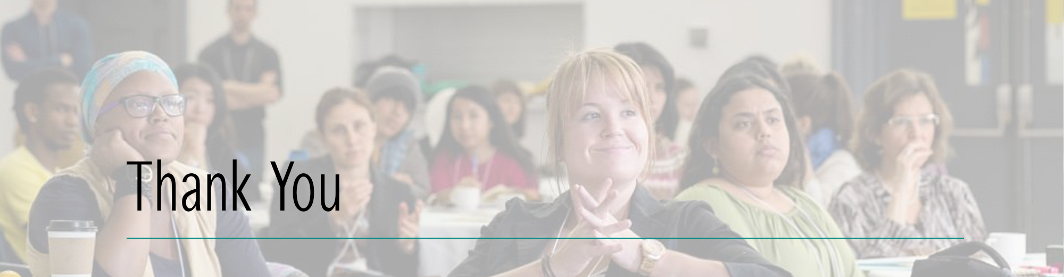

Humber College
The Humber Institute of Technology and Advanced Learning, commonly known as Humber College, is a publicly funded polytechnic college in Toronto, Ontario, Canada. Humber emphasizes hands-on, career-focused learning. They offer a broad range of credentials including bachelor’s degrees, diplomas, certificates, and post-graduate certificates.

Canadian Partnership for Women & Children’s Health
The Canadian Partnership for Women and Children’s Health (CanWaCH) catalyzes Canadian collaboration among 100 Partners who are improving women’s and children’s health in 1,000 communities worldwide. They do this by capitalizing on the data revolution, connecting experts, and communicating impact to stakeholders. Through the power of partnership, they strive to realize a world where every women and children survives and thrives.
At the Canadian-led 2010 Muskoka Initiative, leaders from Canadian organizations that are focused on maternal, newborn and child health, came together at a roundtable hosted by the Honourable Minister of International Cooperation. These leaders saw an opportunity for increased collaboration to improve accountability and effectiveness. Dr. Dorothy Shaw and Rosemary McCarney led the effort to bring together non-governmental organizations, academics and health practitioners to form the Canadian Network for Maternal, Newborn and Child Health.
In 2016, the organization was renamed the Canadian Partnership for Women and Children’s Health to reflect a global shift in lexicon surrounding women’s and children’s health with a focus on sexual and reproductive health and adolescent health. The new name also reflects the Canadian Partnership’s alignment with the Every Woman, Every Child Global Strategy of Women’s Children’s and Adolescent Health.

Leadership Committee Members
Katie Boomgaardt  University of Toronto, Scarborough Campus | Prateep Nayak  University of Waterloo
Julie Cosgrove  Kawartha World Issues Centre  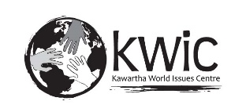 | Eugenia Ochoa  Ontario Council for International Cooperation  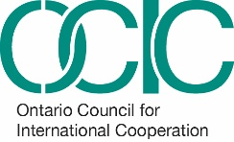
Jessica Dubelaar  Ryerson University | Cassandra Polyzou  Ontario Council for International Cooperation
Kimberly Gibbons  Ontario Council for International Cooperation | Fidaa Shehada  Ontario Council for International Cooperation
Susan MacGregor  Humber College | Tina Sweeney  Cuso International

Volunteers
Selasie Ametorwo, Claudia Aparicio, Karla Cabrera, Elena Cusmir, Eiliyah Zahra Deewan, Alanna Dickinson, Jesse Han, Maggie Huan, Katerina Ioannou, Jessica Meloche, Shenikah Newman, Daniella Prado, Mirna Sabbagh, Vichheka Sok, Ken Wong, Karen Young, Humaira Zahid

Show the world what positive change looks like.
Join the OCIC #BeAChangemaker campaign on
Twitter and Facebook.

 | @ocictweets |  | /LikeOCIC

www.ocic.on.ca/BeAChangemaker
