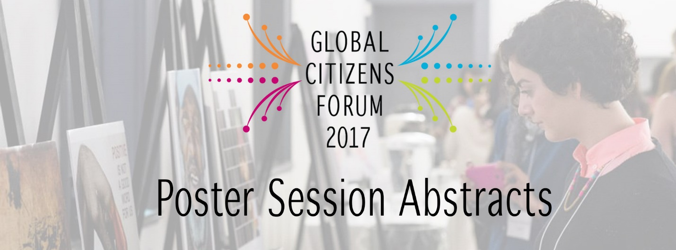

Roadmap of Women Empowerment in Tanzania’s Water and Sanitation Sector
Our group poster will focus on addressing issues of gender inequality and water scarcity in rural Tanzania. Despite the growth of urban areas within the developing world, particularly Africa, rural areas have been marginalized. Thus, the aim is to prevent further marginalization of an already vulnerable group while ensuring that rural communities get clean water and enables women to receive the same opportunities as men in the workforce. This will be done through examining two cases studies that tackled similar issues from different perspectives and involved key stakeholders through the implementation plans. The first case study of the Ghana WASH project focuses on the success of an NGO which attempted to support marginalized groups. The second study of Uganda focuses on the role of the local government in addressing issues on gender inequality through implementing several strategies that help women fit into the workforce. The success of these case studies was used as a baseline for the implementation plan in Tanzania. This is done to enhance the country’s implementation plan and learn from other examples and putting it against the shortcomings in water security for women in Tanzania. Therefore, an implementation plan was put in place to include three main factors. First, various actors should be considered for the success of such a project. Secondly, programs should be properly staffed to ensure that such communities become resilient. Finally, to ensure successful outcomes, financial aid planning followed by project monitoring and evaluation is essential.
Names: Muniyat Haque, Roweida Arafah, Mridula Nair

Scaling Up Local Production of Fortified Foods in Vietnam to Improve Food Security and Nutrition
In Northern Vietnam, nearly one-third of children under the age of two are malnourished due to high rates of poverty, lack of dietary diversity, low rates of exclusive breast feeding and suboptimal nutrition of weaning foods. To tackle these issues in a systematic and sustainable manner, researchers at Ryerson University and the National Institute of Nutrition (NIN) in Vietnam have developed a food systems model and market driven approach to scale up production of fortified complementary foods for children (instant pabulums and instant flours) using locally grown crops. The poster will showcase a two year collaboration between the institutions, aimed at increasing food and nutrition security by building the capacity of women farmers to increase crop productivity, income and integration into food value chains while also supporting access to culturally acceptable fortified foods. The scaling up strategy has three components: 1) the direct procurement of crops from small-scale women farmers; 2) the decentralized production of fortified complementary foods in small-scale food processing (SSFP) facilities; and 3) the distribution of the SSFP products using nutrition counseling centers and local private sector sellers. The poster presentation will share learnings from the project in testing and implementing the food systems model on the ground; and provide an opportunity for the exchange of knowledge on improving food security by strengthening local food systems in a global context.
Name: Melody Mendonca

Engaging diaspora communities in post-war Sri Lanka
There is increasing evidence of the role of diaspora communities in addressing global challenges, particularly those related to the achieving the UN Sustainable Development goals (SDGs) on poverty, the environment, and peace and prosperity. This poster highlights how Comuduit, a diaspora driven organization from the Sri Lankan community in Canada, is developing partnerships and programs with local organizations and institutions in Sri Lanka to foster sustainable development in a post-war context. Comdu.it provides a unique diaspora engagement framework that takes a three-prong approach to include different members of the community. This framework involves providing opportunities for youth, professional, and elders to take part in projects with organizations in Sri Lanka through the following programs:
The Right of Return Program is a 3-month program that aims to provide a space for youth in the Sri Lankan diaspora to explore and better understand the post-war context of the given community they are placed in while engaging in volunteer activity with our local partners.
The Associateship program is targeted at professionals, including new and young professionals, who are committed to invest time and technical assistance to contribute to the efficiency of existing livelihood/educational programs that are run by partner organisations in Sri Lanka.
The Elders program is targeted at retired professionals who are able to contribute an extended period of time to enhance existing programs/initiative run by partner organisations.
This framework demonstrate how diaspora driven initiatives have the capacity to strengthen international cooperation and contribute to achieving the SDGs.
Name: Thursica Kovinthan

Reimagining Development: Community Based Organizing As An Alternative Method of Poverty Alleviation in Tanzania
Development discourse has created a stereotypical vision of the "Third World", plagued by poverty, illiteracy, famine, etc., which necessitates the need for development. This rhetoric exists as a consequence of colonialism. Many development programs, both through government and non-government organizations, recolonize formerly colonized countries by reestablishing ties with former colonizers and continues dependency on foreign aid. Through ties of foreign aid, Tanzania remains financially dependent on loans and grants from the West.
This senior thesis suggests that community based organizing may be more effective at poverty alleviation than foreign intervention in the form of development programs in the Tanga region of northeastern Tanzania. Community based organizations differ from typical large scale development projects common in the region, since CBOs arise in response to specific community needs. Case studies will investigate a CBO, KIUME, in Tanga which supports local women's small businesses as well as a traditional NGO, TALISDA (Tanzania Livelihood Skills Development and Advocacy), also in Tanga which focus on empowering and bettering the community.
Name: Asha Kuziwa

NOTES

