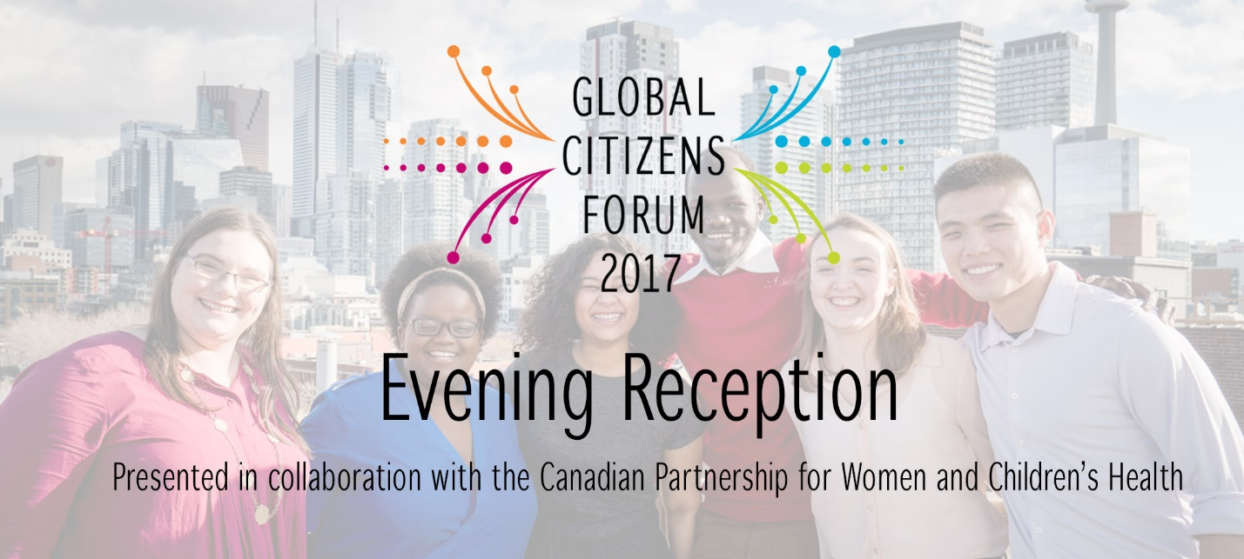

Congratulations to the 2017 OCIC Global Changemaker Youth Ambassadors
- Charlotte Gale Engineers Without Borders
- Rachelia Giardino Kawartha World Issues Centre
- Ruva Gwekwerere Development and Peace
- Tiyahna Ridley-Padmore RESULTS Canada
- James Thuch Madhier World University Service Canada
- Jason Wong Aga Khan Foundation Canada

If Women Mattered: Stories of Resistance, Stories of Allyship Speakers
- James Madhier OCIC Global Changemaker Youth Ambassador 2017
- Neesa Medina Centro de Derechos de Mujeres, Honduras
- Nice Nailantei Leng’ete Amref Health Africa in Kenya
- Judith Odhiambo PhD Candidate, Dalla Lana School of Public Health, University of Toronto

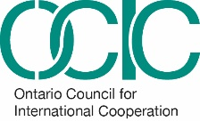
James Thuch Madhier studies Peace, Conflict and Justice at the Trudeau Centre for Peace, Conflict and Justice Studies at the Munk School of Global Affairs, University of Toronto. James has been at the forefront of social change. He served as a Community mobilizer for the Girl Child Education Program at Kakuma Refugee Camp in Kenya from 2012-2013. In November 2015, he won the Nudge Global Leadership challenge in Amsterdam, Netherlands and went on a mission to Ghana and Cote d’Ivoire to investigate child slavery/hazardous child and poverty in cocoa farming. In April 2015, he was selected as a ‘Future Leader’ by the European Commission to contribute to policymaking processes alongside other world leaders in Brussels. He later got invited to the UN General Assembly Summit for the adoption of Sustainable Development Goals by the President of the UN General Assembly. James is currently working on a social venture called the Rainmaker Enterprise which is aimed at installing solar powered irrigation systems in South Sudan to enable sustainable agriculture to reduce poverty, hunger, malnourishment and resolve inter-communal conflicts over limited water and pasture resources. James is one of six recipients of the OCIC Global Changemaker Youth Ambassador 2017 Awards.
Neesa Medina is a Honduran feminist sociologist, and currently works as a Security and Gender Analyst at Centro de Derochos de Mujeres. At the national level, she has participated in forums on violence against women organized by civil society, as well in several panels discussing reforms to the Criminal Code to protect women and their sexual and reproductive rights. She has also developed mobilization and communication campaigns around the same themes. At the international level, she has participated in several conferences as a speaker, exposing the situation of structural violence against women in Honduras, and talking about the security policies that have been implemented by the government so far. In addition, she participated in the civil society delegation that drafted and presented the Alternative Report to the United Nations Committee for the Elimination of Discrimination against Women (CEDAW). Finally, in recent years she has testified as an expert on more than a dozen cases of women seeking asylum in the United States.

Nice Nailantei Leng’ete is a powerful advocate for Alternative Rites of Passage (ARP) for girls in Kenya’s pastoralist communities, having herself escaped forceful female genital mutilation/cutting (FGM/C) at the age of eight. Ms. Nailantei is currently a Project Officer for Amref Health Africa in Kenya, which has to date helped to prevent more than 10,500 girls from being subjected to FGM/C in Kenya and Tanzania. Ms. Nailantei continues to play a key role in the fight against FGM/C, ensuring that girls and women transition to womanhood without undergoing the cut. She educates her community, including Maasai cultural elders, traditional birth attendants (TBAs), mothers and girls, chiefs and church leaders on the negative effects of FGM/C. She has even overcome the challenge of convincing young Maasai men ('morans') to abandon the practice. In 2016, Ms. Nailantei was selected for the Mandela Washington Fellowship for Young African Leaders hosted by President Obama. She has spoken at events in Italy, the Netherlands and the US.

Judith Odhiambo is currently pursuing her Doctor of Philosophy (PhD), at the Dalla Lana School of Public Health, University of Toronto. She has extensive skills in Community Based Research, implementation science, evidence based research, and community mobilization. She is currently concentrating on how HIV-related laws impact public health efforts on HIV Prevention and Care Cascade. As a Black African woman who is an immigrant in Canada, Judith is doing extensive work with African, Caribbean, and Black population. She is also currently doing work with McMaster University focusing on how post-colonial systems of oppression drive HIV epidemics among Indigenous women.
Judith is trained and worked in the field of Organizational Psychology and international development for over 8 years. She has a range of experiences working in multi-sectoral arenas designing and implementing development projects. She has worked with UNICEF, Action Aid, and various Community Based Organizations designing, and facilitating implementation of HIV/AIDS interventions in Africa. Judith continues to utilize her multidisciplinary and multi-sectoral experience to identify competency gaps influencing successful HIV/AIDS interventions especially within the African, Caribbean, and Black communities. Judith holds high leadership positions nationally and locally in Canada. She is currently serving as President of the Board of Directors of HIV/AIDS Legal Clinic of Ontario (HALCO). In addition, she is a board member of Interagency Coalition on AIDS and Development (ICAD). Judith is also the Co-Chair of the Canadian National HIV/AIDS Stigma Index. She also serves as a member of the Advisory Committee on Newcomer, Migrant and Refugee Health Project currently being rolled out by ICAD.

