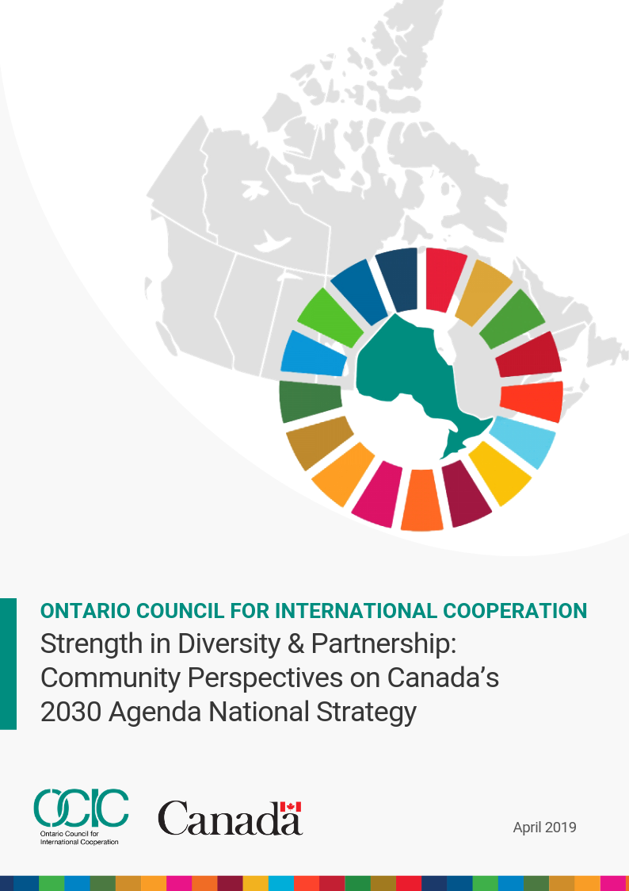

Acknowledgements
This initiative was undertaken by the Ontario Council for International Cooperation (OCIC) with financial support from the Government of Canada’s Sustainable Development Goals program.
OCIC appreciates and acknowledges the many contributions of participants in and stakeholders of this initiative.
Sincere thanks to Yin Brown, Elisa Chang, Adrianna Couto, Vicki Faul, Jeffrey Herskovits, Samir Janmohamed, Courtney Kaupp, Shannon Kindornay, Dr. Shelagh McCartney, Lamia Naji, Minette Samaroo, Lisa Swainston and Christine Zannier for their particular contributions to this report.
Thank you as well to Tamara Borovcanin, Mehnaz Hossain, Myuri Komaragiri and Zuhali Suhrob for supporting this effort.
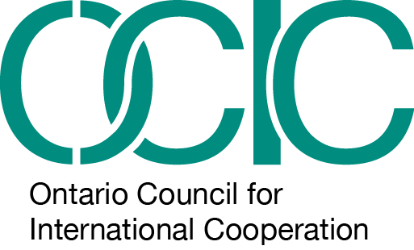
Kimberly Gibbons, OCIC Executive Director

The opinions and interpretation in this report are those of the author and do not necessarily reflect those of the Government of Canada.

Ontario Council for International Cooperation

Strength in Diversity & Partnership: Community Perspectives on Canada’s 2030 Agenda National Strategy

From March 15 to May 15, 2019, the Government of Canada is carrying out a national consultation to develop Canada’s 2030 Agenda National Strategy. As a part of this undertaking, with financial support from the SDG Unit housed at Employment and Social Development Canada (ESDC), the Ontario Council for International Cooperation (OCIC) carried out a series of consultations intended to increase participation of diverse communities and stakeholders including Diaspora, disability-inclusion and Indigenous communities, cultural and scientific institutions, civil society and non-formal education organizations in Ontario.

Key Messages
- OCIC partnered with members of diverse communities to engage 27 organizations, 22 key informants and 148 individuals between March and April 2019. This report includes 43 recommendations to inform Canada’s 2030 Agenda National Strategy and approach to implementation.
- There continues to be a lack of awareness on the 2030 Agenda for Sustainable Development. Ongoing awareness raising efforts are needed, including by working in partnership with diverse communities, cultural and scientific institutions, civil society organizations, and formal and non-formal education institutions.
- Canada’s 2030 Agenda National Strategy should be informed by local priorities and address the needs of diverse communities, including those most at risk of being left behind.
- Canada’s whole-of-society approach to 2030 Agenda implementation should be community-led, supported by efforts to enable local contributions to sustainable development.
- Participants in OCIC supported consultations are eager to build on their engagement in the consultation process by maintaining new connections and exploring opportunities to build community and collaboration around the 2030 Agenda.

Table of Content
Canada and the 2030 Agenda for Sustainable Development
Strength in Diversity and Partnership: An OCIC Initiative
About OCIC
Consultations to raise the voices of diverse communities
Diversity and Partnership Initiative Consultations
Starting a conversation, building relationships and trust
Diverse communities and Canada’s 2030 Agenda National Strategy
Setting Canada’s Priorities for the National Strategy
Leaving No One Behind
Leadership, Governance and Policy Coherence
Accountability, Transparency and Reporting
Measuring Success and the Canadian Indicator Framework
Awareness, Engagement and Partnership
Indigenous Knowledge, Self-determination and Reconciliation
Communities, Municipalities and Cities
Learning, Knowledge and Research
Innovation, Business and Investment
Next Steps
Annex 1. OCIC Consultation Framework
Annex 2. OCIC Consultation References, Resources, Participants and Invitees
Annex 3. Disability Inclusion Community Consultation Reports
Annex 4. Diaspora Community Consultation Reports
Annex 5. Indigenous Community Consultation Reports (attached separately)
Annex 6. NAN Position Paper (attached separately)

Canada and the 2030 Agenda for Sustainable Development
In September 2015, Canada joined Members States of the United Nations in adopting the 2030 Agenda for Sustainable Development, a vision for realizing progress on economic, social and environmental dimensions of sustainable development that includes 17 Sustainable Development Goals and 169 targets. The 2030 Agenda also includes a range of transformative elements, namely a focus on leaving no one behind and promoting human rights and dignity; realizing progress within planetary boundaries and with respect for intergenerational equity; inclusivity, solidarity and participation; and transparency and accountability.
Following its presentation of progress on the 2030 Agenda to the United Nations in 2018, the Canadian government launched a consultation process to develop Canada’s 2030 Agenda National Strategy, including through the use of an online engagement platform. In addition to the online engagement platform, the SDG Unit, housed at Employment and Social Development Canada (ESDC), is supporting a range of organizations to carry out consultations, in addition to its own consultation process.

Strength in Diversity and Partnership: An OCIC Initiative
With funding from the Government of Canada, the Ontario Council for International Cooperation (OCIC) carried out a series of consultations intended to increase participation of diverse communities and stakeholders in Canada’s 2030 Agenda National Strategy by identifying priorities in specific Diaspora, disability-inclusion and Indigenous communities, and exploring how the strategy might contribute to their achievement. In addition, OCIC’s Strength in Diversity and Partnership initiative supported the identification of ways that specific cultural and scientific institutions, civil society and non-formal education organizations in Ontario may likewise contribute to public engagement and achievement of 2030 Agenda priorities.
OCIC partnered with diverse stakeholder groups to identify how they can contribute to Canada’s 2030 Agenda National Strategy, and to explore how the national strategy can enable their work.

About OCIC
As a Council, OCIC strives to increase the effectiveness and collective impact of our members’ efforts to promote sustainable, people-centered development in a peaceful and healthy environment. OCIC is committed to principles of fair and equitable cooperative international cooperation, and promotes public engagement that helps Canadians develop a global perspective and take action for social justice.

Consultations to raise the voices of diverse communities
In March and April 2019 OCIC worked with partners from diverse communities to carry out a series of consultation activities that were grounded in a recognition that local communities and stakeholder groups know what approaches work best in terms of engaging specific communities. OCIC led on outreach to civil society organizations, social enterprises, youth, cultural and scientific institutions, and non-formal education organizations in Ontario through three consultations, an online survey from April 1 - 24, 2019, and key informant interviews. OCIC partners supported six consultations with disability-inclusion, Diaspora and Indigenous communities.

Disability-inclusion communities
Alliance for Equality of Blind Canadians conducted consultations with organizations serving people with disabilities, and with individuals with disabilities.

Diaspora communities
Diaspora community consultations and key informant interviews were led by independent consultant, Lamia Naji and her team, with a diverse sample of Diaspora communities.

Indigenous communities
Indigenous Peoples consultations were undertaken by +city lab, led by Dr. Shelagh McCartney and Jeffrey Herskovits with their long term Indigenous partners. +city lab takes a collaborative approach to investigating and creating innovative solutions to housing issues with marginalized communities in Canada.

Diversity and Partnership Initiative Consultations
In-Person
- March 26-27, 2019 - Nishnawbe Aski Nation, Thunder Bay
- April 3-5, 2019 - Eabametoong First Nation
- April 11, 2019 - Civil Society Organization and Social Enterprises, Toronto
- April 14, 2019 - Diaspora Communities, Toronto
- April 16, 2019 - Disability-inclusion Communities, Toronto
- April 18, 2019 - Diaspora Communities, Ottawa
- April 18, 2019 - Community Builders, Educators and Human Rights Advocates, Toronto
Virtual / Online
- April 16, 2019 - Disability-inclusion Communities
- April 17, 2019 - Youth and Youth-led Groups
In the spirit of leaving no one behind, consultations were organized to ensure accessibility and robust participation through the use of in person and virtual formats. For example, the consultations led by OCIC made use of different learning modalities to ensure all participants were able to engage such as visual and auditory presentations, rapid-idea generation activities, break-out group sessions, and art. The Alliance for Equality of Blind Canadians ensured that consultations with disability inclusion communities were in an accessible space and made use of Captioning in Real Time with text displayed on a screen. Two attendant care individuals were available as well as two volunteers supporting the needs of participants. Honorariums were provided to participants for their time and participation. Participants represented diverse stakeholders in terms of demographics, age, race, gender, sexual orientation, Indigenous status, and disability.
The initiative also provided OCIC with an opportunity to begin conversations with cultural and scientific institutions, non-formal education organizations and social enterprises on their potential to contribute to public engagement and the achievement of 2030 Agenda priorities.
Recognizing that awareness of the 2030 Agenda remains low for many communities in Ontario, OCIC developed a pre-consultation Participant Kit to educate participants on the 17 Sustainable Development Goals and prompt participants to consider their priorities. Discussions were informed by the questions in the Government of Canada’s discussion guide for the 2030 Agenda National Strategy consultation. Where appropriate, OCIC and consultation leads modified questions to ensure relevance. Annex 1 provides information on the key questions that informed the consultations. It includes an overview of the consultation framework used by OCIC and its partners, OCIC’s online survey questions and a specific questionnaire for consultation leads regarding how the Government of Canada can ensure a principled approach to diverse stakeholder engagement to leave no one behind in 2030 Agenda implementation.

Starting a conversation, building relationships and trust
OCIC hoped to hold formal consultations with Indigenous communities, cultural and scientific institutions and some specific non-formal education organizations. At the launch of the initiative it became clear that building relationships and trust would be the necessary first step to engagement, and that more formal dialogue with some target audiences would need to come at a later point in time.
Given the short timeline conversations with Indigenous community leaders and members in northern Ontario were undertaken by +city lab and OCIC within the scope of already existing events and through one to one visits in the community, and outreach on community radio. Conversations were held based on years of partnership and relationship between individuals at +city lab at Ryerson University, Eabametoong First Nation and Nishnawbe Aski Nation. Learnings from throughout this time of relationship will be drawn on throughout this report. The key recommendations from these First Nations that inform this report would not have been possible without the pre-existing relationship.
Key informant interviews with the Royal Ontario Museum, the Ontario Science Centre, the Museum of Contemporary Art Toronto Canada, Akin, the Girl Guides of Canada and the Boys and Girls Clubs of Canada indicate that while none of these entities actively subsume their activities under the 2030 Agenda and the SDGs, they all see the relevance of these frameworks and are interested in further exploration on the ways a National Strategy and funding could help them contribute to and lead in their realization, nationally and internationally. Information from key informant interviews with these organizations is included in this report.
The Royal Ontario Museum, Canada’s largest and most visited museum, opened in 1914. The museum’s new strategic direction includes an aspiration to play a more central role in community and cultural life. In this context, much of what the museum does aligns with the SDGs, such as efforts to ensure inclusivity and accessibility for low-income communities to visit the museum.
Since 1969, the Ontario Science Centre has welcomed more than 52 million visitors. The Science Centre is the public centre for innovative thinking and public dialogue about science, technology and society. The Ontario Science Centre is affiliated with the Canadian Association of Science Centres, which has been exploring the role that science centers and museums can play in raising awareness on sustainable development, including the 2030 Agenda. Preliminary discussions with the Community and Visitor Engagement Specialist suggest that the Ontario Science Centre could play an important role. The Ontario Science Centre is interested in science as a human right, reconciliation, and in convening diverse stakeholders to identify priorities and opportunities for collaboration to advance the 2030 Agenda.
Akin is a Toronto art collective that provides affordable studio space and art-based programming through its sister non-profit organization, Akin Projects. The collective has expressed interest in the 2030 Agenda and Canada’s 2030 Agenda National Strategy. Started 10 years ago in a small studio, the organization has grown to 350 members in nine spaces across Toronto. It offers classes in photography, interior design and sculpture.
A key informant at the Girl Guides of Canada indicated interest in the 2030 Agenda particularly as it relates to gender equality and its impact on young girls and teens. Girl Guides of Canada is part of a movement of nearly 100,000 girls and women across Canada – many of who are actively engaged in learning and action around the SDGs. The World Association of Girl Guides and Girl Scouts represents ten million girls across 150 countries. Girl Guides of Canada sees Canada’s 2030 Agenda National Strategy as presenting a major opportunity to meaningfully engage and include young people in understanding, taking action and monitoring Canada’s progress.
The Boys and Girls Clubs of Canada is the largest youth agency in Canada and was established in 1929. The organization works in communities across Canada to help young people overcome barriers, develop positive relationships and become mature and responsible adults. According to a key informant from the Boys and Girls Clubs of Canada, the organization is supporting the realization of a number of SDGs through its programming. It plans to engage youth on the 2030 Agenda more going forward given the agenda’s focus on inter-generational equity and youth empowerment.
Why Consultation Matters
Hello Kim,
On behalf of the executives and members of the Alliance for Equality of Blind Canadians, I would like to thank OCIC for partnering with AEBC on this very important project. Through these consultations, the disability communities are now aware about Canada’s National Implementation Strategy for the Sustainable Development Goals (SDGs) and Agenda 2030. Not only are we made aware, but also, we (the disability communities) were given the opportunity to contribute to Canada’s National Strategy. I have spoken with many participants before, during, and after the consultations, and they have said that it is the first time they have heard about the SDGS and Agenda 2030...
Sincerely,
Minette Samaroo
President, Alliance for Equality of Blind Canadians Toronto Chapter

Diverse communities and Canada’s 2030 Agenda National Strategy
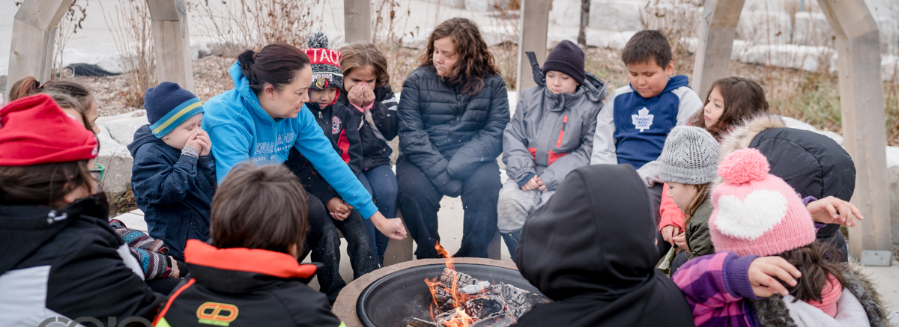
Consultations generated a wealth of detailed information on the priorities of diverse communities for 2030 Agenda implementation and how Canada’s approach can support and enable the efforts of diverse communities. Yet, some of the richness of the discussions and information provided is necessarily lost in a summary report of this nature. In an effort to capture this information, the disability-inclusion, Diaspora and Indigenous community consultation reports are available in Annex 3 and Annex 4. In addition, we have also attached the Nishnawbe Aski Nation response to the First Nations National Housing and Infrastructure Strategy for referral by the SDG Unit.
Neyaashiinigmiing Community Coordinator, Dee Millar and students of Kikendaasogamig Elementary School Picture by Allan Lissner, Praxis Pictures

Setting Canada’s Priorities for the National Strategy

Sustainable development priorities
The 2030 Agenda and the Sustainable Development Goals (SDGs) are integrated and indivisible. Progress on one goal has implications for outcomes for other goals. At the same time, as countries localize the 2030 Agenda, priorities will vary at national, provincial, territorial and local levels. Local communities are best placed to define their priorities and sustainable development solutions. OCIC supported consultations included questions on the sustainable development priorities of diverse communities. Table 1 provides an overview of the priorities noted by participants from diverse communities.
Recommendation 1: Work to advance progress on all SDGs and support diverse communities to address locally defined priorities.

Table 1. Sustainable Development priorities identified in OCIC supported consultations
SDG | Community | Priority
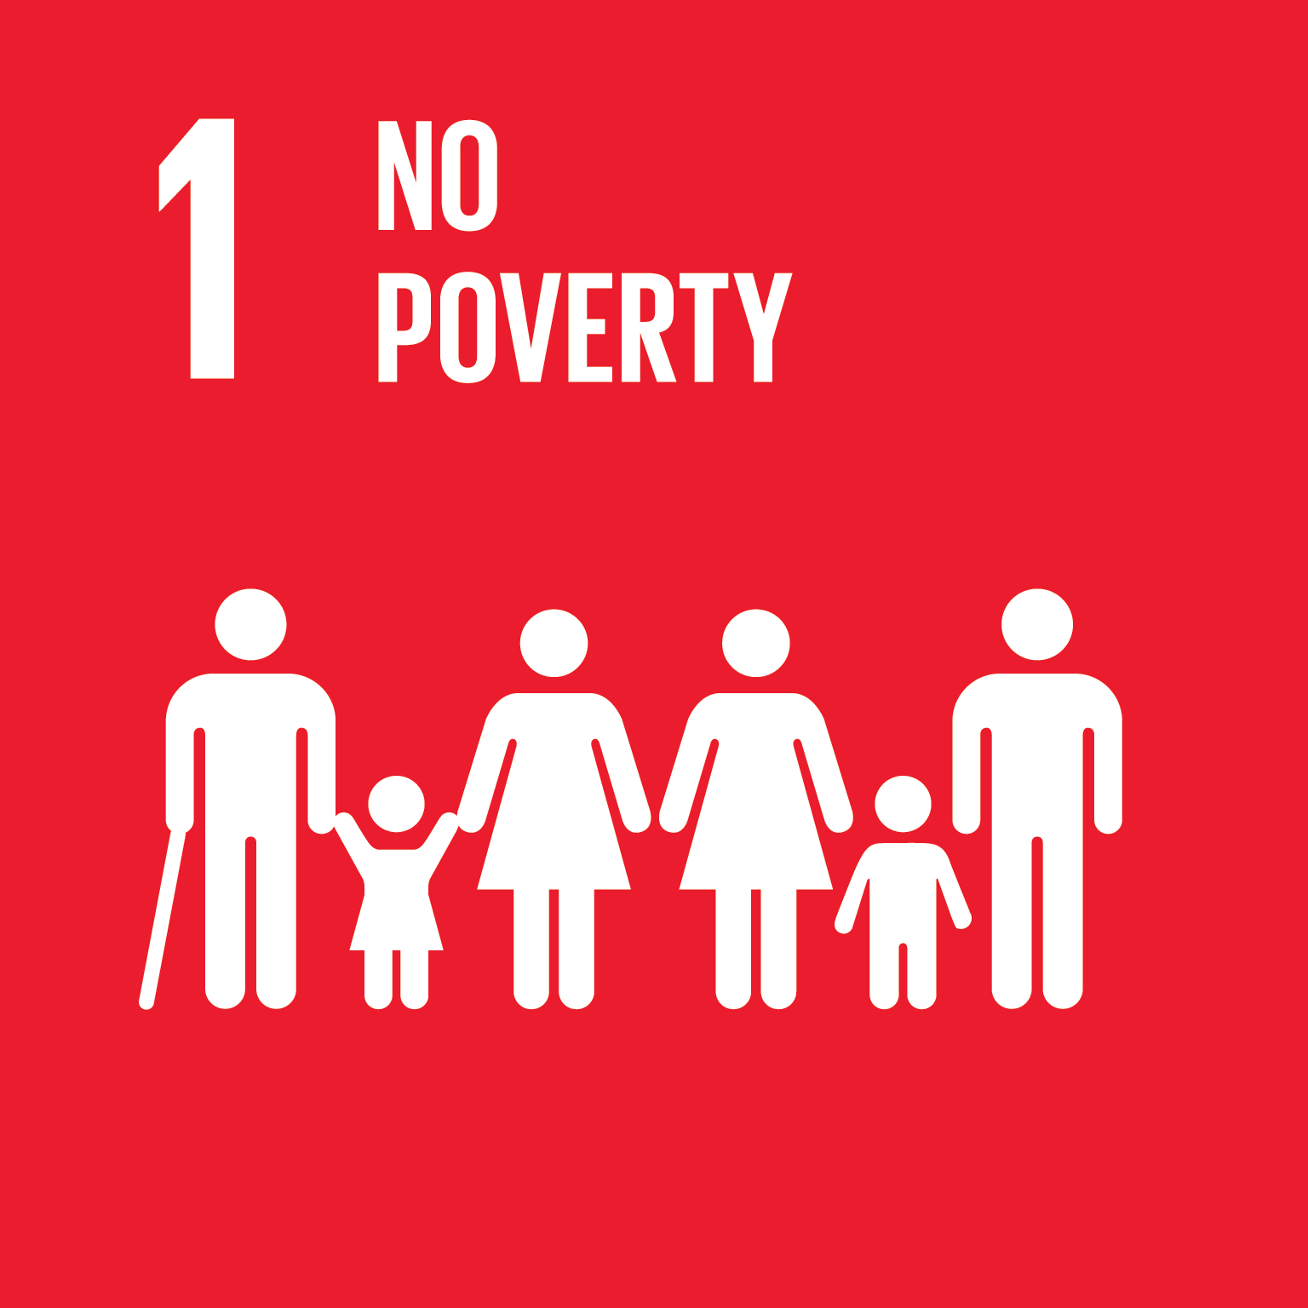 | Disability inclusion | - Among the most highly cited priorities by participants
 | Indigenous Peoples
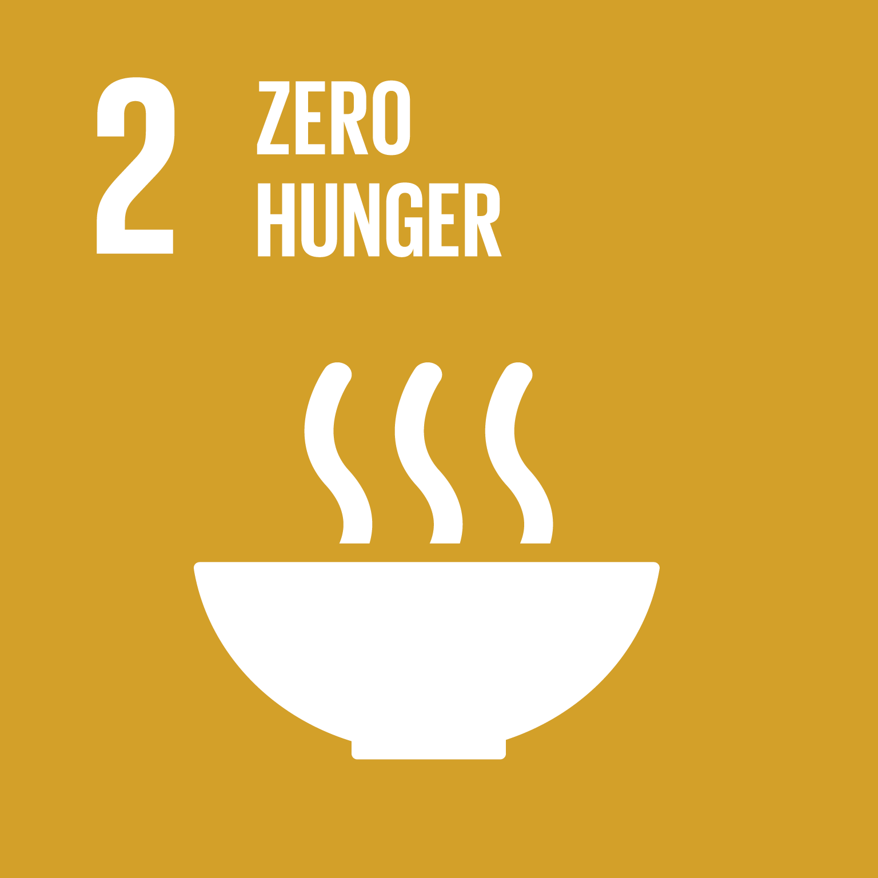 | Diaspora | - Lack of access to nutritious food
 | Disability inclusion | - Addressing and combating hunger  - Sustainable agriculture
 | Indigenous Peoples | - Food security  - Lack of access to nutritious food
 | OCIC consultations | - There is a need to promote local solutions to food security, such as support and incentives for community gardens.

 | Diaspora | - Gaps in formal and informal mental health support
 | Disability inclusion | - Addressing the health care needs of persons
 | Indigenous Peoples | - Community healing needs to occur before community wellbeing  - Mental Health supports with long term horizons in communities  - Improved access to health and social services to support community well-being  - Ensuring the right of elderly to choose where they live and receive care, including through accessible housing
 | OCIC consultations | - Emphasis on mental health  - Improve access and knowledge to new Canadians
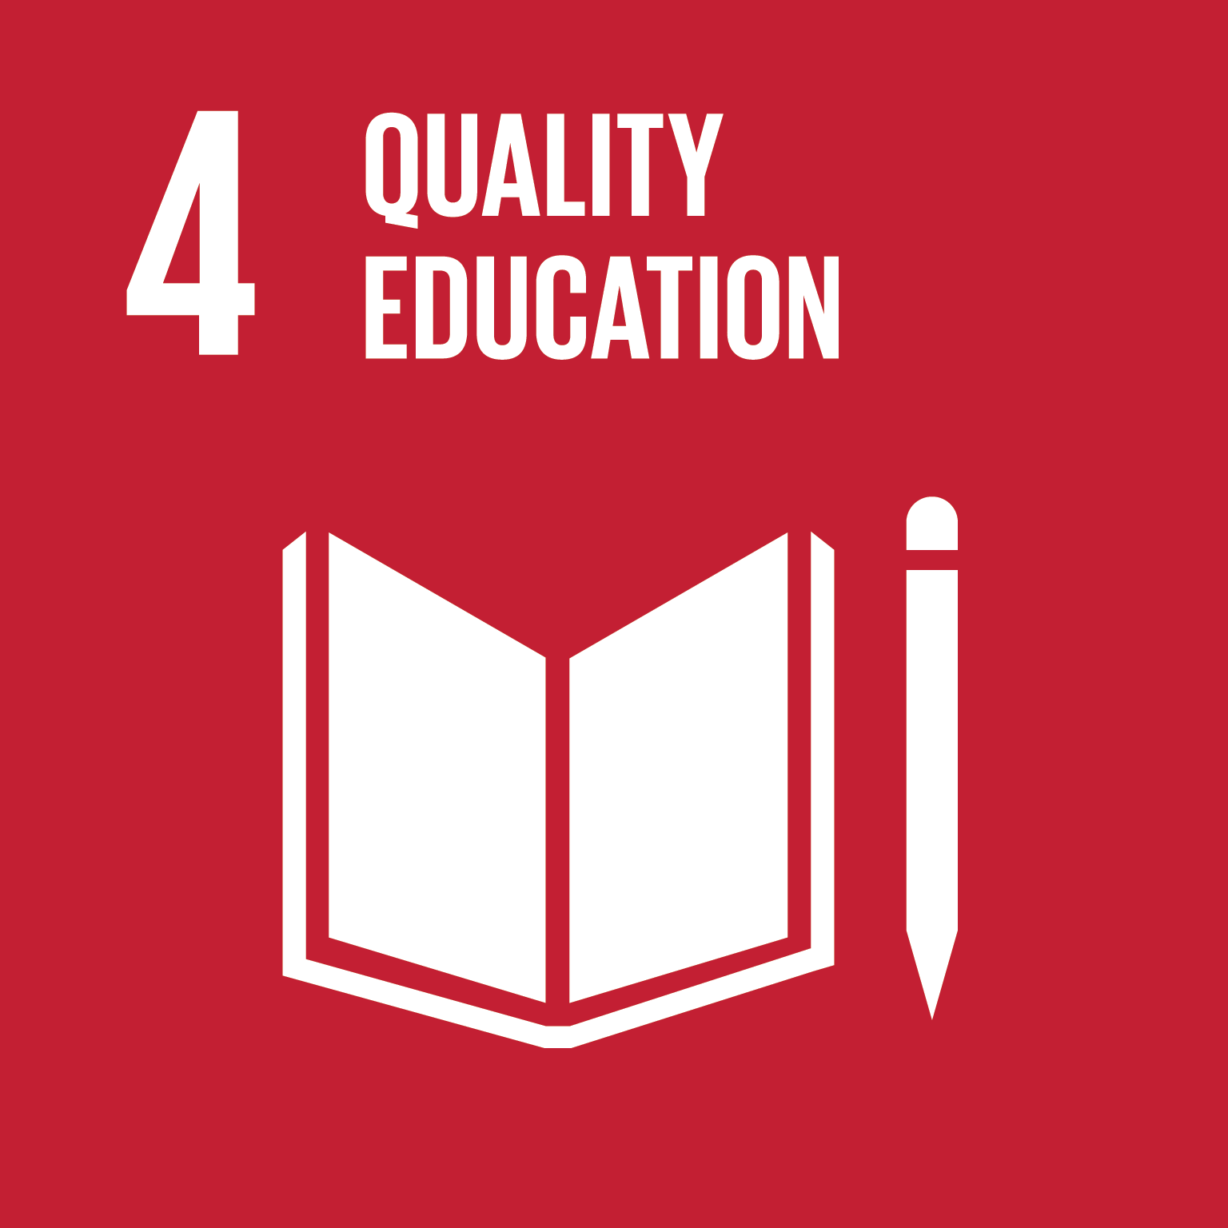 | Diaspora | - Health care needs to be sustainable
 | Disability inclusion | - Access to education and the need to educate society on disability, among the most frequently cited priorities
 | Indigenous Peoples | - Quality education  - Students sure be able to pursue elementary and secondary education in local communities  - Culturally designed education
 | OCIC consultations | - Quality education
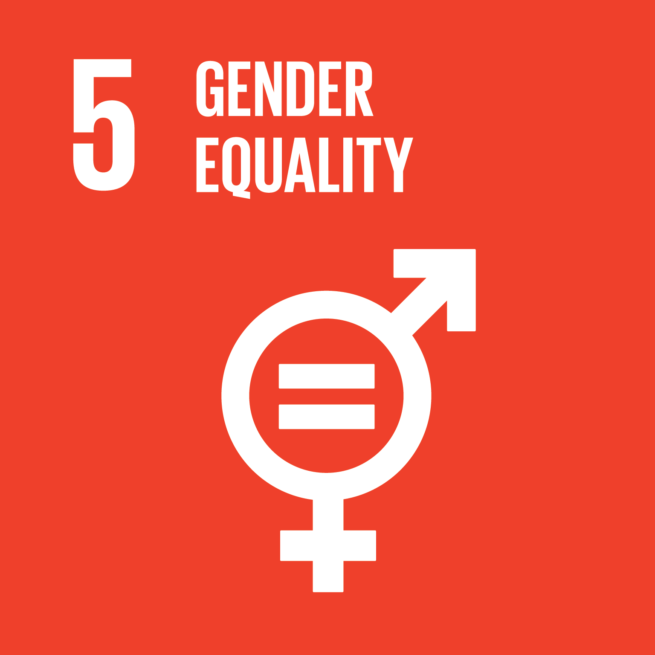 | Diaspora | - Addressing the unique challenges faced by women and girls
 | Indigenous Peoples | - Women and girls living in unstable or violent homes and abusive relationships
 | OCIC online survey and consultations | - Most cited priority goal (18 of 30 survey respondents) in terms of community priorities  - Emphasis on gender equality and addressing gender-based violence during consultations

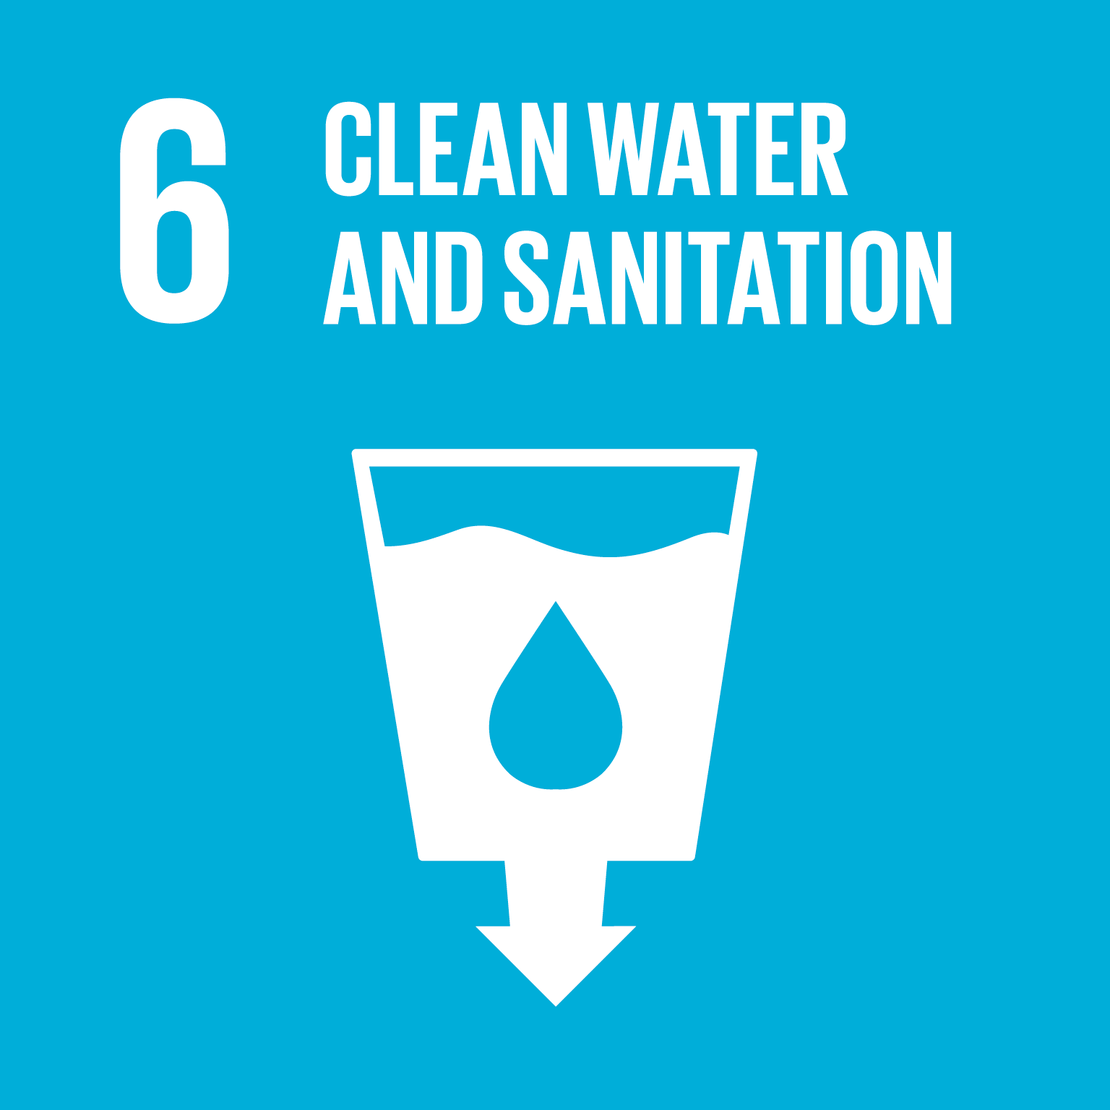 | Disability inclusion | - Clean water for all
 | Indigenous Peoples | - Remove boil water advisories, water security
 | OCIC Consultation | - Address boiled water advisories  - Ensure access to potable water
 | Indigenous Peoples | - Removing reliance on diesel generators, energy security through renewables  - Commitment to have renewable energy in each community
 | OCIC Consultation | - Investing in clean energy  - Commitment to end fossil fuel subsidies
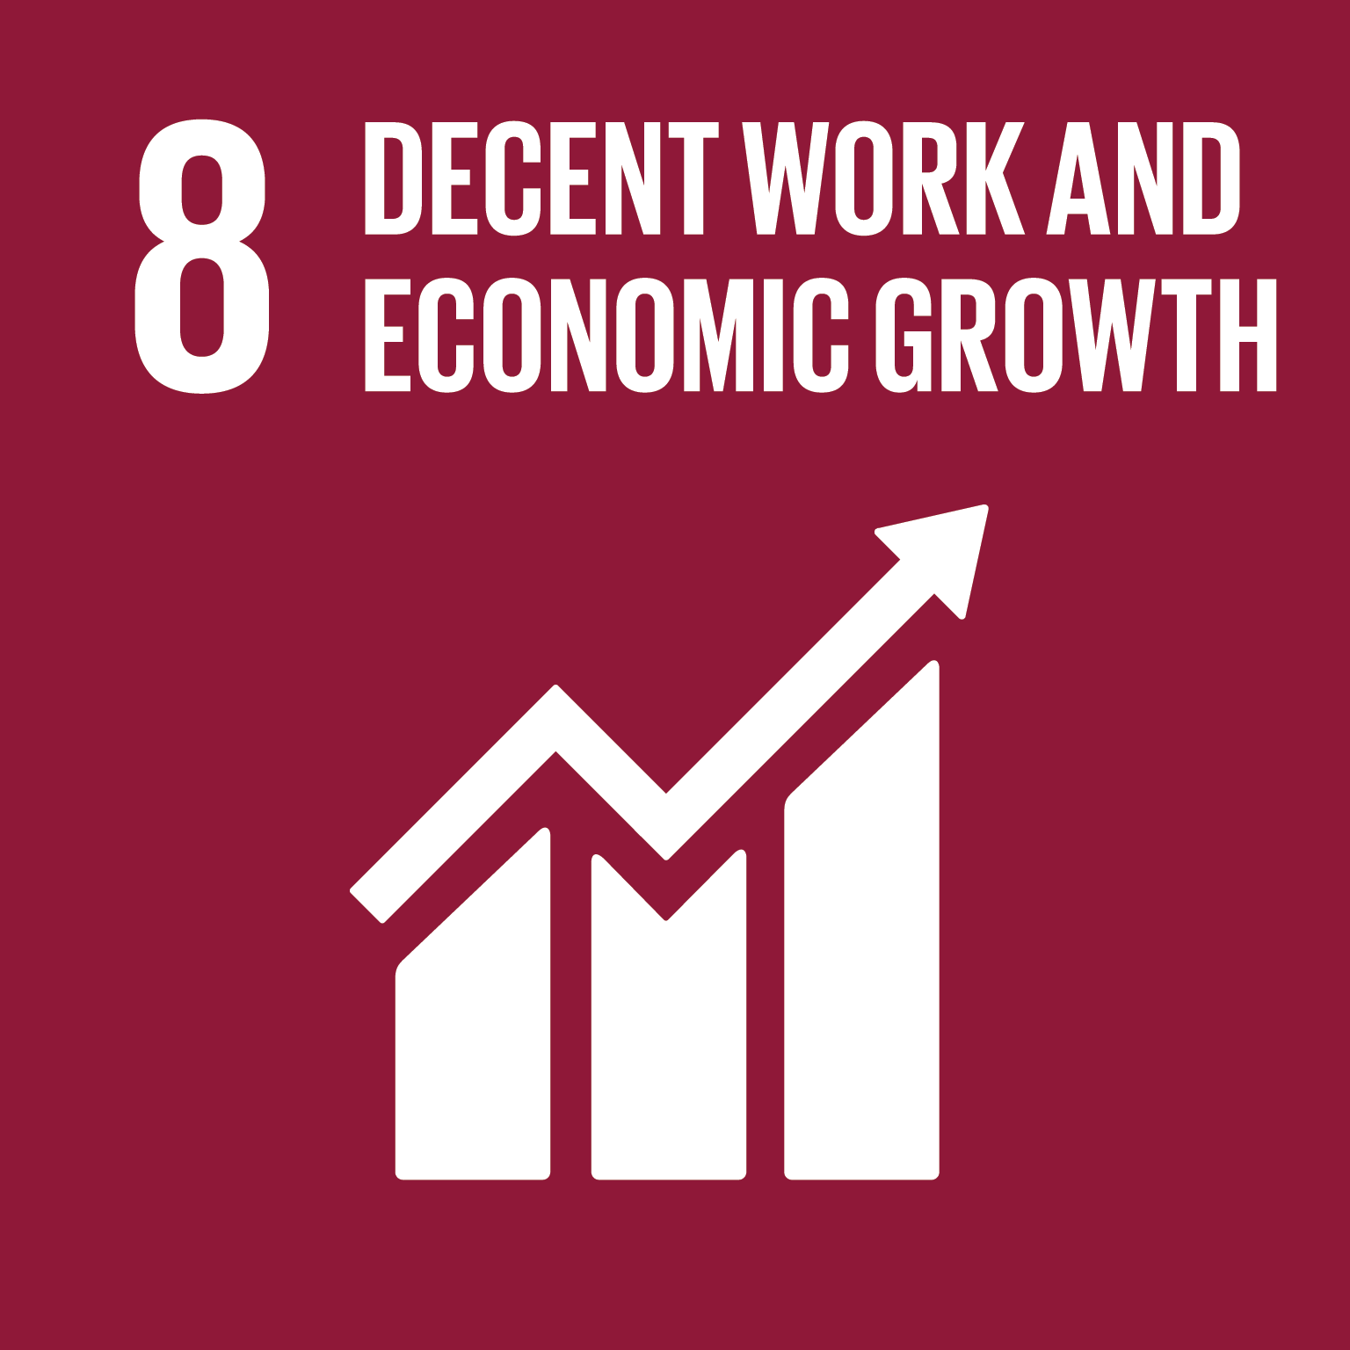 | Diaspora | - Economic growth
 | Disability inclusion | - Creation of employment opportunities for persons with disabilities
 | Indigenous Peoples | - Ensuring skills of persons with disabilities are appropriately matched with employment  - Economic Development and training opportunities that allow people to remain in their communities
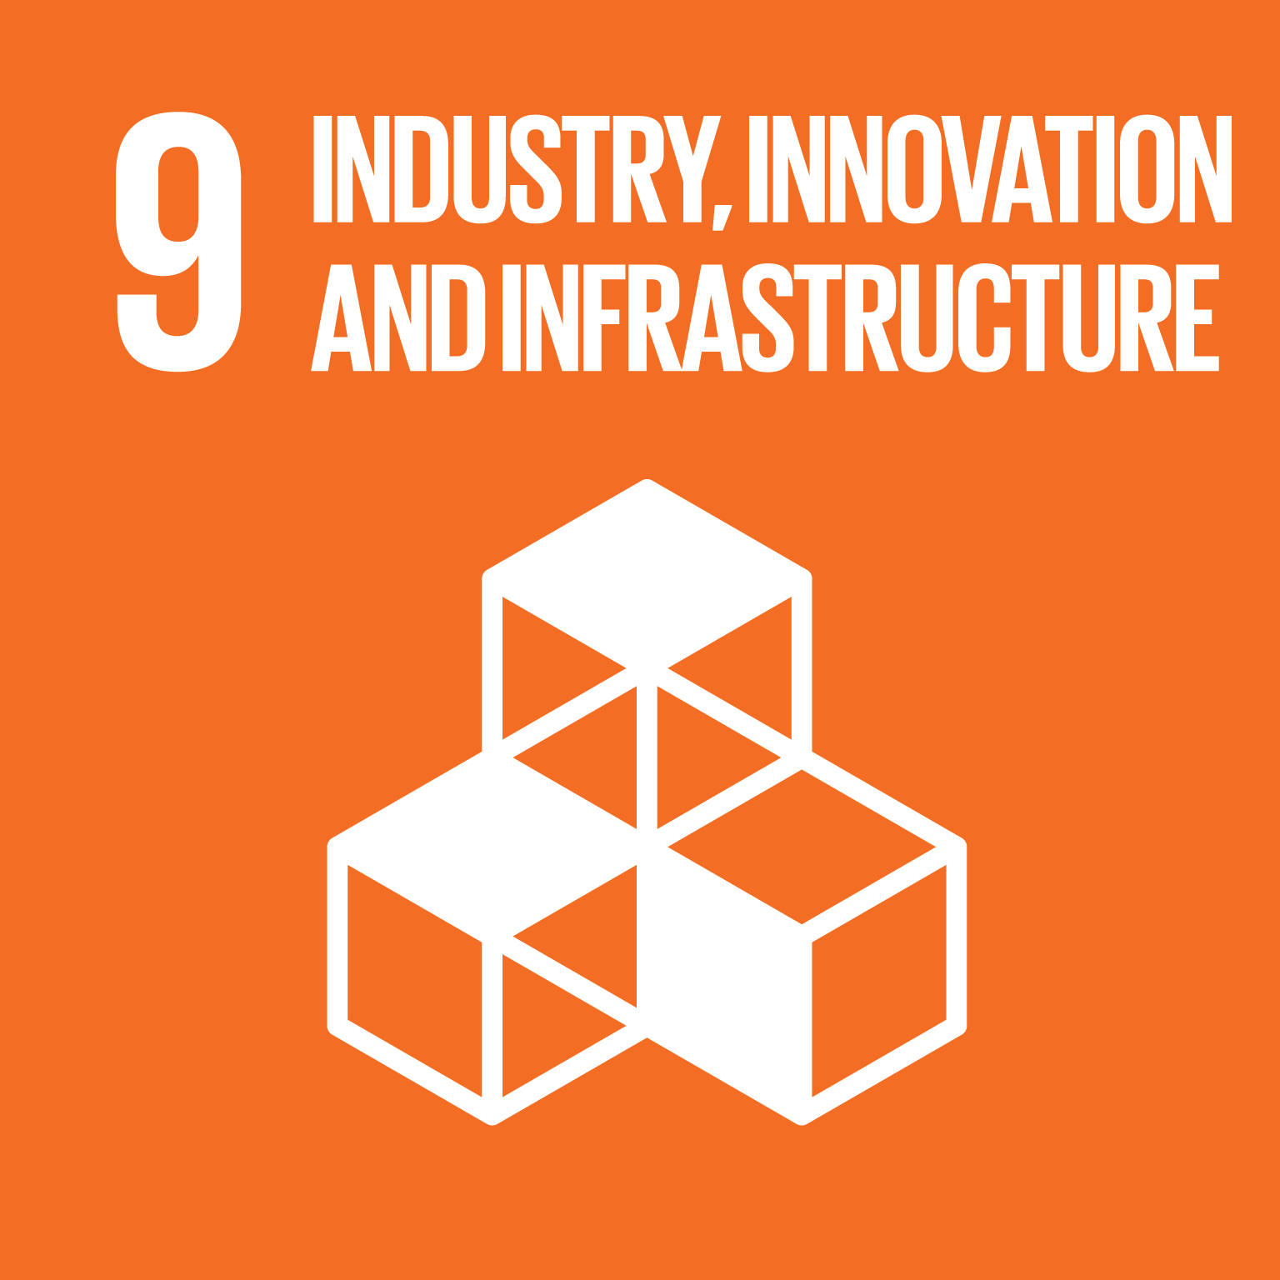 | Disability inclusion | - Accessible transportation  - Lack of services and housing in communities
 | Indigenous Peoples | - Build housing as community industry  - Shift control of housing and infrastructure program design and decision making to localized authorities  - Use a multi-year funding model to create predictability to support local planning

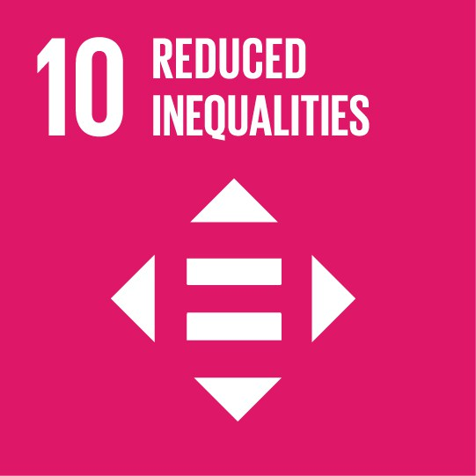 | Diaspora | - Among the most highly cited priorities by participants
 | Indigenous Peoples | - Indigenous Peoples recognised through UNDRIP  - Ensure that a range of infrastructure solutions are supported meeting the unique needs of diverse demographic groups across regions and both on- and off-reserve
 | OCIC online survey | - Highly cited priority goal (15 of 30 respondents) in terms of community priorities
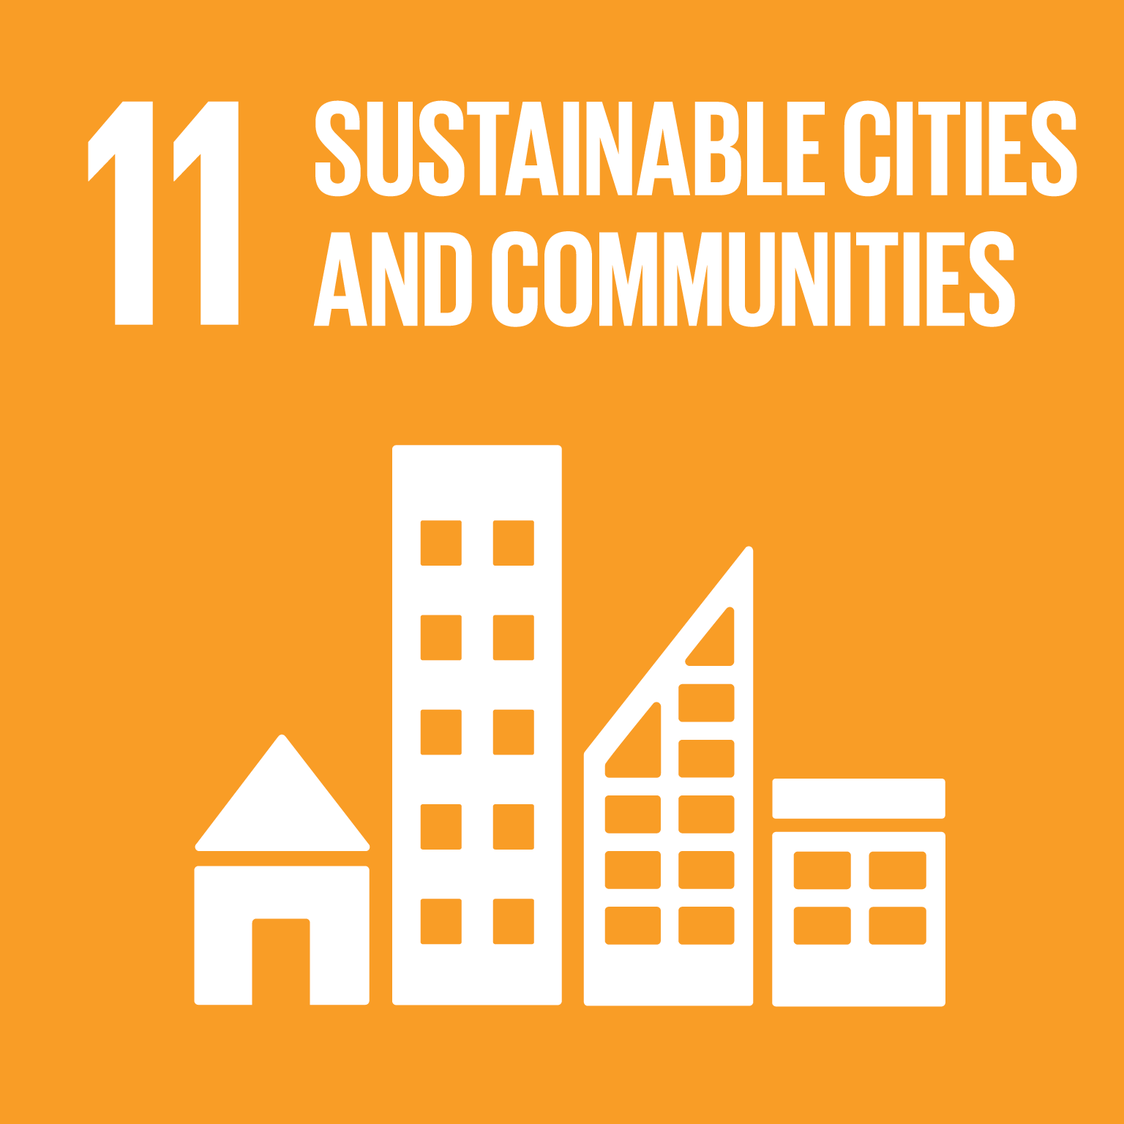 | Disability inclusion | - Lack of accessible housing
 | Indigenous Peoples | - Housing and community growth that meet community needs  - Integrate housing and community infrastructure planning to create livable communities. Community infrastructure includes: community, cultural, health, resource, sports and recreation and economic assets that support the safe and efficient delivery of community services, programs, activities and interests.  - Ensuring the right of elderly to choose where they live and receive care, including through accessible housing  - Create sustainable and resilient communities through the protection and integration of natural resources and traditional lands  - Develop improved education, health and social services in support of community well-being
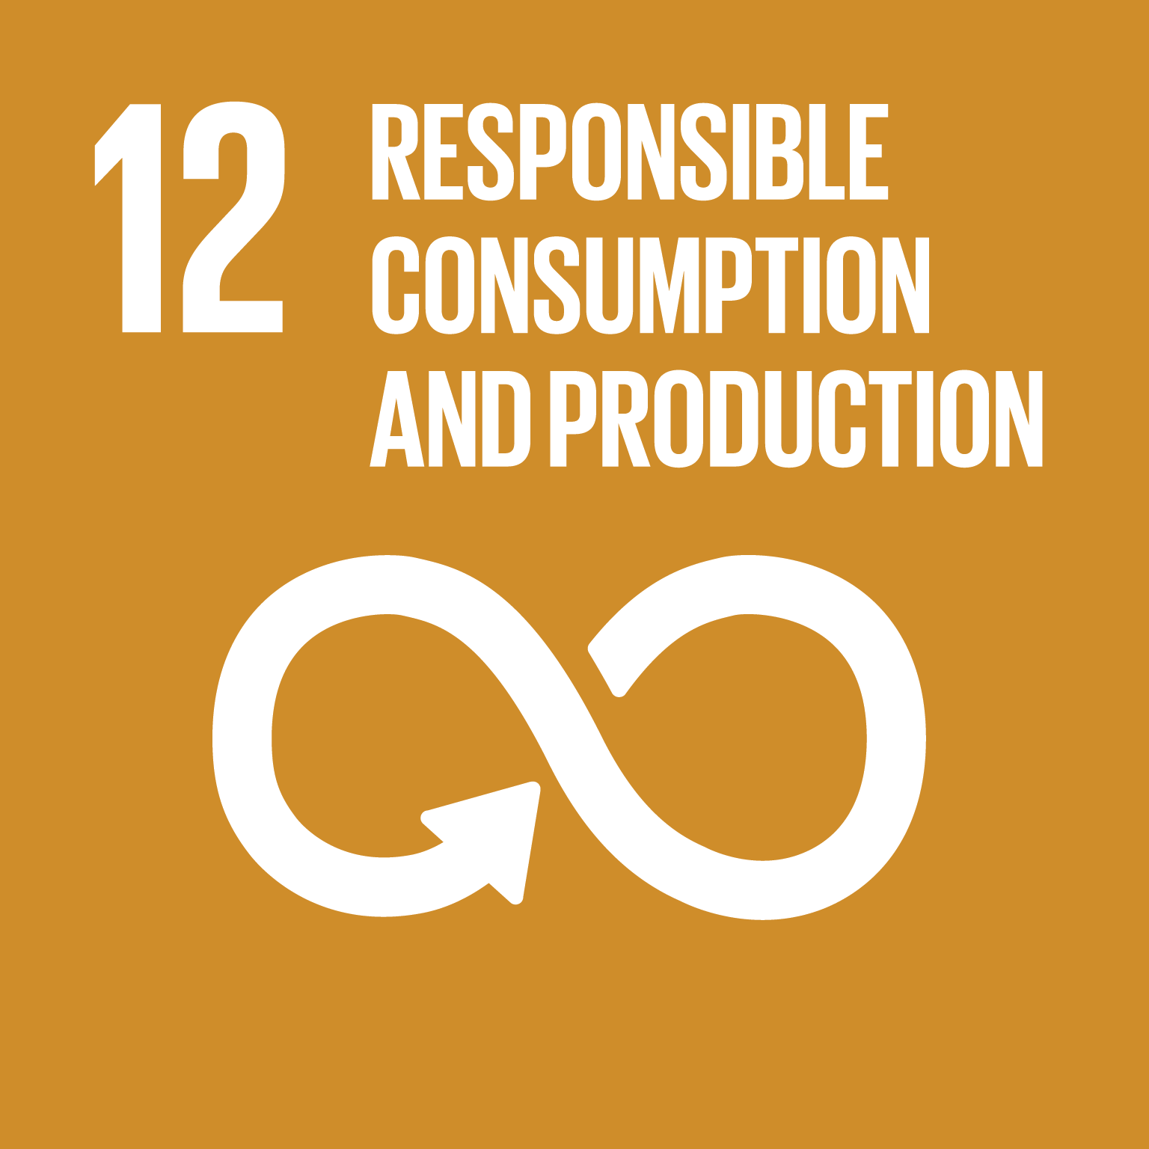 | OCIC Consultation | - Providing direct investment into firms that provide or are sourcing materials responsibly  - Responsible natural resource extraction for production of goods
 | Disability inclusion | - Climate action needed
 | Indigenous Peoples | - Effects of climate change are experienced unevenly especially those located in the North or the Boreal Forest and investment is needed to take into account climate change and traditional livelihoods
 | OCIC online survey and consultations | - Highly cited priority goal (15 of 30 survey respondents) in terms of community priorities  - Climate action needed
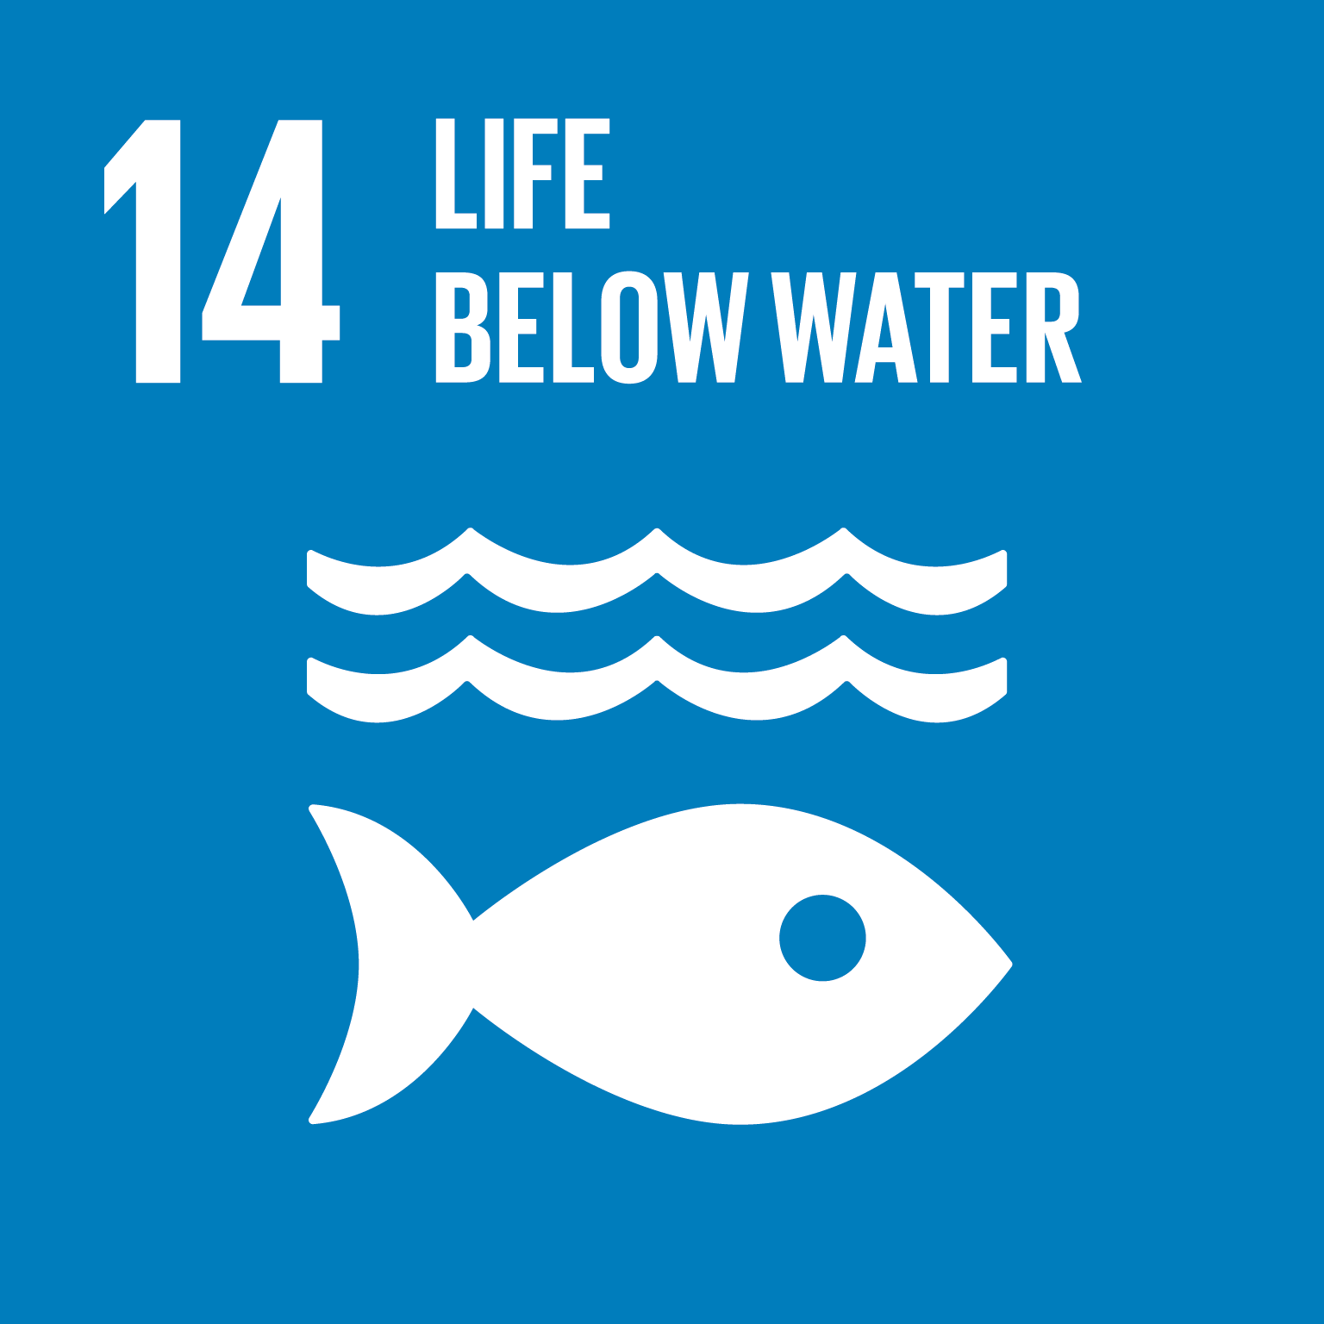 | Indigenous Peoples | - Fish are a major food source for Indigenous communities, polluted water sources by mining extraction endanger all those living on the land  - Free prior and informed consent on all resource, extraction and
 | OCIC consultations | - Environmental sustainability
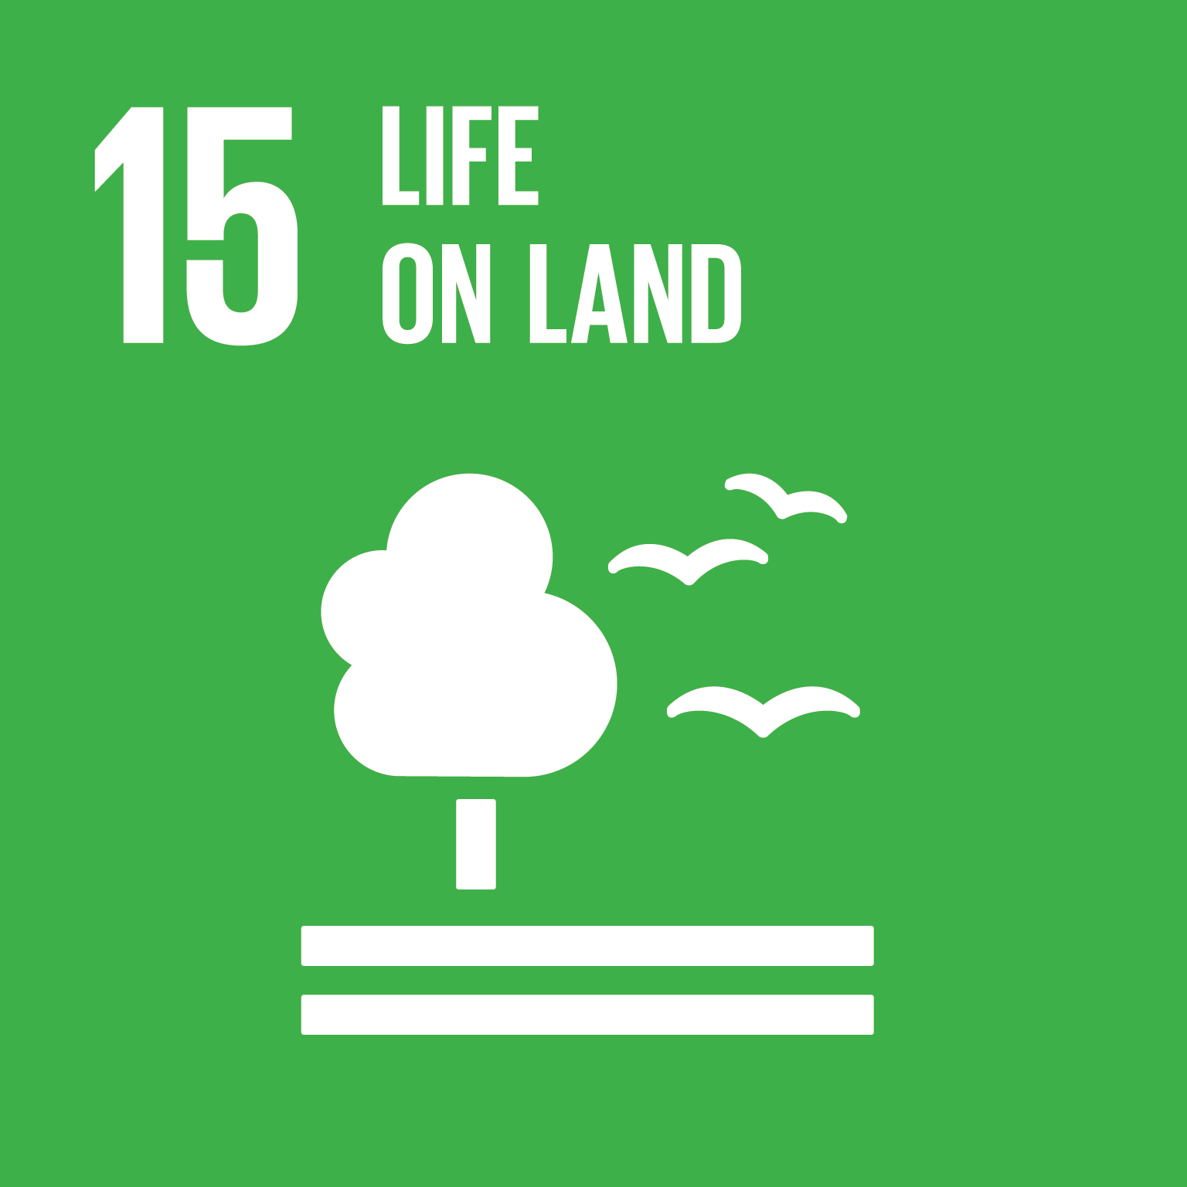 | Indigenous Peoples | - Recognise that land is life and is a relation that needs to be cared for with the same rights as human relations
 | OCIC consultations | - Environmental sustainability  - Incentivising the use of sustainable agricultural practices  - Revisit regulations linked to food and agro-production to include measures of sustainability
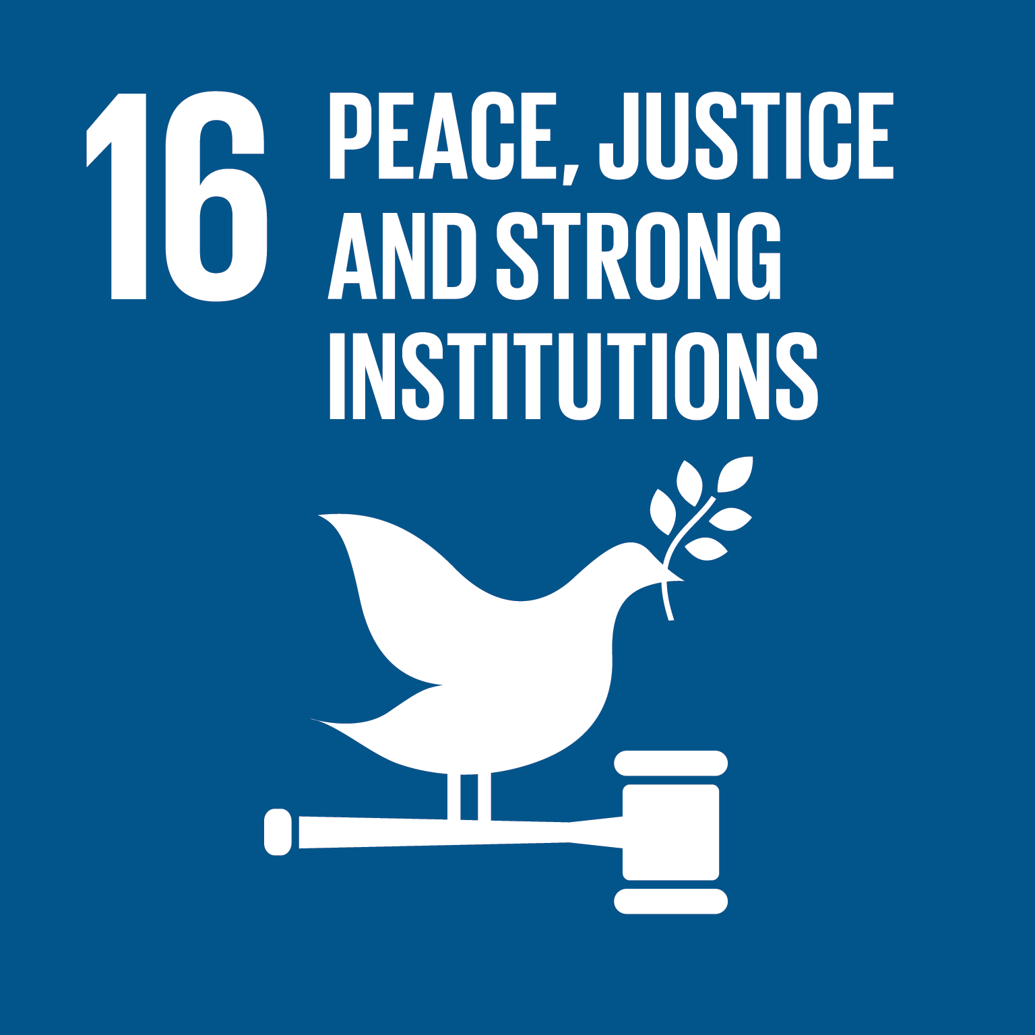 | Diaspora | - Addressing discrimination, and verbal and physical attacks on Diaspora communities  - Raising and valuing the voices of Diaspora communities in decision-making
 | Indigenous Peoples | - Support effective local planning in Indigenous communities through ownership over planning and self-determination, control of funding and capacity development  - Full Implementation of UNDRIP
 | OCIC online consultation | - Highly cited priority goal (15 of 30 respondents) in terms of community priorities
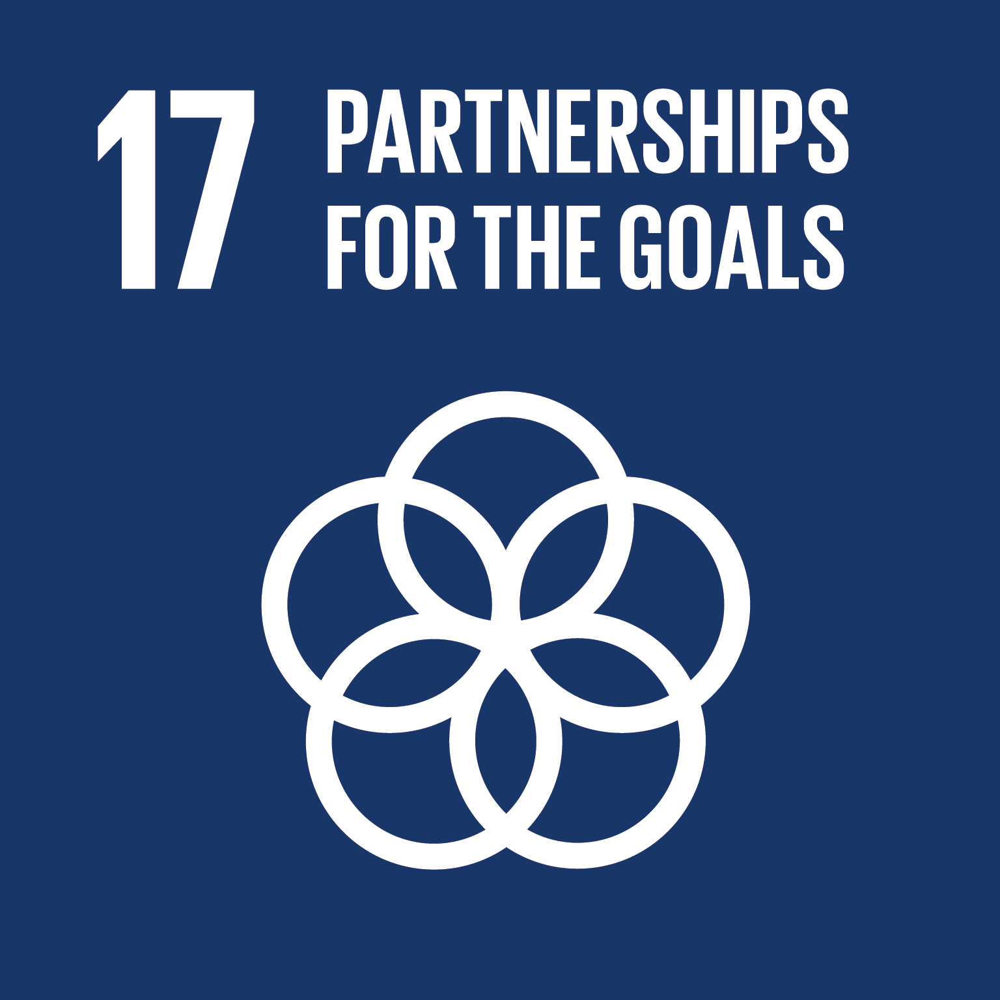 | Diaspora | - Build connections within and across Diaspora groups
 | Disability inclusion | - Bring communities together to cooperation and brainstorm on solutions.
 | Indigenous Peoples | - Partnerships require a recognition of existing power relationships and histories while striving to create equity
 | OCIC online survey and consultation | - Highly cited priority goal (16 of 30 survey respondents) in terms of community priorities  - Partnership was a reoccurring theme

The 2030 Agenda is transformative
In addition to identifying local sustainable development priorities, participants identified priorities related to the transformative elements of the 2030 Agenda. Inclusivity and engagement were reoccurring themes in OCIC supported consultations, with participants noting the need for access to inclusive quality education, eradication of racialized policies, engagement with Indigenous peoples, and advancements on public engagement.
Individuals from Diaspora communities report feeling undervalued by those considered non-Diaspora and face discrimination that undermines inclusivity. Moreover, lack of awareness on available services and insufficient efforts to support new arrivals to Canada undermines integration in Canada and the potential for individuals from Diaspora communities to thrive. Diaspora communities recognized the importance of intergenerational approaches, noting that the needs of youth in Diaspora communities differ from that of their parents. There is a need to identify tailored solutions for youth, including young women and older generations.
Members of the Eabametoong First Nation emphasize the human rights-based nature of the 2030 Agenda, noting the importance of the United Nations Declaration on the Rights of Indigenous People as a means to accelerate implementation and the need for a high degree of local autonomy and jurisdiction over local projects.
Participants from the disability inclusion community emphasized the integrated and indivisible nature of the 2030 Agenda, noting multiple priorities and seeing the SDGs as ultimately intertwined.
Across OCIC supported consultations, participants recognized the importance of leaving no one behind, and identified solutions for how the Government of Canada can support the furthest behind first. Finally, participants at most consultations recognized the universal nature of the 2030 Agenda as an agenda for all people everywhere. For Canada, this means supporting sustainable development in Canada and abroad, and recognizing and reinforcing linkages between global and local actions.
Recommendation 2. Use the transformative elements of the 2030 Agenda to guide 2030 Agenda implementation.

The 2030 Agenda is universal and connects local and global efforts
The 2030 Agenda is an agenda for everyone, everywhere. It has implications for Canada’s efforts to advance sustainable development at home and abroad. OCIC supported consultations with civil society organizations and key informant interviews with cultural, scientific and arts institutions and non-formal education organizations point to the importance of linking domestic and global efforts to implement the 2030 Agenda. Participants recognize the interdependence between nations to achieve the goals and address these issues. The challenges of realizing gender equality and promoting the rights of LGBTQ+2S, disability and Indigenous communities exist in Canada and countries around the world, including Canada’s international development partners. SDGs related to climate action, environmental protection, migrant rights and peace cannot be achieved by any one country alone. Globalization means that issues related to sustainable consumption and production, waste and labour abuse and exploitation involve players from a range of countries. The historical impact of colonialism on global inequality and inequality in Canada denotes inseparable responsibilities for countries to work in alliance and partnership today to ensure inclusive prosperity that leaves no country or person behind.
Progress for diverse communities in Canada impacts their ability to contribute to sustainable development abroad. Diaspora communities are linked to networks of individuals around the world. Efforts to support them in Canada impact their engagement with countries of origin, including in terms of remittances, investments and policy advocacy. There are opportunities to build bridges between Canada and individuals from Diaspora communities who demonstrate a keen commitment to contribute to the social and economic development of their countries and regions of origin.
Recommendation 3. Identify how Canada will support progress on sustainable development at local, national and global levels, recognizing the interlinkages that exist.
Local to global connections have implications for how the Government of Canada implements the 2030 Agenda. It means engaging Indigenous, municipalities, provincial and territorial, and foreign governments to implement the global framework in a way that supports local and individual actions, and connects them to the broader global agenda. There is an opportunity for Canada to serve as both a role model by leading on implementation at local, national and global levels, as well as learning from partners around the world through knowledge sharing, cooperation and partnership. Local to global linkages are not self-evident for many Canadians that are concerned with helping those at home first. There is a need to promote global citizenship in line with SDG 4 on quality education.
Recommendation 4. Include efforts to promote local-global linkages such as activities that raise awareness of sustainable development and promote global citizenship.

What’s working?
Participants highlighted a range of initiatives at local, national and global levels that are working to support their sustainable development priorities. Annex 2 provides an overview of a variety of policies and programs identified during consultations.
At the local level, community engagement initiatives such as community gardens, and senior, volunteer and food programs are supporting sustainable development. Grassroots advocacy initiatives and grants and capacity building programs have helped support community priorities in line with sustainable development. Municipal (Toronto) and provincial efforts to address poverty and homelessness were noted by disability inclusion communities. At the national level, participants pointed to Canada’s Feminist International Assistance Policy (FIAP), Global Affairs Canada’s Volunteer Cooperation Program, youth-related programs in employment and education, and climate action. A National Housing Strategy and Indigenous-related policies, specifically Bill C-262 (An Act to ensure that the laws of Canada are in harmony with the United Nations Declaration on the Rights of Indigenous Peoples), were also referred to as a prospective policies that could address the priorities of historically marginalized communities in Canada. At the global level, participants pointed to international frameworks that support efforts by civil society and youth, and partnerships that target specific sustainability issues.
Recommendation 5. Augment policies and programs that stakeholders have identified as working at local, national and global levels. Successful policies and programs should be scaled up to match the ambition of the 2030 Agenda and leave no one behind.
At the same time, discussions during the consultations suggest that there is a need to engage with civic leaders and governments to create, sustain, and improve more policies and programs that could effectively address needs. Some policies have yet to address the sustainable development priorities of diverse communities, such as in the areas of quality education on sustainability, anti-oppression, consent and sexual orientation diversity. Policies related to the nation-to-nation relationship require urgent attention. Mistrust of government programs is a particular challenge. Northern Indigenous peoples do not trust government programs as they have often ignored or excluded the particular challenges of northern Indigenous peoples due to poor treatment and colonial history. There is a need to recognize a diversity of solutions and the failure of one-size-fits-all programs. Programs are not designed by Indigenous peoples for Indigenous peoples are often not appropriate. True nation-to-nation partnerships are needed with policies and programs based on meaningful relationships with consultations leading to community-led actions that reflect the priorities, solutions and timelines of Indigenous peoples.
Recommendation 6. Outline policy and programming gaps that will be addressed during implementation through consultation with diverse communities on what works and where improvements are needed.

Leaving No One Behind
There is a need for more and better engagement with historically marginalized communities to leave no one behind in Canada. As noted in Canada’s report to the United Nations High-level Political Forum on Sustainable Development on Canada’s progress implementing the 2030 Agenda, a range of diverse communities are at risk of being left behind. These include Indigenous peoples, especially remote communities, LGBTQ2S+ individuals, refugees and Diaspora communities, people with disabilities, youth and seniors. OCIC supported consultations suggest that leaving no one behind requires efforts to create an enabling environment for inclusive engagement and participation (discussed further in the section on engagement below), and address the unique barriers diverse communities face to participation and the issues that matter the furthest behind first.

Addressing barriers and supporting solutions identified by diverse communities
Canada’s 2030 Agenda National Strategy should create equitable and appropriate opportunities for diverse communities to develop leadership and participate in decision-making. For persons with disabilities, there is a need to address attitudinal barriers. Other barriers that diverse communities face include distance and language.
For Diaspora communities, there is a need to focus on the success and upward mobility of Diaspora in Canada as measured by outcome metrics. In addition, systematic education is needed, focused on equity, to address the discrimination and prejudice faced by Diaspora communities. Integrated approaches to settling new arrivals is also needed with a focus on employment, education and healthcare as critical aspects of settlement processes. The disability inclusion consultation pointed to the need for housing, water and food solutions that address affordability and availability. Low income persons with disabilities have been impacted by cuts to healthcare. In addition, there is a need to generate employment opportunities for persons with disabilities, including by showcasing their talents and educating employers on the benefits of employing persons with disabilities.
For Diaspora communities, there is a need to focus on the success and upward mobility of Diaspora in Canada as measured by outcome metrics. In addition, systematic education is needed, focused on equity, to address the discrimination and prejudice faced by Diaspora communities. Integrated approaches to settling new arrivals is also needed with a focus on employment, education and healthcare as critical aspects of settlement processes. The disability inclusion consultation pointed to the need for housing, water and food solutions that address affordability and availability. Low income persons with disabilities have been impacted by cuts to healthcare. In addition, there is a need to generate employment opportunities for persons with disabilities, including by showcasing their talents and educating employers on the benefits of employing persons with disabilities.
Indigenous communities, especially in remote areas, require additional funding to meet basic standards of living. This means increasing in-community access to housing and services housing, health care, education and training.
Recommendation 7. Specifically target the barriers to progress on sustainable development identified by diverse communities with solutions identified in consultation with them.
“Inclusive and alternative models of housing are required. As an example of a population unable, or struggling, to obtain housing are those youth who age out of the foster care system. Whether they are looking for a house of their own in their home community, or are looking to return to their community after having been removed they face high risks of homelessness and further marginalization.”
Oshkaatisak Council, Nishnawbe Aski Nation
Response to the First Nations National Housing and Infrastructure Strategy, 2018

Leadership, Governance and Policy Coherence

Government of Canada leadership
The scale and scope of sustainable development challenges require a whole-of-society approach to implementation that engages federal, provincial, territorial and municipal governments, local communities, Indigenous peoples, civil society, the private sector, academia and others. In this context, the Government of Canada has a leadership role to play in coordinating efforts, facilitating cooperation and establishing an environment that supports partnerships and the capacities of diverse communities to contribute to sustainable development.
Participants identified a number of concrete ways in which the Government of Canada can provide leadership. These include facilitating coordination across government and non-state actors, ensuring policy coherence on sustainable development, and linking the SDGs to local issues by promoting engagement by provincial, territorial and municipal governments. Investments are needed to incentivize sustainable practices, support civil society, including women’s groups, and capacity development.
Recommendation 8. Outline mechanisms to effectively coordinate action on the 2030 Agenda, promote policy coherence and facilitate localization.
Concerted efforts are also needed to raise awareness of the 2030 Agenda with diverse communities in Canada to demonstrate that the agenda benefits everyone and relates to day-to-day needs and experiences. Participants also noted the need for the Government of Canada to demonstrate leadership in including voices of historically marginalized communities and addressing their priorities. For example, more programs could be established to work with employers to provide accommodations for persons with a disability, including financial and capacity development resources. The Government of Canada could ensure greater control of planning and funding by First Nations through multi-year planning and funding cycles that create predictability and support effective local planning. This should be coupled with capacity development and training to ensure effective management.
Recommendation 9. Demonstrate leadership by the federal government on sustainable development and enable opportunities for leadership by diverse communities.

Supporting community leadership
Efforts are underway in communities across Ontario that advance the SDGs. Organizations are working to raise awareness of the 2030 Agenda, including through Canada’s 2030 Agenda National Strategy consultation. As shown by research and analysis on Canada’s implementation of the 2030 Agenda, communities are leading the way in developing local solutions to sustainable development challenges. An opportunity exists for the Government of Canada to further enable community leadership in 2030 Agenda implementation. Access to funding for 2030 Agenda related initiatives is critical to supporting community leadership in this context. In terms of Canada’s global contributions, there is need to increase official development assistance to support local sustainable development priorities in partner countries.
Canada’s 2030 Agenda National Strategy also promises to support community efforts by providing a common vision, policy framework and metrics for monitoring success. Promoting opportunities for engagement across sectors, consultation, collaboration and partnership will be an important element of how the National Strategy can support communities. At the same time, there is a need to address the capacity constraints that local communities face. These include limited awareness of the 2030 Agenda, and lack of available resources to share knowledge and build capacities to collaborate, carry out advocacy activities and effectively monitor and evaluate efforts. Participants in the disability inclusion consultations noted the need to support greater inclusion of persons with disabilities in leadership positions and decision-making processes, and an urgent need to address the lack of education for leaders at all levels (business leaders, municipal and provincial leaders, to department managers) on accessibility and disability.
Recommendation 10. Outline how the Government of Canada will support local leadership on sustainable development, including through the provision of financial and capacity development resources.

Policy coherence
Canada has made a wide range of domestic and international legal and voluntary commitments that support 2030 Agenda implementation. These include legal commitments to protect and promote human rights, environmental conventions and legislation and global commitments to improving the effectiveness of official development assistance and supporting effective financing for sustainable development, such as through the Addis Ababa Action Agenda. Consultations with members of Indigenous communities pointed to the commitments of the United Nations Declaration on the Rights of Indigenous People as one of the fastest ways to achieve the SDGs. One third of the SDGs relate to commitments in the United Nations Declaration on the Rights of Indigenous Peoples. Systemic change will not be guaranteed if the SDGs are adapted to fit current policy frameworks and rooted in colonial structures. The success of the 2030 Agenda relies on the extent to which the Government of Canada is prepared to move forward on respecting the inherent rights and sovereignty of Indigenous peoples.
Recommendation 11. Support and strengthen existing legal and voluntary commitments related to sustainable development.

Accountability, Transparency and Reporting

Accountability
The Parliament of Canada and provincial and territorial legislatures have a role to play in ensuring accountability for 2030 Agenda implementation. There is a need to bridge gaps between communities and their elected representatives to facilitate conversations on the priorities and work happening in communities and educate the public on efforts to promote sustainable development by governments in Canada. One concrete way this could be done is through more roundtables and town halls hosted by elected officials on the 2030 Agenda. Progress on the 2030 Agenda could be integrated as a regular feature of communications sent to constituents. Checking in with communities regularly to ensure that project designs meet the needs of people on the ground, and developing local monitoring and evaluation tools that apply to individual communities promotes shared ownership over results and accountability to local stakeholders. Indeed, participants in the disability inclusion community consultations noted the need for direct involvement in decision-making processes.
Recommendation 12. Ensure accountability for 2030 Agenda implementation by engaging elected officials in the identification of priorities and oversight processes.
Recommendation 13. Establish mechanisms for feedback from local communities on progress.

Transparency
Incorporating the 2030 Agenda and financing for the SDGs into government budgets is an important way to ensure transparency in implementation. Federal, provincial, territorial and municipal governments can promote transparency by making information on SDG allocations easily accessible and communicated in ways that diverse stakeholders can easily understand priorities, investments and related results. Transparent reporting by non-state actors on their funding towards the SDGs is also important. Commercial investors and philanthropic foundations could include information on financing that supports the 2030 Agenda as part of their regular reporting on activities.
Recommendation 14. Incorporate the 2030 Agenda into official budgets to ensure transparency on spending and activities.
Recommendation 15. Promote transparency on the contributions of investors and philanthropic foundations to the 2030 Agenda by facilitating reporting by them.

Reporting
Engagement with diverse communities on reporting processes offers an opportunity to raise awareness, validate information, identify collective efforts to address gaps in progress and celebrate shared success. Collaborative and participatory decision making and evaluation practices through stakeholder, youth and community engagement can enhance reporting accessibility. While collective reporting on the 2030 Agenda is important for understanding the contributions of diverse stakeholders to sustainable development, there is a need to ensure that information collected via reporting mechanisms suits the capacity of local partners, and that results are accurate and relevant to beneficiary communities.
Recommendation 16. Identify ways to include reporting by diverse communities in official reporting processes in line with existing capacities and reporting processes.
Reporting processes should include parliament and legislatures, and more localized forms of engagement. There is a need to educate the public on the mechanisms in place to reach the SDGs to promote actions by citizens to hold elected officials accountable. The SDG Data Hub is an important initiative that ensures transparency and up-to-date information on Canada’s progress against SDG targets. In addition to this effort, progress reports are needed.
Recommendation 17. Report progress on Canada’s 2030 Agenda National Strategy to elected officials.
Identifying the most appropriate ways to reach diverse audiences, especially those with limited prior knowledge of the 2030 Agenda is a challenge. Balance is needed between technical reports and more “human” reports and storytelling. Media campaigns and mobile applications could play an important role in widely communicating information on progress and as a means to engage the public. Regional and local conversations on progress should be facilitated in accessible spaces and online to complement official reports with regular reporting to organizations that represent those at risk of being left behind. Further consultations with communities could help to determine the best ways to engage local stakeholders and share information.
18. Reporting on Canada’s 2030 Agenda should make use of diverse reporting tools to engage citizens.

Measuring Success and the Canadian Indicator Framework
Global metrics to measure success on the 2030 Agenda in Canada do not necessarily reflect the measurement priorities of diverse communities. Participants in consultations focused on how Canada’s approach to monitoring the 2030 Agenda can be grounded in the local priorities and needs of communities.

Measuring progress on gender equality: A view from Girl Guides of Canada
According to the Director of Strategy at Girl Guides of Canada, there are three indicators for SDG 5 on gender equality that the Government of Canada could use to better reflect the Canadian context and ensure that girls are not left behind.
5.1 End all forms of discrimination against all women and girls everywhere
Girl Guides of Canada conducted a nationally representative poll with Ipsos in 2018 that surveyed teens. The results highlight a number of areas where young people experience gender inequality or hold attitudes that are contrary to gender inequality. In monitoring this indicator, there is a need to include gender inequality experienced by young people. Participation in sports and online environments were reported as key locations where discrimination occurs.
5.4 Recognize and value unpaid care and domestic work through the provision of public services, infrastructure and social protection policies and the promotion of shared responsibility within the household and the family as nationally appropriate
In 2018, Girl Guides of Canada looked at the gendered experiences of young girls and boys in summer ‘work’ – including both formal, paid jobs and other work. The April 2019 Girls at Work report suggests that issues associated with care work (paid and unpaid) start as early as during teenage years. The Canadian Indicator Framework should include a monitoring of care work for young people – not just adults.
5.B Enhance the use of enabling technology, in particular information and communications technology, to promote the empowerment of women

A 2019 report by the Girl Scouts Research Institute, Decoding the Digital, explores the different experiences and behaviours of girls and boys online. This report – along with the lessons on girls and digital spaces in Canada from Girl Guides of Canada’s 2018 research – suggests that targets around digital empowerment in the Canadian Indicator Framework should include consideration of the nature of experiences that young people are having online.

Working directly with communities
Marginalized communities and community-based organizations should participate directly in monitoring processes, including identifying monitoring needs and through the provision of data, to ensure that governments in Canada have a good understanding of what they need and how progress can be achieved. Indicators defined by external organizations may not be suitable for communities. National level indicators should not be imposed at the expense of locally developed indicators. For Indigenous peoples, community self-determination means that communities should be enabled to use their own metrics to determine progress. It is important to know how diverse stakeholders measure success in their own work and how these metrics could be used to shape the way the government and other organizations measure success and feed into official monitoring and reporting processes. At the same time, there is a need to educate diverse communities on metrics to monitor the 2030 Agenda and how they can contribute.
Recommendation 19. Facilitate community-based monitoring on local priorities and identify ways to include local monitoring as part of official monitoring processes.

Measuring progress on housing in the Eabametoong First Nation: An intergenerational approach
The Eabametoong First Nation Housing Needs Assessment moves beyond measuring housing as physical shelter to an occupant-focused assessment recognizing the important physical, social, and cultural role housing has for the well-being of individuals and the community. Rooted in local knowledge and experience, the assessment was developed around a unique set of community created metrics that sought to measure housing need as well as record community strengths and solutions.
The needs assessment, along with associated workshops and discussions, was used to collect high-quality and relevant local data to support the creation of local solutions and action plans. Community members of all ages were engaged through the process on housing conditions, design and future community growth. Surveys typically utilized for housing needs assessments focus on heads of households which provides limited perspectives and feedback. Eabametoong expanded the survey to all community members and created a range of questions to allow for in-depth feedback across various housing topics. By building inclusion into the process and rooting the assessment in locally created metrics, Eabametoong First Nation is able to better understand and meet the needs of all community members.

Ensuring appropriate levels of disaggregation
Statistics that provide an understanding of progress for smaller groups of society, including particular communities, is helpful to inform actions that work to leave no one behind. Participants from Diaspora communities highlighted the importance of high-quality data on Diaspora communities that disaggregates based on country of origin, sex, age, education (including parents’ education), religion, employment, number of years in Canada, home ownership, and whether they spoke English/French upon arrival, among other statistics. Current levels of disaggregation are insufficient to allow for nuanced analysis of the success and shortcomings in livelihood outcomes for Diaspora communities. Experience for Girl Guides of Canada suggests disaggregating data to the most local level possible, such as postal codes, is helpful. Consistency is also important. It is challenging when data has different age cut-offs for children and youth (for example 4-15 versus 4 to 18). In addition, disaggregation by more specific age groups (younger children age 5-12 and older youth age 13-18) would be helpful to inform child and youth programming.
Recommendation 20. Support additional consultations with diverse communities on the levels of disaggregation needed to support their efforts, with steps taken to address data gaps.

Data accessibility
Information should generally be made more accessible. Citizens and community-based organizations should be able to easily access information on their own communities.
Recommendation 21. Ensure data about communities provided by communities to monitor progress on Canada’s 2030 Agenda National Strategy is freely available and accessible to them.

Awareness, Engagement and Partnership

Awareness
Raising awareness of the 2030 Agenda is a crucial first step in the implementation process to engage citizens and generate a whole-of-society approach. Participants across OCIC supported consultations recognized the need for increased public awareness on the 2030 Agenda and efforts municipal, provincial, territorial and federal governments to address sustainable development. To make the goals relevant for the public, participants suggested a national advocacy campaign and that more diverse, interactive, and engaging ways of presenting and introducing the 2030 Agenda be applied for diverse audiences.
Opportunities to raise awareness of the 2030 Agenda include social media campaigns (including Facebook, Snapchat, Instagram and Twitter), radio advertising, including ethnic media and news channels, online training, and town hall meetings. Working in collaboration with civil society organizations, grassroots organizations, formal and non-formal educational institutions and members of diverse communities can ensure reach and that efforts to raise awareness make use of the most relevant methods of communication. In this context, it is important to establish the 2030 Agenda as a Canadian agenda, rather than only an agenda of the United Nations.
Efforts to raise awareness with Diaspora communities could include a focus on the experience of members of Diaspora communities with information provided in a range of languages in the places that Diaspora communities convene, such as religious institutions and cultural community centers.
For youth, Girl Guides of Canada has found that there are very real challenges to reaching young people under 14 with written or electronic communication. The most consistent way that Girl Guides of Canada reaches young people is through established networks. For example, when consulting on changes to their uniform, Girl Guides of Canada reached thousands of girls in a few weeks by supporting adult “catalyst” volunteers to create spaces for girls to provide input using “dotmocracies” and drawing activities for example. Attempts to reach girls by email or social media are not nearly as successful.
Youth consulted by OCIC similarly noted that while social media has a good reach, it is often not enough to incite action. Integrating the SDGs into education is also an important avenue to generate awareness.
Recommendation 22. Launch a national campaign to raise awareness of the 2030 Agenda, delivered in partnership with organizations that are best placed to reach diverse audiences.

An arts based approach to awareness raising and engagement on the 2030 Agenda
The Museum of Contemporary Art Toronto Canada aims to use its space and visual art as a medium for discussion amongst the general public with regards to its transformative nature and to encourage a broader understanding of the world around them. The museum also works to build a number of partnerships with organizations within the City of Toronto, including the Ontario Science Center. This partnership in particular aims to create works that explore the intersections between art and the sciences. The Museum of Contemporary Art Toronto Canada is keen to experiment to find optimal ways to engage with people and create unique experiences. In this context, artistic expression has potential to support public engagement on the 2030 Agenda.

A principled approach to engagement with diverse communities
The government of Canada has a role to play in creating an enabling environment for members of diverse communities to engage on the 2030 Agenda, including as part of efforts to leave no one behind. Civil society organizations have proposed a useful set of principles for effective multi-stakeholder engagement. OCIC supported consultations point to the importance of ensuring that engagement with diverse communities is timely, open and inclusive, transparent, informed and iterative.

Timely
Multi-stakeholder engagement that is timely occurs with time frames well established in advance of engagement opportunities. Effective engagement of diverse communities requires ample advance notice, clear information on objectives and efforts to identify appropriate individuals for participation.
Recommendation 23. Provide advance notice of engagement opportunities and their objectives.

Open and inclusive
Multi-stakeholder engagement is open and inclusive when efforts are undertaken to consult a range of communities, including those at risk of being left behind, according to methods that address barriers to participation. Participants noted that adopting and enforcing an anti-oppression framework and policy (and/or providing anti-oppression training) is essential to create a safe, equitable space and avoid tokenism in engagement. As noted by participants in the Diaspora community consultation, inclusivity means asking who is not in the room to elevate their issues and relevant solutions and who experiences a constant threat to losing their seat at the table. Accessibility considerations should be central to the design of opportunities for partnership, including by making use of appropriate technologies that can increase engagement by members of diverse communities.
Efforts are needed to identify key stakeholders in communities, and working with them, how to address barriers to inclusion, such as time, physical barriers and lack of child care, interpretation services and security. Support is needed for rural and remote groups to effectively participate in engagement opportunities held in urban areas. This could include travel subsidies and alternative participation options such as online activities and live streaming opportunities. When scheduling timing for engagement initiatives, particularly with student communities, consideration is needed for major examination periods, holiday and break periods and adopting youth-oriented language and lenses and reduced use of acronyms.
Recommendation 24. Facilitate the creation of safe and inclusive spaces for engagement on the 2030 Agenda, including by working in partnership with a range of diverse stakeholders that are best placed to engage different stakeholders.
Engagement strategies should be informed by input from diverse communities on how they can best be engaged to ensure inclusivity and leave no one behind. No single approach to engagement is perfect. Open and inclusive engagement makes use of a variety of consultation formats including online, audio and in-person opportunities that suit the needs of diverse communities. Information should be available in accessible formats and make use of context-friendly language. Accessibility is a factor for consideration at the inception of engagement processes. Accommodation requirements should be understood well in advance and based on input from participants. Engagement with members of Diaspora communities may rely on having translation available. To ensure inclusivity, consultation may also have to occur on evenings and weekends, in locations that already convene diverse communities, and through smaller group formats. Addressing barriers in terms of distance and economic status may mean offering travel subsidies to participants.
25. Make use of a range of engagement mechanisms to reach diverse communities.

Harness existing safe spaces to engage citizens on the 2030 Agenda
Participants in OCIC’s consultations noted that the Toronto Public Library could be used more to engage members of the local community. Membership is free of charge and the library gathers different groups of people (seniors, parents, Diaspora individuals, students, etc.). The library could have regular meetings on sustainable development priorities for the community, with topics selected by members of the community.

Canada’s enabling environment for engagement and participation on the 2030 Agenda should support leadership by members of diverse communities. For example, participants from the disability inclusion consultation noted that there is a need to include persons with disabilities in decision-making processes and support their leadership on sustainable development. In practice, this could mean supporting members of diverse communities to lead engagement processes in partnership with the Government of Canada, supported by appropriate resources. For Girl Guides of Canada, the movement is committed to practicing and celebrating practice and celebrate ‘girl-driven’ and girl-leadership across the organization.

Promoting girls’ leadership in practice: A view from the Director of Strategy, Girl Guides of Canada
Girl Guide of Canada’s strategic plan challenges the organization to ensure that the voices of all girls are heard and actioned, and that girls are embedded in the organization and drive change at every level of decision making. Methods to support ongoing engagement include:
- Using a range of research, evaluation and learning methods to better understand the perspectives of young people (surveys, online focus groups, events, etc.).
- Developing and supporting meaningful structures of young people (Youth Board, Youth Council, advisory committees) which are supported by staff and provide a safe and inclusive space for people to explore issues and voice their opinions.
- Ensuring that there are opportunities on existing councils and committees across the country, so that young people have a ‘seat at the table’ and are fully supported to play this role. This includes providing training and other supports to both young people and the adults around them to enable them to participate fully.
- Considering cultural and other challenges to mainstreaming ‘girl-driven’ philosophy and practice across the organization and looking to address them.
The Government of Canada can learn from Girl Guides of Canada’s challenges, lessons and practice in creating safe and welcoming spaces for young people in different ways. The 2030 Agenda National Strategy could consider how to partner with organizations that already have the capacity to engage and ensure that young people are able to participate.

Recommendation 26. Support leadership by members of diverse communities to participate in decision making, including as part of efforts to leave no one behind.

Transparent
Information on engagement processes should be clear and widely communicated. In this context, it is important to ensure that opportunities for engagement are widely advertised through a variety of channels. Members of diverse communities pointed to the importance of media and social media to encourage engagement well in advance of opportunities.
Recommendation 27. Make use of a range of communication channels to promote engagement opportunities, including media and social media.

Informed
Participants in engagement processes should be informed about the purpose of engagement, how their inputs will be used and expected outcomes. This includes providing documentation before interactions and follow-up documentation to explain how inputs were used. The provision of background materials to participants in accessible formats to ensure they are well informed of key issues addressed through engagement opportunities is good practice. Accessible consultation reports should be provided to participants as part of follow-up.
Recommendation 28. Ensure appropriate documentation is provided in advance of engagement opportunities and that follow-up occurs with participants on their inputs.

Iterative
An iterative approach to multi-stakeholder engagement includes opportunities for engagement throughout 2030 Agenda implementation. There is a need to establish opportunities for engagement with diverse communities on a regular basis. Members of diverse communities highlighted the importance of supporting community-based efforts to facilitate ongoing engagement. In addition, regular communication on the 2030 Agenda through a range of channels would support ongoing engagement by members of diverse communities. Finally, follow-up from engagement processes should demonstrate actions in line with inputs received.
Recommendation 29. Establish a plan for ongoing engagement on the 2030 Agenda, working in partnership with diverse communities.

Promote participation
The Government of Canada has a role to play in promoting inclusive partnerships and participation for 2030 Agenda implementation. Financial and capacity development support is critical in this context. Communities at risk of being left behind should be supported to lead partnerships that address their priorities through solutions defined by them. A key informant from the Boys and Girls Club of Canada noted that the Government of Canada has had some success in providing tools to support partners in the past. The organization has benefited from tools such as documentation, online training, and town halls to encourage inclusive participation by youth.
Recommendation 30. Provide financial and capacity development support to diverse communities to lead partnerships that support 2030 Agenda implementation.

What does it mean to be an ally?
OCIC supported consultations asked participants what it means to be a good ally in 2030 Agenda implementation. While views varied, a number of key themes arose.
An ally is aware of privilege and power. They understand the importance of truth and humility. A good ally gives people the space to come up with solutions that work for them. They listen to marginalized and most impacted groups and understand that social justice is central to sustainable development. Central to allyship is non-judgmental and respectful communication.
An ally gives the stage. Listen, listen, listen. Learn. Advocate. Repeat.
An ally is someone who is willing to get out of their comfort zone to collaborate with new partners who work differently. An ally overcomes fear to innovate. They commit to being present and open. They support collective efforts, collaborative approaches and shared advocacy. They are willing to do the work that is not “flashy,” but significant to the long term goals of sustainable development.

Indigenous Knowledge, Self-determination and Reconciliation
The 2030 Agenda has potential to support the efforts to promote and respect the rights of Indigenous peoples in Canada. At the same time, there is a risk that 2030 Agenda implementation could direct attention away from existing legal obligations with respect to nation-to-nation reconciliation in Canada. Implementation of the 2030 Agenda should not force Indigenous peoples to (re)frame their inherent rights in the form of the SDGs in order to access programs and funding or to engage and determine programs and policies that address their needs. Funding and support for the 2030 Agenda is not a substitute for the Government of Canada’s obligation to Indigenous peoples. Commitments to the 2030 Agenda do not supersede treaties or substitute commitments under UNDRIP.
Recommendation 31. Ground efforts to leave no one behind in existing legal obligations, including the United Nations Declaration on the Rights of Indigenous Peoples.
With these important caveats in mind, a number of opportunities to engage Indigenous peoples on the 2030 Agenda were identified through the consultations.

Cooperation with Indigenous peoples and groups
Canada’s approach to 2030 Agenda implementation should involve Indigenous communities and individuals (not just national Indigenous organizations) throughout the process through meaningful consultation and partnerships that ensure local ownership. Indigenous peoples involvement and engagement must be supported, and in ways that are appropriate for Indigenous communities and not just the Government of Canada.
Recommendation 32. Cooperate and engage with Indigenous peoples in ways identified by them.
Canada’s engagement with Indigenous communities abroad should equally respect obligations under United Nations Declaration on the Rights of Indigenous Peoples. This means ensuring the commitment to free, prior and informed consent is upheld by the Government of Canada in the sustainable development efforts it supports directly. It also means ensuring that Canadian companies that operate abroad respect the United Nations Declaration on the Rights of Indigenous Peoples and are held accountable for violations to the rights of Indigenous peoples and local communities.
Recommendation 33. Clearly set out how Canada will support Indigenous peoples abroad in line with United Nations Declaration on the Rights of Indigenous Peoples.

Respecting Indigenous knowledge and wisdom
Indigenous communities have a wealth of knowledge around sustainability practices. An opportunity exist to promote greater learning from Indigenous communities by the public and all levels of government as part of 2030 Agenda implementation. Efforts should be informed by Indigenous wisdom and there is a need to incorporate Indigenous knowledge and wisdom into information on sustainable development as part of public awareness-raising efforts. An approach to 2030 Agenda implementation that respects and incorporates Indigenous knowledge and wisdom provides an important an opportunity to build trust and respect, strengthening the nation-to-nation relationship and promoting reconciliation.
Recommendation 34. Inform 2030 Agenda implementation by Indigenous knowledge and wisdom.

Respecting the Indigenous experiences, knowledge and priorities: Recommendations to First Nations National Housing and Infrastructure Strategy by Nishnawbe Aski Nation
- Shift control of housing and infrastructure program design and decision making to localized authorities
- Support capacity development and training of local housing managers and develop a peer-support network to maximize potential success
- Support localized authorities in developing occupant-focused community housing and infrastructure plans
- Use a multi-year funding model to create predictability to support local planning and eliminate unnecessary deadlines and administrative burdens on First Nations
- Reassess Maximum Unit Price and geographic multipliers to fairly represent the true cost of housing in northern and remote communities
- Ensure funding models support all stages of the building process including: design, procurement, management, materials, labour, maintenance and evaluation
- Consider combining minor and major capital programming to support integrated housing and infrastructure planning
- Ensure that a range of housing solutions are supported meeting the unique needs of diverse demographic groups across regions and both on- and off-reserve
- Support the development of a continuum of housing both on- and off-reserve targeted to reduce and eliminate homelessness
- Treat housing as a social determinant of health, affecting the physical, mental and spiritual well-being of people
- Create meaningful pathways for community involvement in the design and planning process by including training and engagement in funding models
- Support the creation of community-led housing designs to meet the climatic, geographic and cultural needs of each First Nation
- Develop a specialized building code for northern First Nations
- Support capacity development and training in the transition to local control across all aspects of the housing system including: management, construction, maintenance, renovation, finance and other aspects of housing
- Create in-community experiential education programs
- Establish a scholarship program with pathways towards further education in housing related fields including: architecture, engineering, design and planning
- Integrate housing and community infrastructure planning to create livable communities. Community infrastructure includes: community, cultural, health, resource, sports and recreation and economic assets that support the safe and efficient delivery of community services, programs, activities and interests.
- Ensure housing investment is met with required hard and soft infrastructure investments
- Create sustainable and resilient communities through the protection and integration of natural features
- Develop improved education, health and social services in support of community well-being.

Committing to reconciliation
In addition to existing legal obligations, the Calls to Action from the Truth and Reconciliation Commission of Canada provide an important basis for realizing progress on the 2030 Agenda that leaves no one behind in Canada. Indeed, monitoring progress on the Calls to Action could serve as an important element of the 2030 Agenda monitoring framework. The reconciliation process needs to continue with promises backed by action.
A challenge in the Canadian context is the limited understanding of the reconciliation process by the general public. There is a need to raise awareness of Canada’s colonial history, the injustices that occurred, Canada’s legal obligations, and the role of the reconciliation process in building a strong nation-to-nation relationship going forward. The Calls to Action from the Truth and Reconciliation Commission of Canada could be used as part of Canada’s monitoring framework for 2030 Agenda implementation.
Recommendation 35. Ensure implementation of the 2030 Agenda is explicitly linked to and supportive of reconciliation.

Communities, Municipalities and Cities
A key challenge for localizing the 2030 Agenda in Canada is identifying ways to showcase the 2030 Agenda as a locally-relevant agenda, rather than a national or global framework. There is a need to translate the SDGs to the local level and encourage grassroots participation. For example, contextualizing the SDGs for the Diaspora community largely entails a localized lens around day-to-day, micro-level activities and access to services that support members of the Diaspora community to thrive. The role of provinces, territories and municipalities is to ensure Diaspora communities can access services without barriers such as language, distance and cost.
Incorporating the 2030 Agenda into existing programs and community-level communications, including by working with community-based organizations, is an important means to engage citizens. Opportunities to engage citizens at the local level could include information sessions held in local community spaces or places of worship, programming for community garden groups and weekend events tailored to parents and their children. In addition, further grassroots action could be achieved through the provision of funding for community-level initiatives. For example, community gardens contribute to food security, sustainable communities and can operate as sites for collaboration and partnership. However, such initiatives are often funded by the individuals who choose to participate. This can act as a barrier to entry for individuals and families who cannot afford to join such initiatives. Finally, urban planning and design was noted as an avenue to advance sustainable development through sustainable sourcing, eco-friendly infrastructure development and the creation of mixed-use spaces that can promote community.
Recommendation 36. Support community-led efforts to realize sustainable development by facilitating collaboration between different levels of governments and through the provision of funding for locally owned initiatives.

Learning, Knowledge and Research
Education institutions are important contributors to the 2030 Agenda including in terms of realizing progress on SDG 4 on quality education and SDG 9 on industry, innovation and infrastructure, which includes a target related to scientific research. Education institutions carrying out research and analysis that supports the identification of sustainable development priorities and solutions, assesses what works and what does not and independently evaluates progress. Education institutions can enhance learning and research around the SDGs.
To increase engagement with education institutions on the 2030 Agenda, consultation participants proposed that the Government of Canada work directly with universities and colleges to fund research tied to the implementation of one or more of the SDGs. Importantly, participants in the youth consultation noted that such an approach could also encourage students to engage directly on the SDGs in their studies.
Recommendation 37. Facilitate opportunities for SDG-related research by working with research funding bodies, colleges, universities and other research institutions.
Classrooms serve as one of the easiest access points to students where knowledge and best practice with regards to the SDGs can be shared. Building the SDGs into academic curricula at all levels was noted by participants at the OCIC consultations. Such an approach recognizes the importance of ensuring children and students of all ages have an understanding of the challenges currently faced around the world and how they fit into the global framework. Importantly, collaboration with Indigenous communities should inform efforts to integrate the 2030 Agenda into curricula, respecting Indigenous knowledge and wisdom on sustainable development.
Advancing learning and research on the 2030 Agenda in Ontario should be grounded in leadership by the Ontario Ministry of Education, government institutions that fund and advance research, primary, secondary and tertiary educational institutions, civil society and Indigenous communities. Support for collaboration and partnerships within and among these institutions have the potential to advance collective efforts on sustainable development education.
Recommendation 38. In partnership with provinces, territories, Indigenous peoples, and other stakeholders, the Government of Canada should support their leadership to integrate the 2030 Agenda into academic curricula.
Partnerships between research institutions and local communities are also important for supporting the identification of local priorities and solutions. Moreover, providing opportunities for participatory research on the 2030 Agenda is a good practice that promotes collective ownership over research agendas and ensures relevance to local communities and specific stakeholder groups. For example, Girl Guides of Canada recently examined good practices for participatory research methods with young people. The work drew from contributions from leaders in the Canadian youth service sector and beyond and highlighted the need for young people to play a leadership role in supporting and advancing learning and research.
Recommendation 39. Facilitate inclusive, participatory research on the 2030 Agenda that meets the needs of local communities and diverse stakeholder groups.
Finally, cultural and scientific institutions and non-formal education institutions have an important role to play in supporting awareness raising, learning and research on the 2030 Agenda. For example, the Royal Ontario Museum is supporting the SDGs. As one of the largest informal learning providers for schools and universities, the museum contributes to SDG 4 on quality education with an expertise in hands-on learning. It also contributes by conducting research with individuals in developing countries on art, culture and nature.
Recommendation 40. Engage cultural and scientific institutions, and non-formal educational institutions to raise awareness of and contribute to the 2030 Agenda, including through learning initiatives and research.

Innovation, Business and Investment
A whole-of-society approach to 2030 Agenda implementation includes facilitating and promoting contributions from the private sector. The inclusion of the private sector as a partner for sustainable development was welcomed by some participants in the consultations. At the same time, discussions on the role of the private sector should distinguish between different types of businesses, their contributions, effective forms of engagement. Approaches to partnering with multinational firms, for example, may differ from social enterprises or small and medium-sized enterprises and other types of businesses. The former are part of global value chains and many have already begun embedding the SDGs into their business operations while the 2030 Agenda may be new to smaller enterprises. There is an opportunity to more explicitly link the role of small and medium businesses to the SDGs so their day-to-day business models can embed social impact and sustainable development.
Recommendation 41. Take differentiated approaches to private sector engagement that facilitate diverse types of private sector actors to contribute to sustainable development.
Participants at OCIC consultations identified two key ways to engage the private sector on sustainable development. The first is with respect to the enabling environment for positive private sector contributions. Incentives could be created for companies to take action on the 2030 Agenda, such as accreditation systems that recognize good practice and determine eligibility for government procurement processes. Companies also respond to consumer demand. Awareness raising campaigns can be used to raise consumer knowledge regarding how products are produced and their impacts on sustainable development. In turn, more educated consumers can put pressure on retailers and manufacturers to adopt more environmentally and socially sustainable methods of production.
42. Establish incentives for the private sector to incorporate practices that contribute to sustainable development into business operations.
The second way to engage the private sector is through direct partnerships. There is a need to facilitate discussions between the private sector, community leaders, civil society, members of diverse communities and others to identify local challenges, solutions and opportunities for collaboration. At the same time, it was recognized that there remains a need to build awareness of the 2030 Agenda and its importance for the private sector as part of the implementation process.
43. Support efforts by communities to collaborate with private sector partners and others on sustainable development.

Next Steps
The consultation on Canada’s 2030 Agenda National Strategy has made an important contribution to raising awareness of the 2030 Agenda, facilitating collaboration between diverse communities and launching a nation-wide conversation on the future of sustainable development in Canada. Going forward, there is a need to build on consultation by enabling different stakeholders to come together and supporting their contributions to sustainable development. OCIC supported consultations show that diverse communities in Ontario are ready and able to provide leadership to implement the 2030 Agenda and leave no one behind.
Canada’s 2030 Agenda National Strategy should identify new ways for historically marginalized communities to access resources to carry out the work that supports their priorities themselves. Allies that have expertise on the 2030 Agenda can play a supportive role, respecting the leadership of members of diverse communities. Canada’s 2030 Agenda National Strategy must move beyond research and consultation. Diverse communities have been “researched to death,” often with little follow-up and action. Going forward, the next step is to convene diverse communities, develop collaborative solutions that harness the skills of a range of stakeholders and provide funding to support diverse communities to implement their own solutions in partnership with others.
For its part, OCIC will continue to take efforts to influence and inspire people to take action to realize sustainable development in Canada. OCIC looks forward to partnering with diverse communities and the Government of Canada to raise awareness of the 2030 Agenda and support people living in Canada to engage in national conversations on how to best realize sustainable development in Canada. In addition, OCIC will continue to support community priorities and community-led approaches to implementing the 2030 Agenda in partnership with communities that are most at risk of being left behind.

Annex 1.
OCIC Consultation Framework

Questions
Consultation Leads Questionnaire
Collective OCIC Survey Questions

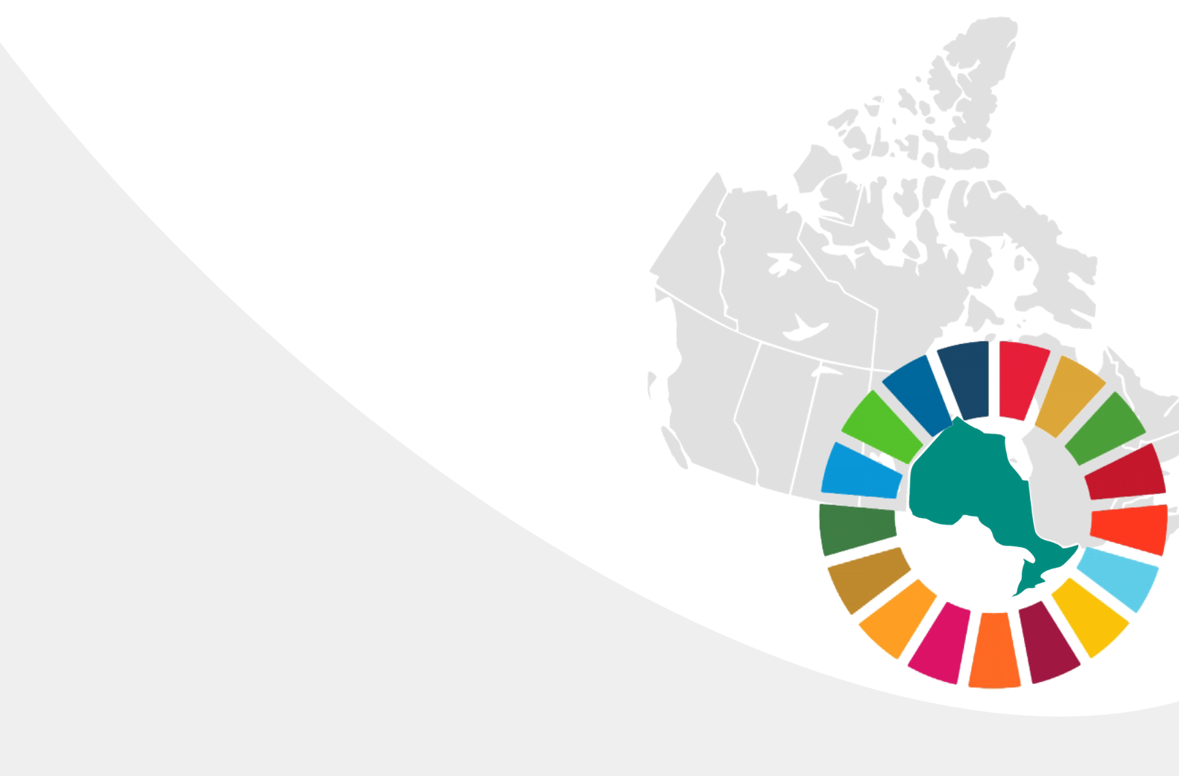

Annex 1. OCIC Consultation Framework
OCIC’s consultation framework made use of the discussion guide prepared by the SDG Unit to support the national consultation process. While consultation partners were encouraged to frame their consultation activities around their priorities, the discussion guide served as a useful tool to help frame discussions and ensure some consistency in the consultations across Canada. The framework prepared by OCIC drew from the discussion guide prepared by the SDG Unit and consultation partners were expected to revise consultation questions according to the specific needs of their community.
Through this approach, OCIC hoped to ensure that the consultations were complementary of the efforts by others, while still grounded in a recognition that local communities and stakeholder groups know what approaches work best in terms of engaging diverse communities. The framework was a tool to support consultation leads and could be adapted as needed.

Questions

1. Setting Canada’s Priorities for the National Strategy
- What are your community’s sustainable development priorities?
- What sustainable development policies or programs have successfully engaged and supported your priorities?*
- How does implementing the SDGs domestically and internationally complement each other? How are they linked?

2. Leaving No One Behind
- Where should Canada focus its efforts to be more inclusive?
- What kinds of engagement [online, in person, large forums, small-scale events] do you think best allows communities at risk of being left behind to be involved in the National Strategy?
- What are Canada’s biggest challenges in ensuring no one is left behind? What are your community’s specific priorities in this regard?

3. Leadership, Governance and Policy Coherence
- How can the Government of Canada support effective implementation of the SDGs at the community level?
- What is happening in your community to advance the SDGs?*
- What support does your community want to be able to advance sustainable development?

4. Accountability, Transparency and Reporting
- How can reporting on progress be made accessible to your community?
- How do you already report on advancing your priorities within your community? How could this be part of national reporting?
- What accountability, transparency and reporting mechanisms could be built into Canada’s implementation plan to meet the needs of your community?

5. Measuring Success and Canadian Indicator Framework (CIF)
- How should Canada’s Indicator Framework reflect local priorities? What kinds of targets should be included, and what local resources or tools for this are already being used?
- How can Canada ensure it is accurately measuring the impacts of the SDGs on historically marginalized communities [women, Indigenous peoples, newcomers, persons with disabilities, seniors, members of the LGBTQ2 community, non-binary individuals and youth]? What data disaggregation would be helpful within your community?
- How can the Government of Canada ensure the indicators it tracks meet your priorities (and ensure no one is left behind)?* Is there additional disaggregation that could be used [geographic, rural vs urban, sex, age, income]?*
- What kind of information do you need to inform your work/priorities? How can access to information on your community and that impacts your community be improved?
- What specific kinds of targets should be reflected in the CIF?

6. Awareness, Engagement and Partnerships
- What types of communications initiatives and approaches should Canada use to build awareness around the SDGs?
- What are the best methods to supporting ongoing engagement on Canada’s implementation of Agenda 2030 with all of society?
- How can Canadians most at risk of being left behind be included and engaged in all aspects of the implementation process?
- What specific considerations are needed to ensure inclusivity and access for your community to effectively participate in engagement opportunities?
- What kind of partnerships, networks and events are needed to advance the 2030 Agenda? What existing partnerships, networks and events should be supported?
- How can Canada better engage youth in your community on Agenda 2030 and the SDGs?
- What does being a good ally or working in allyship towards sustainable development mean to you?
- What role, if any, can OCIC and its members play in supporting your priorities?

7. Indigenous Knowledge, Self-Determination and Reconciliation
- How can Canada’s reconciliation process with Indigenous peoples inform the implementation of Agenda 2030 and how can Agenda 2030 support reconciliation?
- How does Indigenous traditional knowledge contribute to Canada’s understanding and achievement of the SDGs? How can it do more?
- What Indigenous traditional knowledge and best practices should be applied to a national strategy for sustainable development?
- Do SDGs and their targets adequately reflect and include Indigenous traditional knowledge, directly or indirectly? If not, where do you see the gaps?
- How can Canada best partner with Indigenous peoples through the development and implementation of the National Strategy to strengthen the nation-to-nation relationship?

8. Communities, Municipalities and Cities
- What are some of the biggest sustainable development challenges in your community? How is your community addressing these challenges?
- How can the role of local communities, municipalities and cities in addressing sustainable development be increased?
- What knowledge does your [local, regional, cultural, social, working, religious, secular] community have that could inform Canada’s National Strategy?

9. Learning, Knowledge and Research
- What are the opportunities to enhance learning and research around the SDGs?
- What tools or mechanisms can be used to share knowledge and best practices around the SDGs?
- Who should take a leadership role in supporting and advancing learning and research towards sustainable development solutions?

10. Innovation, Business and Investment
- How can Canada show leadership in innovation, business and investment to advance the SDGs?
- How can partnerships with the private sector be developed to foster innovation?
- How can business and the private sector be encouraged to invest in opportunities that support progress to advance the SDGs?

Consultation Leads Questionnaire
The Progressing National SDGs Implementation (2019, 3rd Edition), an independent report prepared by a coalition of global civil society organizations to assess the status Agenda 2030 implementation, highlighted a number of principles for effective multi-stakeholder engagement. The principles sit within a recognition of the importance of establishing an enabling environment for diverse communities to engage on sustainable development through supportive policy and legislation, institutionalised engagement and predictable and diverse funding. A series of questions were prepared for consultation leads, and aimed to provide a basis for a discussion on how the Government of Canada can take a principled approach to engaging diverse communities.

Timely
- How should future engagement opportunities and consultations be structured to ensure that they are timely for your community to effectively participate?
- When should future consultations and engagement occur? How should diverse communities feed results from their efforts, and other inputs, into the National Strategy?

Open and inclusive
- What kind of engagement [online, in person, large forums, small-scale events] do you think best allows diverse communities, including those at risk of being left behind, to be involved in the National Strategy?*
- What specific considerations are needed to ensure inclusivity and access for your diverse community to effectively participate in engagement opportunities?
- How can Canadians most at risk of being left behind be included and engaged in all aspects of the implementation process?*

Transparent
- What engagement opportunities should be established in advance as part of regular implementation processes?
- What accountability and transparency mechanisms could be built into Canada’s reporting structure?*

Informed
- What types of communications initiatives and approaches should Canada use to build awareness around the SDGs in your community?* How should the government partner with/support your community in this regard?
- How should documentation be presented to your diverse community before and after engagement opportunities to ensure effective participation?

Iterative
- What are the best methods to ensure ongoing engagement on Canada’s implementation of the 2030 Agenda with all of society?*
- How can 2030 Agenda implementation make use of existing, effective engagement mechanisms?

Collective (OCIC) Survey Questions
To ensure inclusivity in the consultation process, OCIC prepared a small set of survey questions to facilitate participation by diverse stakeholders who were unable to participate in formal online and offline consultations. These questions draw from the longer set of questions that informed the formal consultations.

1. Setting Canada’s Priorities for the National Strategy
- What are your community’s sustainable development priorities? (listing of SDGs)
- How is your community addressing its sustainable development priorities?
- What sustainable development policies or programs have successfully engaged and supported your priorities?
- What support does your community need to advance its sustainable development priorities?
- What specific considerations are needed to ensure inclusivity and access for your community to effectively participate in engagement opportunities? How would you like to be engaged?
- How can Canada’s reconciliation process with Indigenous peoples inform the implementation of Agenda 2030? How could the national strategy strengthen the nation-to-nation relationship?
- How does implementing the SDGs domestically and internationally complement each other? How are they linked?
- What accountability, transparency and reporting mechanisms could be built into Canada’s implementation plan to meet the needs of your community?
- What role, if any, can OCIC and its members play in supporting your priorities?

Annex 2.
OCIC Consultation References, Resources, Participants and Invitees

OCIC Consultation References and Resources
Consultation Participants and Invitees

Annex 2. OCIC Consultation References, Resources, Participants and Invitees

OCIC Consultation References and Resources
Participants highlighted a range of initiatives at local, national and global levels that are working to support their sustainable development priorities.
Initiative | Description
30% Club Canada | The aim of the 30% Club Canada is to include board chairs and CEOs to achieve better gender balance at the board level as well as in senior management levels. The name of the organization comes from their aspirational goal that can be achieved in Canada through focused efforts by the business community.
4Rs Youth Movement | The 4Rs Youth Movement is a youth-driven initiative that was launched to change the country by changing relationships between Indigenous and non-Indigenous young people. Through the networks and support of 14 founding national organizations, 4Rs is about engaging young people in critical cross-cultural dialogue that furthers reconciliation.
Accessibility for Ontarians with Disabilities Act (AODA) | The purpose of the Accessibility for Ontarians with Disabilities Act is to benefit all Ontarians by developing, implementing and enforcing accessibility standards in order to achieve accessibility for Ontarians with disabilities before January 1, 2025. Accessibility standards were written through the involvement of persons with disabilities, the Government of Ontario and representatives of industries and various sectors of the economy.
Art Metropole | Art Metropole is a non-profit artist-run center incorporated in 1974 supported by independent donors, the Canada Council for the Arts, the Ontario Arts Council and the City of Toronto.
Art Gallery of Ontario (AGO) | Founded in 1900, the Art Gallery of Ontario is one of the largest art museums in North America. The AGO hosts a wide range of exhibitions and programs ensuring the work of diverse and underrepresented artists are showcased amongst pieces created by other established artists. Annually, the AGO attracts 873,000 visitors.
Association of Ontario Science and Technology Centres (ASTC) | The Association of Science-Technology Centers is a global organization providing collective voice, professional support, and programming opportunities for science centers, museums, and related institutions, whose innovative approaches to science learning inspire people of all ages about the wonders and the meaning of science in their lives. Founded in 1973, ASTC now represents over 600 members in nearly 50 countries, including not only science centers and museums, but also nature centers, aquariums, planetariums, zoos, botanical gardens, and natural history and children’s museums, as well as companies, consultants, and other organizations that share an interest in informal science education.
BRAC | BRAC is an international development organization based in Bangladesh. They envision a world free from all forms of exploitation and discrimination where everyone has the opportunity to realise their potential. Their mission is to empower people and communities in situations of poverty, illiteracy, disease and social injustice.
Center for Addiction and Mental Health (CAMH) | The Center for Addiction and Mental Health is Canada’s largest mental health and teaching hospital. CAMH is fully affiliated with the University of Toronto and is a Pan American Health Organization/World Health Organization Collaborating Center. The center works with more than 3,000 physicians, clinicians, researchers, educators and support start, offering clinical care to more than 34,000 patients each year. Through their foundation, CAMH raise funds for new programs, research and augment services.
Canada Service Corps. | In 2018, Justin Trudeau launched the Canada Service Corps, a national youth service initiative. Canada Service Corps encourages young Canadians to get involved in service to their communities and gain valuable skills and experience that will benefit them in every aspect of life. It will also provide young Canadians with service opportunities that currently do not exist. The Government of Canada has launched a new website for young Canadians so they can provide feedback about what service means to them, fund national, regional, and local scale projects to engage young Canadians from all backgrounds, and offer an online matching service through Volunteer Canada that helps young people to find volunteer opportunities in their communities.
Canadian Association of Science Centres (CASC) | CASC is a national platform for Canada’s Science Centres and informal science engagement. Science Centres have relevance to all sectors of the population and have become important meeting places for science and society. Research shows that science centres demystify science, conveying its beauty, showing its necessity and making it accessible to the general public.
Canadian Hemp Farmers Alliance | The Canadian Hemp Farmers Alliance seeks to create agriculture growth in Canada by creating Canada’s largest Hemp Farmers Co-operative.
Centre for Equality Rights in Accommodation (CERA) | The Centre for Equality Rights in Accommodation is a not-for-profit charity that works to advance housing security and human rights in housing for tenants, and to promote the human right to housing across Ontario. They defend housing rights and human rights by providing direct services to marginalized Ontarians; educating individuals and communities; and advancing progressive and inclusive housing law and policy. They work in partnership with many groups across Ontario and have consultative status with the United Nations Economic and Social Council.
Centre for Gender, Diversity and Inclusion | Statistics Canada produces statistics that help Canadians better understand their country—its population, resources, economy, society and culture. In addition to conducting a Census every five years, there are about 350 active surveys on virtually all aspects of Canadian life. Statistics Canada's Centre for Gender, Diversity and Inclusion Statistics provides disaggregated dual gender (men & women) statistics on education and skills development, economic participation and prosperity, leadership and democratic participation, gender-based violence and access to justice, poverty reduction, health and wellbeing.
Community Food Centres of Canada | Community Food Centres of Canada build health, belonging and social justice in low-income communities across Canada through the power of food. They envision a Canada where food is treated as a basic right and central to health, and where everyone has the means, knowledge, and voice necessary to access good food with dignity.
Cultural Diplomacy Program at Queens University | What unites all these diverse research agendas is our passion for social justice. We believe that all our research should in some way be capable of addressing real world problems. Students engage in community based research, working with Indigenous peoples, artists, students, prisoners and activist groups to bring about social transformation. They also conduct artistic research (research creation) and present their work in a variety of media.
Devex | Devex is a media platform for the global development community, a social enterprise working to make the $200 billion aid and development industry do more good for more people, and the largest provider of recruiting and business development services for global development.
Employment and Social Development Canada (EDSC) | Employment and Social Development Canada works to improve the standard of living and quality of life for all Canadians. They do this by promoting a labour force that is highly skilled. They also promote an efficient and inclusive labour market.
Employment Ontario | Employment Ontario delivers employment and training services to people across the province, develops policy directions for employment and training and supports career and employment preparation and adult literacy and basic skills.
Feminist International Assistance Policy | The Feminist International Assistance policy seeks to eradicate poverty and build a more peaceful, inclusive and more prosperous world. Through this framework Canada aims to promote gender equality through empowering women and girls. The feminist approach was adopted because the Canadian government believe women and girls have the ability to achieve real change in terms of sustain
Food Secure Canada (FSC) | Food Secure Canada is a pan-Canadian alliance of organizations and individuals working together to advance food security and food sovereignty through three inter-locking goals: zero hunger, healthy and safe food, and sustainable food systems.  Building on the People’s Food Policy and diverse community food practices, we work with our members towards food sovereignty and for deep and lasting change in our food system.
Global Affairs Canada | Global Affairs Canada manages Canada’s diplomatic relations, provides consular services to Canadians, promotes international trade and leads Canada’s international development and humanitarian assistance.
High Resolves | High Resolves designs and delivers transformational curriculum based on proven design principles from learning science, behavioural economics, social psychology, and neuroscience. They also run Videos for Change, a national competition in partnership with Network Ten and Platypus that gives high school students the opportunity to create social advocacy videos. High Resolves has a range of teaching resources that covers a number of the SDGs and are all specifically tied to reducing inequality and improving education.
Indigenous Advisory Council | The Indigenous Advisory Council (IAC) is made up of members from different Indigenous communities and of representatives from Indigenous service providers in Toronto. The IAC meets quarterly and provides feedback and guidance on the direction of Indigenous initiatives at Toronto Public Library, including the Land Acknowledgement Statement, Elders in Residence program, and Read Indigenous campaign.
International Council of Museums Canada (ICOM) | The International Council of Museums is an international organization of museums and professionals committed to the conservation, continuation and communication to society of the world’s natural and cultural heritage, present and future, tangible and intangible. They act within Canada as an advisor on and a reference centre for international information that may be of interest to Canadian museums and the Canadian public. They also aim to increase the awareness of the Canadian public about the existence of museums in Canada and to further the understanding of their role in culture and society.
International Development Organization (IDA) | The International Development Association (IDA) is the part of the World Bank that helps the world’s poorest countries. Overseen by 173 shareholder nations, IDA aims to reduce poverty by providing loans (called “credits”) and grants for programs that boost economic growth, reduce inequalities, and improve people’s living conditions.
International Science Centre and Science Museum Day | The International Science Center and Science Museum Day (ISCSMD) is a yearly, global event illustrating the impact and reach of all the world’s science centers and science museums. It demonstrates the role these institutions play with their millions of visitors in raising awareness of—and engagement in—sustainable development and the solutions to worldwide challenges such as climate change, human health (HIV/AIDS, Zika, clean water, etc.), energy, waste, water shortages, gender, oceans, and other global issues. Science centers and science museums worldwide take the opportunity of this day to celebrate and promote their missions through widely diverse informal science education and engagement activities addressing the critical topics articulated in the SDGs.
ME to WE | ME to WE is a social enterprise that provides products that make an impact, empowering people to change the world through consumer choices. The organization creates employment and economic empowerment for over 2000 people in WE Village communities around the world through artisanal and Fairtrade products and global service trips.
Ministry of Education | The Ministry of Education is responsible for delivering early years, child care and publicly funded education from kindergarten to Grade 12. They develop policy and programs to support child care and early years centers; make sure child care settings are safe and follow the law by funding; manage licensing and inspecting; fund and oversee publicly funded elementary and secondary school education; develop and publish curriculum documents and teaching resources for Kindergarten to Grade 12; set provincial standards and guidelines for assessments, etc.
Ministry of Training, Colleges and Universities | The Ministry of Training, Colleges and Universities develops policy directions for universities and colleges of applied arts and technology, plans and administers policies related to basic and applied research. In addition, the ministry authorizes universities to grant degrees, distributes provincial funds to college and universities, provides financial assistance to post-secondary school students through OSAP and registers private career colleges.
National Housing Strategy | The National Housing Strategy is Canada’s $40-billion plan to ensure that Canadians have access to housing that meets their needs and that they can afford. The plan aims to ensure provision of safe and affordable housing for citizens to ensure better socio-economic outcomes while also strengthening the middle class and bringing people out of poverty.
National Youth Council (NYC) - Boys and Girls Clubs of Canada | The Boys and Girls Clubs National Youth Council is committed to providing representation for Boys and Girls Club youth, reflecting issues and goals from across the country, and ensuring youth input into national initiatives and activities. NYC members serve as ambassadors and role models for other children and youth throughout the organization, positively influence decision-making on issues related to young people, and plan a national youth forum every two years.
Native Canadian Centre of Toronto (NCCT) | Native Canadian Centre of Toronto is a membership-based, charitable organization. NCCT offers a wide range of programs and services based on Indigenous cultural traditions and teachings. They aim to empower the Indigenous community in Toronto by providing programs that support their spiritual, emotional, physical and mental well-being. The Native Canadian Centre of Toronto is dedicated to working with all of our relations toward a better future.
North American Cultural Diplomacy Initiative (NACDI) | The North American Cultural Diplomacy Initiative is a transdisciplinary partnership that includes academics, policymakers and practitioners from North America and beyond to establish cultural diplomacy as a critical practice. By interrogating and advancing cultural diplomacy, they aim to raise their profile as a valuable tool to foster international and transcultural relations—that is, to measure it and mobilize it to inform public policy development and implementation. In addition, they aim to advance new scholarship and research that provides greater understanding of how cultural diplomacy functions to connect North America globally; not merely as part of the “soft power” tool-kit of nation states, but as a multi-directional and potentially activist practice that encompasses a broad range of non-state actors, including cultural institutions, managers, producers, consumers and communities seeking to imagine counter-hegemonic possibilities and inclusive futures.
Ontario Chamber of Commerce (OCC) | The Ontario Chamber of Commerce is an independent organization with a mission to support economic growth in Ontario by defending business priorities at Queen’s Park. OCC’s vision is to foster a vibrant and economically sustainable province that is driven by innovation and the expanding business community. OCC represents local chambers of commerce and boards of trade in over 135 communities across Ontario and network of 60,000 members.
Ontario Federation of Indigenous Friendship Centers (OFIFC) | The Ontario Federation of Indigenous Friendship Centres is a provincial Indigenous organization representing the interests of member Friendship Centers located in Ontario. Friendship Centers are not-for-profit corporations which are mandated to serve the needs of all Indigenous people regardless of legal definition. The centers are the primary service providers for Indigenous people requiring culturally-sensitive and culturally-appropriate services in urban communities. The Friendship Center’s vision is to “improve the quality of life for Indigenous people living in an urban environment by supporting self-determined activities which encourage equal access to and participation in Canadian society and which respect Indigenous cultural distinctiveness
Ontario Indigenous Youth Partnership Project (OIYPP) | The Ontario Indigenous Youth Partnership Project is based on an understanding that if we allow Indigenous voices to guide and shape the partnership, we will have a culturally appropriate and more effective way of working with Indigenous youth.
Ontario Student Assistance Program (OSAP) | The Ontario Student Assistance Program is a financial aid program that can help students pay for college or university. Funding is provided through grants and student loans and is open to Ontarians of any age who are Canadian citizens, permanent residents or protected persons.
PowerShift: Young and Rising | PowerShift: Young and Rising aims to provide young people will the tools, skills, knowledge and networks required to build to a long-lasting, diverse, and intersectional climate movement.
Prime Minister’s Youth Council (PMYC) | In July 2016 the Prime Minister’s Youth Council was launched by Justin Trudeau as a platform for young people to engage directly with him, his Cabinet, Parliamentarians, and with senior government officials to ensure that the government does a better job of understanding and addressing the needs and perspectives of Canada’s youth, at the highest levels of government.
Resource Movement | Resource Movement aims to bring together young people with wealth and class privilege to become leaders working towards the equitable distribution of wealth, land and power. Their vision is a world where wealth and power are shared, and Indigenous land rights are respected. A world where all communities can tell their own stories, live well, and shape their own future.
Sociéte Économique de l’Ontario (SÉO) | The Sociéte Économique de l’Ontario is a provincial network that takes an innovative and dynamic approach to economic development, entrepreneurship, employability and immigration to consolidate Ontario’s Francophone and bilingual economic space. Inclusive approaches are used to ensure full participation of stakeholders in Ontario and Canada.
The Circle on Philanthropy and Aboriginal Peoples in Canada (The Circle) | The Circle aims to build connections and foster collaboration by developing programs that foster more and better conversations, connections, and relationships among Aboriginal Peoples and philanthropic organizations; deepening understanding of key issues in Aboriginal communities such as Aboriginal education, land and people, Aboriginal health; and securing key partnerships and memberships that leverage the Circle’s capacity and reach.
The Ontario Science Centre’s Sensory-Friendly Saturdays | Working in close collaboration with Geneva Centre for Autism, the Science Centre developed family-friendly programs — including an open-format planetarium experience, current research and accessible technology — to enhance accessibility for those affected with sensory processing difficulties and neurodevelopmental disorders. With a variety of communities in mind, Sensory-friendly Saturdays were developed to provide an environment that is inclusive, accessible and respectful.
The Working Centre | The Working Centre is a nonprofit organization with charitable status and is an amazing community hub. Their main projects give people access to tools to create their own work combined with continuous ways of learning and co-operating. They organizes their projects into six areas; the Job Search Resource Centre, St. John’s Kitchen, Community Tools, Access to Technology, Affordable Supportive Housing and the Waterloo School for Community Development.
Toronto District School Board (TDSB) | The Toronto District School Board is the largest and one of the most diverse school boards in Canada servicing approximately 246,000 students in 582 schools in Toronto in addition to 140,000 life-long learners in the Adult and Continuing Education programs.
Toronto Housing Plan 2020-2030 | The City of Toronto over the 2019 year is working with housing stakeholders and the public to develop a plan to address housing and homelessness challenges over the next decade. Information is being gathered through online questionnaire, engagement with Indigenous communities with the Indigenous Community Advisory Board and Toronto. Organizations serving marginalized and equity-seeking groups are also being contacted.
Toronto Public Library | Toronto Public Library provides free and equitable access to services which meet the changing needs of Torontonians. The Library preserves and promotes universal access to a broad range of human knowledge, experience, information and ideas in a welcoming and supportive environment.
Toronto Youth Cabinet | Established in 1998 by the Toronto City Council, the Toronto Youth Cabinet is the official youth advisory body to the City if Toronto. The cabinet is youth-led and promotes youth participation in civic affairs and policy development. Membership is open to individuals ages 13-24. The cabinet has a number of Working Groups targeting issues including urban health, housing, education and transit.
UNOPS | UNOPS helps the UN and its partners provide peace and security, humanitarian and development solutions. They are focused on implementation, and are committed to UN values and private sector efficiency.  Their services cover infrastructure, project management, procurement, financial management and human resources. Their partners call on us to supplement their own capacities, improve speed, reduce risks, boost cost-effectiveness and increase quality.
United Nations Association in Canada | The United Nations Association in Canada strives for a better world through innovative national projects focused on pressing global issues of concern to the UN. They work closely with the educational communities in every province and territory to build their capacity to educate young people from a global perspective.
United Way Greater Toronto | United Way is a worldwide not-for-profit movement. As the largest non-governmental supporter of social services in the region, they are dedicated to creating the opportunities people need to improve their lives and build a better future.
Vote Compass | Vote Compass is an Australian federal election app developed by political scientists for exploring how voter views align with those of the running candidates.
YMCA of Greater Toronto | The YMCA of Greater Toronto works to engage with the community to provide customized programs that support local needs while embracing diversity. Services are offered to children, teens, young adults and families, including childcare, education and training programs, employment and immigration, family and youth and health and fitness programs.
YWCA | YWCA Toronto is an association by, for and about women and girls. Their programs promote equality, economic security and lives free from violence, and offer a range of housing options, employment and training programs, community support programs, girls’ programs and family programs. They also engage in systemic advocacy.

Consultation Participants & Invitees

OCIC Consultations
Total Organizations | 22 Organizations - AIESEC Canada, Big Brothers Big Sisters of Canada, Canadian Association for Community Living, Canadian Hemp Farmers Alliance, Centennial College, Centre for Equality Rights in Accommodation, Centre for Social Innovation, Development and Peace, Educate a Girl, High Resolves, HI$TORY, Humber College, I Talk To Strangers Canada, JAYU, North Hamilton Community Health Centre, Nurturing Tanmiya Inc., Older Women's Network, POSHAK, Ryerson University, Tides Canada Foundation, Youth and Philanthropy Initiative Canada, YWCA Toronto
Key Informants | 6 Key Informants - Akin, Boys and Girls Clubs of Canada, Girl Guides of Canada, Museum of Contemporary Art Toronto Canada, Royal Ontario Museum, Ontario Science Centre
Individuals | 36 Individuals not affiliated with organizations (Including 30 survey respondents)  24 Individuals affiliated with organizations above

Diaspora Consultations
Total Organizations | N/A
Key Informants | 3 Key Informants - Diaspora from Bosnia, Lebanon, Nigeria
Individuals | 19 Individuals - Diaspora from Algeria, Bangladesh, El Salvador, Ethiopia, Eritrea, Guadeloupe, India, Kenya, Lebanon, Mali, Pakistan, Somalia, Sri Lanka, Syria, Tanzania, Vietnam, Yemen

Disability Consultations
Total Organizations | 5 Organizations - Alliance for Equality of Blind Canadians, Canadian Council for the Blind, Centre for Independent Living Toronto, Royal Bank of Canada
Key Informants | 4 Key Informants - Citizens with Disabilities Ontario, Canadian Council on Rehabilitation and Work, Spinal Cord Injury Association Ontario, Springtide Resources
Individuals | 16 Individuals not affiliated with organizations

First Nations Consultations
Total Communities | 2 First Nations Communities - Eabametoong First Nation, Nishnawbe Aski Nation
Key Informants | 9 Key Informants
Individuals | 75 individuals

OCIC’s Outreach Table
Number of organizations/institutions: 120
Number of individuals not affiliated with organizations/institutions: 130

A Million Elephants, African Bronze Honey Company, Aga Khan Museum, Aid Through Trade, AIESEC Canada, Akin, Alveole, Amnesty International Canada, Amref Health Africa in Canada, Ark Imports, Art Gallery of Mississauga, Art Gallery of Ontario, Art Gallery of York University, Art Museum at the University of Toronto, Artscape, Bata Shoe Museum, Big Brothers Big Sisters of Canada, Big Village, Boys and Girls Clubs of Canada, Burlington Performing Arts Center, BurlingtonGreen Environmental Association, Canada Africa Partnership Network, Canada Aviation and Space Museum, Canadian Association for Community Living, Canadian Feed The Children, Canadian Hemp Farmers Alliance, The Canadian Partnership for Women and Children’s Health, Casa Relief, Centre for Equality Rights in Accommodation, Centre for Social Innovation, Chic Made Consciously, Chicza Canada, Christian Children's Fund of Canada, Circle of Hands Uganda, comdu.it, Community Foundations of Canada, Cuso International, Dandarah, Development and Peace, Didi Bahini, Dovercourt Boys and Girls Club, Ecologos, Educate a Girl, For Youth Initiative, Gardiner Museum, Girl Guides of Canada, Girls 20, Harbourfront Centre, HI$TORY, High Resolves, Hot Docs, I Talk To Strangers Canada, imagineNATIVE, Inclusive Growth Consulting, Institute for Youth Health and Development, International Development and Relief Foundation, Inter Pares, International Institute for Sustainable Development, JAYU, JobStart, Just One, KAIROS, Kawartha World Issues Centre, Kids Right to Know, Kind Karma Company, La Villa, Learning for a Sustainable Future, Little by Little, Mamaa Trade, MCIS Language Solutions, Museum of Contemporary Art Toronto Canada, Myseum of Toronto, National Gallery of Canada, Native Canadian Center of Toronto, North Hamilton Community Health Centre, Nurturing Tanmiya Inc., Oikocredit, Older Women's Network, Ontario Arts Council, Ontario College of Art and Design University, Ontario Science Centre, Ontario Trillium Foundation, Pathways to Education Canada, Plan International Canada, Planet in Focus, POSHAK, Power to Girls Foundation , Praxis Pictures, Red Sky Performance, RESULTS Canada, Right To Play, Ripley’s Aquarium of Canada, Roota, Royal Ontario Museum, Ryerson Image Centre, Ryerson University, Salanga, SKETCH Working Arts, Skills for Change, Society Socks, Spadina Museum, Starling Minds, Talis, The Mary Ward Centre, The Salvation Army, Theatre Ontario, Tides Canada, Toronto Public Library, Toronto Youth Cabinet, Wakami Canada, Western Ottawa Community Resource Centre, White Ribbon, World Accord, World Vision Canada, YMCA of Greater Toronto, Young Women in Business, Youth and Philanthropy Initiative Canada, Youth Challenge International, YWCA Toronto, ZZR Capital

Annex 3.
Disability-Inclusion Community Consultation Reports

Introduction
Disability-Inclusion Community Stakeholder Discussion Questions and Responses
Summary
Recommendations and Conclusion

Annex 3. Disability-Inclusion Community Consultation Reports

Introduction
The objective of the Consultations with the disability and intersecting marginalized communities was to gain an understanding of their priorities and perspectives on Canada’s National Strategy on the Sustainable Development Goals. Participants identified key action areas that needed to be addressed in order to “leave no one behind.” The consultation sessions were a communication forum for these communities to exchange their ideas with each other and strategize on the roles that government leaders can play to support the efforts of the disability communities.
The Consultation Lead reached out to all partners and leaders in disability communities across Ontario to educate them about this important initiative and to engage them and act through participation in a Strategy Focus Group and contribute their perspectives in an interactive discussion.
In the planning stages, we recognized that we needed to build trust with individuals and organizations as they shared their priorities. A pre-consultation questionnaire was developed to educate participants about the 17 sustainable development goals and to think about what their priorities were and what policy considerations were in place with the organizations that they supported, volunteered, and/ or worked for.
In addition, considerations for the audience and participant characteristics were also required to determine that these participants would reflect the communities that Ontarians live in. Characteristics such as demographic, age, gender, race, ethnicity, type of disability, LGBTQ, and indigenous were included. These considerations were included in the pre-consultation questionnaire. With this demographic information, it provided the data regarding our research participants and was necessary for determining a representative sample of the target population for generalization purposes.
For these Consultation sessions, there was a good mix of Ontario-based disability organizations. There were participants that resided in Southern Ontario, Northwest Ontario, and the Niagara region. Leaders were successfully engaged from Citizens with Disabilities Ontario (CWDO), Canadian Council on Rehabilitation and Work (CCRW), Spinal Cord Injury Association Ontario (SCI) and Springtide Resources. In addition, there was a representative from RBC engaged to provide their input in these Focus Groups.

Disability-Inclusion Community Stakeholder Discussion Questions and Responses

1. When we think of all these sustainable development goals and speaking for an organization, which ones do you think are the priorities for Ontario?
- Poverty is certainly one of the top goals along with partnerships followed by education. Poverty is a major issue for blind people and overly for people on ODSP. Education and health are important and more needs to be done on mental health, more in the line of education and not sure how that can be done to educate society and the world in general to be aware of what (disability) blindness is and the challenges faced. In this way persons with disabilities can make an integrated society where everyone is included, and people do not feel marginalized or left out.
- Persons with disabilities need more emphasis on hunger and combating hunger. Economic growth is important as well as clean water and sanitation for communities for all.
- Climate change is a major problem for persons with disabilities to tackle and need to put pressure on America and China and all the nations who are signatories to international agreements on climate.
- The biggest barrier persons with disabilities face are attitudinal barriers. One suggestion was to have a framework that examines stigma and bias and, in this way, can educate society to deal with the attitudinal barriers that persons with disabilities face.
- Education, poverty and equality were among the most frequently cited priorities for respondents. Several respondents would note more than one priority and viewed them through a framework which saw these goals as intimately intertwined.

2. In speaking as an individual, what specific policies or programs would successfully address any of the priorities that we talked about?
Several respondents cited that the mayor of Toronto is doing a lot on homelessness issues and poverty reduction strategies. Another respondent said that Members of Parliament James Maloney, MP for Etobicoke-Lakeshore is doing things to help engage people experiencing poverty.
A housing strategy was also cited. Housing Now Toronto has a 10-year strategy and they have 11 sites already designated in Toronto to build new housing stock on. About 1,100 new units and 20% designated for accessible housing.

3. Leave no one behind - How can Canada be more inclusive? Any ideas how we can achieve this?
Multiple respondents expressed the need to include persons with disabilities in decision making processes, especially ones that involve persons with disabilities. This needs to exist on every level, from the creation of the policies and programs to conducting the academic research. This also needs to happen in the field of technology and innovation, where accessibility is considered at the inception of the design process rather than merely left as an afterthought.
Multiple respondents proposed that there needs to be a fixed position such as an Accessibility Minister created. Comments suggested indicated that without centralization, persons with disabilities remain isolated in their own silos, with each disability community or group advocating for themselves and they may not receive support from each other.
Many respondents suggested that it be mandatory for someone with a disability to serve on a board of directors.
Respondents also cited the importance of having access to education, as this is fundamentally tied to employment.
The importance of centering accessibility in design processes rather than including it as an afterthought. Consideration of accessibility in the first steps in the creation of that technology, rather than in the last stages.

4. In terms of awareness, engagement & partnership, what types of communications initiatives and approaches should Canada use to build awareness around the SDGs?
One respondent recommended that technological accessible consideration is important for the success of persons with disabilities. The suggestion was to move to customized platforms for people with disabilities rather than enlisting mainstream companies to create it. One suggestion that was made by one respondent was to get the government involved in creating customized accessible technology platforms.
Multiple respondents detailed the numerous barriers that they faced in the workplace. These were present throughout the hiring process. Several respondents cited that persons with disabilities are working in jobs, that they are overqualified for and find that skills, education and experience are not fully recognized in the workplace.
Several respondents raised the issue of facing multiple barriers to accessing employment, with the example that it is difficult to get a foot in the corporate world. Competition is a significant barrier, as it presents a great challenge to even those without disabilities, to finding employment.
Several respondents mentioned the difficulty of navigating disclosure in the workplace and the potential threats they face to their status at work and promotional prospects if they were to disclose their disability to their bosses. Many see very little upside to disclosure.
Several respondents expressed their agreement that it is important to educate hiring managers about the strengths and abilities that persons with disabilities bring to the workplace. The major challenges are not having access to educational and work opportunities.
Another suggestion is adopting a framework that acknowledges everyone’s unique needs. In the workplace respondents cited that hiring managers are not fully educated on the types of disabilities and they may group people into types of disability and not understand their unique talents and abilities that they bring to the workplace.
Several respondents stated that there needed to be greater influence from business leaders to government leaders, down to the micro level of department managers. This solution cited that sustainability in employment can come from persons with disabilities and groups that support people with disabilities, coming together and collectively saying to leaders that our voices need to be heard in the workplace.

Observations
It was noted by the observers that several respondents were interested in on line platforms and there was an in-depth discussion on the use of Zoom and conference calls and making online communication accessible.

5. What is Canada’s biggest challenge and who is being left behind?
Canada’s biggest challenges are loneliness and isolation. One respondent cited that there is very high employment for the blind which is 70%. There are not enough creative housing solutions or water solutions to make it more affordable and available. Food programs make it hard to not leave people behind.
Healthcare has seen many cuts from the government about the health facilities and how that affects those on low income with disabilities.
The note taker observed that the participants disagreed on whether Canada should support international development versus domestic development. It is important to point out that those who cared more for internal issues dominated over those who did want to support Canada’s international development efforts.

6. In terms of leadership, governance & policy coherence, what is happening in your community to advance the SDGs?
Many respondents cited the lack of education for leaders at all levels (business leaders, municipal and provincial leaders, to department managers) on accessibility and disability. Part of this problem is also a lack of inclusion of persons with disabilities in leadership positions and in decision making processes. Respondents have stated that it is often others without a disability lens making the decisions for persons with disabilities.
This points to the urgent need to educate our leaders. One respondent referenced a piloting of a tool to educate employers on disability and had said that it has only been piloted to a small group and is in the testing stages.
Many respondents suggested approaching leadership opportunities as a platform for communicating with a wider upcoming election and explored the idea of creating a grassroots party and leveraging the platform that would come with it. This may be a different way to develop a centralized platform, which can be used to get the message out to the broader public.
Several respondents informed the group of upcoming events or meetups within their own communities and fields, as spaces and opportunities for further discussion and work on accessibility. A respondent suggested viewing the upcoming election as a possible opportunity for the disability community to convey their message to the wider public.
One respondent cited accessibility camps as they provide an excellent opportunity to learn and challenge our current methods of measuring accessibility and inclusion.

7. What communication initiatives can we start in our communities to get people to understand these what these 17 sustainable goals are in Canada?
There were several suggestions stated: Peer to Peer learning which encourages participation by others.
Many respondents agreed that many persons with disabilities have accessibility and health issues and using an online platform will provide easier access and a larger reach of people. Many respondents suggested that future consultations include youth, high school and university students.
During the discussion one respondent cited that transportation especially accessible transportation is a huge issue for people with disabilities. As the Canadian population ages, Wheel Trans is leaving people behind. The government can focus on providing accessible and affordable transportation.

8. What does be an ally mean to you? How are we being good allies?
Several respondents said that central to ally ship is communication, which should be accompanied by a non-judgmental attitude and respecting everyone’s point of view. When that happens, it is possible for everyone to be good allies to each other.

9. In terms of accountability, transparency & reporting measuring success, what kinds of targets should be included for Canada? And how can the government of Canada track and meet your priorities to track the success of this happening and not leaving anyone behind?
One respondent recommended that one method to measure success is to engage the public in signing a petition and advocate for the rights for people with disabilities the use of online petitions will increase inclusion and bring people from different neighbourhoods together.

10. How can the Government of Canada ensure the Canadian Indicator Framework (CIF) meets your priorities (and ensures no one is left behind)?
One respondent proposed creating a “Disability Analysis” because currently there exists all kinds of employment equity actions related to women. This type of framework and analysis on the experiences of those who live at the intersections of disability is lacking. Further, ageism is an issue.
An involvement measurement was also proposed. An involvement measurement can provide some insight into the level of involvement of people with disabilities who are in the workplace.
Another measurement cited was a Disability Equality Index and mentioned a Return on Disability Group initiated by Richard Donovan which has been implemented at. RBC. RBC has also put together sustainable development Exchange Traded Funds (ETF’s).
A respondent suggested that the disability community organizations can showcase people’s talents. Identify individual strengths or let people show what they used to do (i.e. pre-disability) and what they can still do in the workplace. There are also stigma and attitudinal barriers and culture barriers. It was mentioned that newcomers to Canada may have less experience or exposure to disability organizations. Showcasing strengths and abilities will inspire others and in this way; people can be educated about the value of hiring persons with disabilities.

11. How can Canada’s Reconciliation process support this?
Indigenous communities need to be more involved. One respondent cited that the Elders and teachers need to be brought back and lead their communities. Trust is huge, and it takes a lot to build that trust especially when in the past no-one listened.

12. What are the biggest sustainable challenges and how are your communities or organizations looking at addressing these?
Several respondents proposed a framework that combines the priorities of education and economic growth, by the latter and references employment opportunities for persons with disabilities. On education, one respondent cited that many abled educators are undereducated and that poses a problem to receiving quality education.
One respondent asserted the need to include the neurodiverse and autistic community. The respondent cited that many of the protectors are neurotypical parents. As a result, the focus is overwhelming on autistic children, with many forgetting that these children will become autistic adults. The plans often neglect to address autistic adults and it is usually others deciding what is best for them.
Healthcare needs to be sustainable. Agriculture needs to be sustainable and migrant workers need to be treated well and supported. Farms and the Environment need to be sustainable. Communities need to have more pulling and working together many respondents agreed that there needs to be cooperation and brainstorming to identify solutions to sustainability. One respondent cited that economic growth – needs to be part of transportation and it is important to find new ways to use our resources (i.e. less pollution).
One respondent suggested that infrastructure is central to this concept of sustainable cities and cities need to understand the various factors involved regarding infrastructure. This remains a challenge in Toronto, the leadership is not in touch with the people’s needs with infrastructure.

What kind of partnerships, networks and events are needed to advance the 2030 Agenda? What existing partnerships, networks and events should be supported?
Several respondents discussed the need for accessible online platforms for communication. The lack of affordability of some technology was also cited as a barrier for people with disabilities.
Several respondents seemed to appreciate the discussion had during this consultation and demonstrated enthusiasm to use these connections made over this session as a source of networking and partnership with each other going forward. The discussion included brainstorming community building events, effective ways of engaging with and communicating to the public.
Many respondents suggested having an event like a conference, a place for the meeting of the minds. It could be on the provincial scale (federal may be too complex). This can be an opportunity to pool resources and collaborate to find solutions.
One respondent suggested that the group write a story as this is a way to bring awareness to the work they do. This would be a more proactive way to get the stories out to the public.
Several respondents suggested to create a centralized organization for people with disabilities. Since there will not be a government forum, proposes the group do an online forum instead.
Many respondents recommended using social media such as Twitter or Facebook groups, and from there each of the respondents can reach out to their own networks.

What specific considerations are needed to ensure inclusivity and access for your community to effectively participate in engagement opportunities?
Many respondents stated that there needs to be a concrete effort made to ensure that everyone has as seat at the table.

13. What are the best methods to supporting ongoing engagement on Canada’s implementation of Agenda 2030 with all of society?
Many respondents were eager to build upon the conversations had during this consultation and keen to use that to build community and collaboration. Maintaining these connections and access to a community can help ensure that people stay engaged and can participate.

Summary
AEBC Toronto held 2 focus groups on the same day Tuesday April 16. The in- person focus group was held in the afternoon from 1 – 3 PM at the Centre for Independent Living in Toronto (CILT), and 15 individuals participated. The meeting took place in an accessible space, and accommodations were provided for all our participants. There was Captioning in Real Time where the text was displayed on the screen and there were two attendant care individuals and two volunteers supporting the needs of our participants.
The in-person group was a wide mix of demographic, age, race, gender, sexual orientation, indigenous, and diverse disability. This session was recorded and confirmed with the participants that they were comfortable with the recording of the session and confirmed they were comfortable with photos being shared on social media. All confirmed in the room verbally that they agreed. AEBC provided lunch and refreshments in advance of the meeting. In addition, AEBC provided honorariums to all the participants for their time and their participation in this discussion.
There was active representation from Centre for Independent Living in Toronto (CILT), Springtide Resources and Canadian Council on Rehabilitation and Work (CCRW). There was a very lively interactive discussion, and many individuals cited poverty, hunger, and barriers to education as the issues that they faced.
The online session was also well attended. It was held at the CNIB Community Hub in the evening. It was a two-hour session, and there were 12 participants. Some of the participants had policy and governance backgrounds and experience. In addition, honorariums were provided to the online participants for their time and their participation in this discussion.
There was active representation from Citizens with Disabilities Ontario (CWDO), Spinal Cord Injury Association Ontario (SCI), Alliance for Equality of Blind Canadians, and corporate representation from RBC. The participants were a wide mix of demographics, age, gender, race and type of disability. Many of the participants cited lack of fair employment opportunities as a huge barrier. In addition, the participants also cited ageism as a contributing factor and there was a good discussion about whether to disclose to an employer that one has a disability. Other common themes that were noted were a lack of leadership at the government level to educate businesses about the power of hiring people with disabilities.
In fact, this group moved to brainstorming and identified a solution. Their solution is to work with government at the municipal levels and have government leaders work with business leaders and educate these business leaders about hiring people with disabilities. The education and training would include all hiring managers to undergo this training. The government leaders and business leaders would be accountable for hiring people with disabilities. Large employers such as banks who have large hiring needs would be part of this hiring initiative for persons with disabilities.
There were several very interesting observations that differentiated both groups. It was noted that the tone changed towards certain questions which indicated the feelings of the participants towards certain questions. It was apparent that for some in the in-person session the tone changed, and they were not aware of Truth and Reconciliation. It is recommended that for future sessions additional information outlining this will benefit group discussions.
Additional observations noted were that participants’ facial expressions body language and gestures may have indicated unspoken responses to certain questions. There were two individuals who appeared uncomfortable throughout the discussion. There were suggestions by the note takers that English may not have been there first language and the speed of the conversation may have been intimidating for some of the participants. It is recommended for future sessions to provide materials for all types of participants. This will include written materials, documents. Electronic documents were shared with all participants in advance of the discussion and perhaps there were individuals who did not prepare in advance for the discussion.
In comparison, for the evening online session, the note takers observed that this group was more independent and was a very active group that searches out information and is very comfortable with technology.
Given that both focus groups had a wide mix of diverse characteristics from age, gender, ethnicity, race, sexual orientation and type of disability, they both were a representative sample of the target population.

Recommendations

Key Issues affecting Disability Community
Poverty, hunger climate change and lack of housing especially accessible housing are the key issues facing the disability community. All countries, including The United States and China should sign on to the international agreement on climate change. Accessible housing should not be 20 percent, but 50 percent.

Building Community
Build allies with disability and marginalized communities. Organize events that will bring people together. Build partnerships within the disability communities; partnership is essential for moving forward.

Educating Public and Awareness Training
The power of conversation especially the in-person consultation can be used to keep communities informed. Future sessions should Include high school and university students, and all ages. There needs to be more work done in the workplace and in communities to remove attitudinal barriers. The voice of the disability communities should be heard in government agendas and policies.

Employment
More equitable employment and inclusive hiring in required for persons with disabilities to succeed. Persons with disability should be hired and given positions according to their skills, education, work experience, and ability. It is critical to educate employers about the benefits of hiring persons with disability; and put system in place for this to be measurable and accountable. Hire mature workers and remove ageism barriers. Both groups of youth and mature workers need work and fair employment opportunities available for them to succeed.

Leadership and Accountability
More measurement on accountability for business leaders / government leaders on what they are doing for persons with disabilities. Government officials should work closely with employment service providers to put measures in place for employers to provide accommodations for persons with disability. This includes financial and training resources.
Mandatory requirements for community disability organizations and have a representative on each board with a disability to represent and speak for persons with disabilities.

Equal Education
It is critical to ensure that technology is affordable and available for all. In addition, build access to digital information by the visually impaired. It is critical to make technology affordable and available for all in order to have equal education.

Conclusion
Throughout both consultations, participants identified three goals as their priority. They are Poverty, Education, and Employment. It is critical to educate society and the world about disability and the challenges faced by persons with disabilities.
As a society it is important to include the voice of the disability communities at all levels. As society engages leaders in conversation, leaders can gain insight by speaking with those with lived experience.
Building community and leadership, educating society about disability and training, providing fair employment opportunities, educating leaders about the value of hiring persons with disabilities and providing equal education for all persons with disabilities including accessible training platforms will close the gap and bring equality for persons with disabilities to realize their goals. These recommendations will lead to an integrated society. Thus so no one will be marginalized, and no one will be left behind.

Annex 4.
Diaspora Community Consultation Reports

Contextual Backdrop – How ‘Diaspora’ is interpreted and defined by Diaspora consulted
Diaspora Community Stakeholder Discussion Questions and Responses
Appendix 1. Diaspora consultation participant/attendee information
Appendix 2. Community issues and challenges
Appendix 3: Community priorities
Appendix 4: Photos for notes
Appendix 5: Participant responses for ‘leaving no one behind’
Appendix 6: Select aggregated responses from post-event survey
Appendix 7: Resources and documents

Annex 4. Diaspora Community Consultation Reports

Contextual Backdrop – How ‘Diaspora’ is interpreted and defined by Diaspora consulted
The “Strength in Diversity & Partnership: Community Perspectives on a National SDG Strategy” effort by OCIC engaged Diaspora to support the development of Canada’s 2030 Agenda National Strategy. The following table outlines how Diaspora is interpreted by those who identify as such:

Diaspora defined by Diaspora
- One with many homes
- People who have two or more homes
  - People who call two places home
  - People who have a sense of belonging in two or more spaces
- Those who are part of two or more cultures and don’t fit either
- To be connected to something other than your current environment
- Dual identity
- Distant or lost connection to home
- A person or group staying outside of their country of origin but may contribute to his/her country of origin
- A group of people dispersed from their country of origin/”homeland”
- People with connection to a country that is different where they currently reside, but is a place where they have roots and call home
- Group of people with similar background and culture into a community
- Having “homes” (where the heart is) elsewhere from the place I currently live in
- “NETWORK” of people who share similar nationality and histories
- MOVEMENT – moving to another country and having the ability to make changes back home country of origin through network, knowledge etc. Overall, contributing to a movement
- The movement and relocation of people from their place of origin. Often living in smaller fragmented communities together.
- Someone with a different country/background of origin than where they currently reside
- People living outside their country of origin. Can be grouped by country, race and ethnicity
- Those who are part of two or more cultures and don’t fit either – UNIQUE
- Back home its interpreted as, used with a negative definition, people who left during the war, living fancy new lives elsewhere; I disagree with that, I think its people who left but still have ties to their new countries
- Community of people who have multiple identities living away from ancestral, cultural land

Diaspora Community Stakeholder Discussion Questions and Responses

Setting Canada’s Priorities for the National Strategy
While Diaspora members convened originate from a range of countries, ethnic and religious backgrounds, the following issues are commonly felt by the community at large:
- Significant fragmentation within and across Diaspora communities: Within Diaspora communities, those from the same country of origin may be fragmented along sub-sectarian and religious lines, which can be a feature of holding onto identities in the Diaspora. Additionally, fragmentation can occur when members of the same region are in Canada yet disparate networks impede their ability to connect, despite strong willingness and interest to do so.
- Unique challenges faced by women and girls: Women and girls may lack access to supports even while living in Canada. Cultures, traditions and perceptions can result in unfavourable attitudes towards women and girls, with domestic abuse remaining prevalent. Many newcomer women may be unaware of their rights generally. In Toronto in particular, there is a gap to support non-Anglophone Diaspora women, including Francophone women and girls.
- A sense of being undervalued by those considered non-Diaspora: Diaspora individuals report being unheard and undervalued by non-Diaspora groups. Diaspora individuals, particularly those who are a person of colour or whose family members wear a religious identifier (e.g. hijab, turban), can be perceived as a threat and are discriminated against. Often, identities can be inaccurately confused for another group (e.g. a Sikh perceived as Muslim) due to sheer ignorance and closed-mindedness. Sometimes Diaspora individuals are on the receiving end of verbal and physical attacks, yet their experiences are nullified or dismissed as exaggerated or not a big deal.
- Gaps in formal and informal mental health support: In many Diaspora communities, being open about challenges with depression and/or mental health is either taboo or discussions that don’t typically occur. This makes it difficult to access support during times of distress, such as when family members of an individual residing in Canada are in the midst of civil conflict back home. Currently, some Diaspora members access informal support through their friends, although there is a clear need to be made aware of affordable formal mental health supports that are cross-culturally sensitive in terms of understanding language and context.
Diaspora individuals consulted outlined the following as priorities for their communities, some of which reflect issues outlined above:
- Unify and connect: Building connections within and across Diaspora groups is considered an integral priority. At an intra-community level, building stronger connections through a celebration of identity and what comes with that – food, language, culture, people – creates a network that is healing from a peer-to-peer perspective. It also facilitates increased confidence and pride, building an appreciation for being different and unique as Diaspora individuals. This acts as a coping mechanism against perceived and actual discrimination that is faced. At an inter-community level, there is a hunger to learn from Diaspora groups across ethnic and religious backgrounds, to discern how those who’ve been in Canada longer have successfully navigated academic, professional and financial systems. Stronger connections intra and inter will yield more leverage as a broader community, but also a stronger sense of self, speaking to both community and individual empowerment.
- From surviving to thriving: There is a need to go beyond merely arriving to Canada, towards a focus on medium and long-term integration supports. Many Diaspora communities and their families are largely focusing on day-to-day navigation of unfamiliar systems, be it within education, health and employment spheres. There is a significant learning curve upon arrival to Canada which limits the degree of meaningful integration for the first generation, with the potential to stunt the growth of forthcoming generations. Newcomers to Canada who already have had good or high-level education in their countries of origin (e.g. for example, former socialist countries under Yugoslavia) or newcomers who already spoke English and/or French upon arrival may be more able to navigate Canadian systems relatively than other diaspora groups.
- Linkages to existing services and resources: Related to the above, there is a hunger to clearly understand relevant resources and supports already available but unknown to Diaspora communities. Supporting the timely awareness and access of resources requires innovative and unconventional communication channels that enable broader and more holistic outreach.
- Resources and services that are most in demand by Diaspora communities reflect day-to-day needs, for example: information on filing taxes; information on navigating education and employment; successfully accessing health care; information on how to get a health card or driver’s license.
- When discussing access, emphasis must be placed on language barriers as, in many instances, even if resources may be vaguely known, meaningful accessibility may be impeded by a lack of understanding between a service professional and Diaspora community member, particularly when the latter is an elder. This calls for services and (free) guides in various languages.
- Intergenerational support: For first generation parents and adults arriving to Canada, their experiences and needs will differ from that of their offspring, the latter of whom are embedded in Canadian schools and work environments in a way that their parents may not be. This calls for tailored services that address the basic needs of parents, while filling the gaps for children who may not have an adult or mentor familiar with the process. As such, there is a need to specifically identify solutions that are tailored to youth, including female youth, and older generations. There is also an opportunity to leverage and document the insider knowledge the younger generation is picking up, which can be used to support their parents as well as other newcomer young people. Additionally, families leaving conflict may mean that parents pass down intergenerational trauma to their children when in the Diaspora. It will be important to offer early mental health interventions so parents and young people can cope while also navigating their new lives in the Diaspora.
Overall, through discussions and an SDG mapping exercise, the issues and priorities most relevant for Diaspora community members were found to in large-part revolve around four SDGs: SDG 3 (good health and well-being), SDG 4 (quality education), SDG 5 (gender equality), SDG 8 (decent work and economic growth), and SDG 10 (reduced inequalities). SDGs 16 (peace and justice) and SDGs 17 (partnerships) were two other goals that had prominence, although to a lesser extent than the four listed. For Diaspora communities, this highlights a focus on local, immediate and individual needs representing ‘survival mode’, and a limited focus on SDGs from an international development perspective. As more Diaspora communities progress from an economic and social integration perspective, and as they spend longer periods of time in Canada, it will be interesting to note any shifts in focus, for example, to SDG 13 (climate action) or SDG 14 (life below water).
Nevertheless, Diaspora members often articulated their sense to contribute to their country of origin in an impactful way through: financial remittances and development to support individual households and (SDG 1), financial investments to support trade (SDG 9) and participation/advocacy in policy processes that facilitate stability, peace and democracy (SDG 16). As such, there are opportunities to build bridges between Canada and Diaspora individuals who demonstrate a keen commitment to contribute to the social and economic development of their countries and regions of origin.

2. Leaving no one behind
For Diaspora communities in Canada, ‘leaving no on behind’, centers on cultivating and adopting a more holistic definition of equity, particularly in day-to-day experiences. While Canada prides itself on being a multicultural mosaic, there is a sense that, in reality, the focus is on having diverse Canadians physically live in Canada, and not going beyond that. There is a need to shift this multicultural reality from one that focuses on the number of Diaspora in Canada (an output metric) to the success and upward mobility of Diaspora in Canada (an outcome metric).
Shifting to outcome metrics requires greater diversity in all aspects of Canadian society, including public sector, private sector, politics and civil society, where Diaspora can attain and sustain high-level and influential roles. Shifting to outcomes also necessitates an equity lens throughout policymaking and consultation processes, where two questions are posed: 1) who is not in the room to elevate their issues and relevant solutions and 2) who is at a constant threat to lose their seat at the table?
Given the discrimination and prejudice faced by Diaspora communities, consciously and unconsciously by others, there is a need for more systematic education on equity. Ideally, Diaspora community members and Canada as a whole will work towards a future where diverse individuals do not have to rationalize between equities. It will be important to understand which countries are getting this right and how we can learn from them to embrace rather than tolerate differences.

3. Leadership, Governance & Policy Coherence
Supporting a mass-integration of SDGs in a way that is relevant to Diaspora communities requires a de-politization of the sustainable development agenda. The SDGs can be perceived as inherently ‘Left’, which may thus mean limited uptake by those who are center or right on the political spectrum. There is a clear need to disassociate the SDGs, and its focus on education, health, and jobs for all, with the political spectrum, particularly as supporting the success of Diaspora communities can be conflated with anti-immigration sentiments. A whole-of-government campaign at different levels of government promoting SDGs for all in theory and practice, including for Diaspora, is of essence.
Moreover, given unique challenges faced by women and girls from Diaspora communities, governments can facilitate female-specific programs and projects that are tailored to their needs and growth. As the needs of different women will vary, it will be important to understand root causes and identify solutions that can be undertaken by Diaspora communities as well as broader society. Implicit in this is the need for women and girls to learn about their various rights and opportunities very early on to ensure they can access needed supports throughout their lives.
Advancing SDGs for Diaspora communities must first be met through greater awareness, and this is expanded upon in question 6. Additionally, meaningful adoption and awareness of SDGs by Diaspora communities requires a localization of the goals so that they are more relevant and relatable to the day-to-day needs and experiences of Diaspora. Often, SDG conversations, actions and events are concentrated at the federal level and focus on the international development space. There is an opportunity to link the SDGs to local issues, and elevate the role of municipal and provincial governments, as well as non-profits advancing social issues, all of which would make the SDGs far more applicable to Diaspora communities living in Canada.

4. Accountability, Transparency & Reporting
This topic gained limited traction during the in-person consultations and key informant interviews. This likely speaks to a general lack of awareness on how to engage SDGs in the first place, which is a few steps before reporting on them.

5. Measuring Success
A precursor to measuring the success of the SDGs on Diaspora communities is first raising their awareness and engagement. Prior awareness provides a baseline to measure from and metrics they can collectively asses as a community. Ideas for raising awareness of the SDGs to Diaspora communities are outlined in question 6.
An indicator of progress for Diaspora communities would be reflected by the collection of high-quality data on Diaspora communities that disaggregates based on: country of origin, sex, age, education (including parental education), religion, employment, number of years in Canada, home ownership, and whether they spoke English/French upon arrival, among other statistics.
Disaggregated data allows for a nuanced analysis on the success and shortcomings in livelihood outcomes and can thus enable a better depiction of Diaspora livelihoods upon arrival and over a continuum (e.g. First year in Canada, versus 5, versus 10 years). Currently, detailed data is not available as, for example, many Canadians from different countries of origins who speak different languages are classified under the umbrella group of ‘Black’. Additionally, statistics around happiness (e.g. the happiness index) and mortality rates can go a step further by highlighting the status and progress around mental health.
Another indicator of progress would be the institutionalization of laws, policies and services tailored to the success of Diaspora communities, where the focus is on thriving communities rather than their survival. This can involve policies that focus on community building and equity, and core funding to community centers serving Diaspora communities. Here, metrics should focus on both the accessibility and use of services by Diaspora community members.
Government and media campaigns that call-out the valuable contribution of long-standing and new Diaspora groups in Canada, which also promote anti-Islamophobia, would be strong indicators of progress around SDGs for Diaspora communities. An example of a successful campaign is the Boston transit authority campaign on anti-Islamophobia, racism and harassment (here). Other platforms that call-out the success of Diaspora are also key metrics that would highlight more healthy integration and participation of diverse communities in Canada.

6. Awareness, Engagement & Partnerships
Awareness around the SDGs must be socialized in a broader and more holistic manner. Communication frameworks for the SDGs should consider the successes of alternate social impact and health campaigns such as: The Canada Food Guide; UNICEF charity boxes; Salvation Army bells, and; Poppies. The mass socialization of these icons began early in school, and their icons are in large-part omnipresent in society. An analysis of these campaigns can shed light on how the SDG icon/pin, and its underpinning ethos, can be mainstreamed. This is a timely moment to socialize SDGs as youth today are far more curious, interested and invested in social causes.
Diaspora communities may be unaware of the SDGs, and simply learning about them may catalyze engagement. Raising awareness can involve simple innovative partnerships that focus on Diaspora members’ experiences, focal points, commitments, and traditions to ultimately go where they are. This can include SDG pamphlets in various languages made available at Churches, Mosques, cultural community centers and immigration oriented non-profits.
Additionally, going where-they-are may also simply imply door-to-door canvassing by multi-lingual Diaspora volunteers, as Diaspora community members enjoy in-person interactions. In this case, there will be a need to ensure that those who offer their time to learn about SDGs are informed of next steps and are not over consulted. In the case of consulting elders and parents, highlighting how the SDGs are relevant to their children’s futures will be particularly beneficial and relevant to parent priorities. Furthermore, engaging Diaspora youth will be effective through social media channels such as Facebook, Snapchat and Instagram. Elder Diaspora community members are also quite active on platforms such as WhatsApp, where it is very common for them to form group chats with family and community members abroad.
Given recurring challenges around fragmentation and disparate networks within and across Diaspora communities, OCIC can play the unique role of facilitator and connector, bringing diverse groups together for different events focused on the SDGs. In addition to bring together diverse communities, OCIC can coordinate an ecosystem of partnerships around the successful integration of Diaspora, bringing together relevant stakeholders in government (including municipal and federal levels), civil society (e.g. YMCA, immigration centres) and private sector (multinationals and small/medium businesses). As a convener, OCIC can elevate specific actionable tasks via a working group approach.
Finally, given a lack of disaggregated data on Canada’s diverse communities, OCIC can advocate for deep dives which surface nuanced information around different Diaspora groups. The role of data is emphasized in questions 5 and 8.

7. Communities, Municipalities & Cities
As mentioned previously, contextualizing the SDGs for the Diaspora community largely entails a localized lens around the day-to-day, micro-level activities. This involves experiences that revolve around services such as transportation, education and health, most of which are regulated and supported at the provincial and municipal levels. Accordingly, the role of municipalities and provinces is to ensure Diaspora communities can access services without barriers such as language, distance and cost. Resource centers are often found in urban centers, which places an undue burden on low-income individuals who may not have convenient access to transportation, including affordable transportation.
Diaspora community members should be able to benefit from services the same way non-Diaspora individuals can, which doesn’t seem to be currently the case, particularly for elder members of the community. This is highlighted by the reality that many children accompany their parents to various appointments, taking time out of their days to ensure their parents’ needs can be understood, acting as translators and guardians. While children are an important part of the solution to enhance access to parental supports, a more sustainable solution requires services that are available in different language and service professionals who are empathetic and patient.

8. Learning, Knowledge & Research
There is an opportunity to dive deeper on Diaspora communities to better understand who they are and how they are progressing in Canadian cities. Analysis from more relevant indicators, as outlined in question 5, will undoubtedly surface in-depth insights that track how different Diaspora communities are progressing and succeeding. While a smaller sample size, it did seem that responses during the Ottawa in-person consultation underscored racism and discrimination in more pronounced ways than in Toronto. This can suggest a need to comparatively assess the needs and progress of different Diaspora in different Canadian cities, including those with smaller population sizes and less diverse demographics.

9. Innovation, Business & Investment
The SDG process has invited and welcomed private sector participation, which is a shift given a previous approach that seemingly excluded private sector and framed their role in society as largely negative. In this current climate, there are several ways they can be brought in.
As quick wins, private sector organizations can share their physical space to Diaspora communities to offer affordable or free access for Diaspora-specific events, including networking, brainstorming and research. Spaces can enable incubation of ideas and actions. As an example, Cadillac Fairview – which includes properties such as the Eaton Centre – provides ME to WE with affordable spaces as part of its corporate social responsibility commitment. While this is a long-term example of leasing, it highlights the opportunities for infrastructure partnerships focusing on social impact.
In the more medium-term, private sector organizations can increase employer bridging programs where they source young students and professionals, and ultimately transition them as full-time employees. Consultancies such as Bain are an example of this. Private sector organizations can consider increasing their diversity and thus pursue programs that emphasize outreach and placement for Diaspora individuals.
Generally, there is a need to unpack what private sector means, distinguishing the role of multinationals versus small/medium businesses. The former are part of a large value-chain and may be increasingly embedding SDGs in their processes as large private equity firms mandate adherence to environmental, sustainable and governance requirements. There is an opportunity to more explicitly link the role of small and medium businesses to the SDGs, beyond their municipal permit requirements, so their day-to-day business models can embed social impact and SDGs.
Additionally, Canada is a leader in explicitly addressing mental health supports, and Bell Let’s Talk is an example of whole-of-society efforts that openly tackle the issue. Given the taboo nature of therapy in many cultures, coupled with the explicit yearning for cross-cultural mental health supports, there is an opportunity to build an ecosystem that graduates Diaspora individuals as counsellors and psychologists to enable more formal and relevant avenues for mental health support. Can private organizations or individuals support scholarships for diverse applicants? Can current diverse psychologists be provided financial or tax incentives to support low-income Diaspora individuals?
Furthermore, given the need to sharpen specific skills for newcomers and immigrants, can private sector companies such as Shopify, for example, host free skill-based workshops on digital literacy, sharing their time and expertise to individuals (particularly adults) who otherwise may be inaccessible to training that is short, tailored and specific?
Finally, given a strong interest by Diaspora community members to contribute to trade in their countries and regions of origin, there are opportunities to broker systematic relationships between key Canadian institutions such as the Toronto Chamber of Commerce and, at the federal level, Trade Commissions. There is currently disconnection that can be filled through a better understanding of how these services can be leveraged.

Appendix 1: Diaspora consultation participant/attendee information
Please note that this list reflects participant attendance, and not participation registration. For different reasons, including weather, scheduling, logistic information and Easter holidays, a total of 5 participants were unable to participate in an in-person consultation or Key Informant Interview despite registering. Some of these participants included those from Diaspora who are not considered a visible minority and with longer migration histories in Canada (i.e. Poland, Portugal). Their perspectives were meant to ensure a diverse and holistic analysis reflecting different community perspectives. Efforts to integrate other voices, including for example individuals from the Filipino Diaspora, may support a more holistic elevation of community issues and priorities.
Gender | Country of Origin
In-person consultations Toronto/Ottawa
F | Bangladesh
M | Somalia
F | Algeria, Ethiopia
F | Kenya
F | Guadeloupe
F | Vietnam, India
M | Tanzania
M | Ethiopia, Syria, Yemen
M | Mali
F | Pakistan
M | Pakistan
F | El Salvador
F | Sri Lanka
M | India
F | India
M | Pakistan
F | Eritrea
M | Ethiopia
M | Lebanon
Key Informant Interviews
M | Nigeria
F | Bosnia
M | Lebanon
Total number of participants = 22

Appendix 2: Community issues and challenges
Below are the community issues/challenges raised by Diaspora participants during in-person consultations in Toronto and Ottawa, as well as during Key Informant Interviews:
- To be heard
- Organizing and ability to advocate for marginalized individuals in their communities and across diaspora assisting one another and creating network e.g. Somali + Pakistani + Ethiopian communities
- Huge learning curve upon arrival that can limits degree of meaningful integration of first generation, stunting potential of second generation
- Intergenerational gaps
- Engaging with mainstream process
- Resource allocation and recognition of value of Diaspora community
- Political climate, change in government, instability
- Lack of cultural competency of service/gov’t providers (i.e. not grounded in empathy)
- Staying connected to roots while connecting to new location/home
- A broken, incomplete connection to countries of origin and lack of access to a network of people from your community/similar communities to understand common challenges
- Disjointed, fragmented
- Dealing with the hurt/pain when and if things go wrong elsewhere e.g. Venezuela
- Lack of partnerships of resources, and implementation and technology for such learning
- Internal – sectarian divides
- External – ignorance and misunderstanding [ towards us]
- Fragmented
- External – being perceived as a threat
- External inequalities – employment, racism, politics
- Day-to-day threats; islamophobia, physical attacks
- Language barriers not being understood
- Misunderstand ethnic origin/difference
- Day-to-day challenges, how does multiculturalism translate day-to-day
- Internal inequalities, gender, racism, education
- External – discrimination, ostracized (police, education, mental health)
- Connection to unique roots
- Access to preventative healthcare
- Prioritized differences
  - Creates barriers
  - Adhering traditions
- Intersection between this community and your identity
- Acknowledging the distinct identity; unknown erasure
- Day-to-day survival; translator role that removes autonomy and movement from parents
- Defining things ourselves and our language
- Yearning of acceptance by white majority and not by our own
- Visible identifiers bring on additional threats – hijab (woman); turban (man)
- Intergenerational trauma; narratives are passed down (racism, sexism)
- Perpetrators are politics and media on assimilation and divisiveness
- Ignorance, gender/domestic abuse
- Lack of empathy

Appendix 3: Community priorities
Below are the community priorities raised by Diaspora participants during in-person consultations in Toronto and Ottawa, as well as during Key Informant Interviews:
- To bring inclusion and more diversity into our society
  - Workforce
  - Leadership
  - Politics
- A center to build vocational skills for skilled immigrants
- Education on Canadian workplace requirements of adoption
- EQ, Soft skills – differentiation between types and needs for profile immigrants; tailored support
- Awareness of information that exists
- Contributing to country of origin, particularly for those still suffering from the aftermath of the civil war
- Building a sense of community (i.e. celebration of culture, food, language etc.), with a focus on network, services, and intergenerational support
- People everywhere living a safe, secure and meaningful life
- To remain connected through defining goals and listening and including youth voice
- Mobilization of Diaspora community; building bridges to the home country (trade/federally/provincially)
- Learn from inter-faith, connecting to jobs; who is better at what? (pedigree built overtime)
- Guidance for all and women on rights, bank account, OSAP, school processes, grants, jobs, applications
- Settling in with an open heart
- Include gender perspectives in the process
- Staying connected to roots while connecting to new location/home
- Intergenerational support
- To open space for a more visible/organized network of Latinx diaspora in Toronto/Ontario (particularly young professionals)
- Reaching out to your community – INTEGRATION
- Creating a connection with home and being part of something impactful at home e.g. policy, investment, development
- Being the bridge between Canada and Africa
- To be heard despite our culture and background as immigrants
- Formal outlets for culturally-relevant mental health support, and strengthening culturally-specific informal channels
- Connections within and across Diaspora
- Accessing resources and finding my community
- Tech enabled solutions to enable services in multiple languages, leverage AI, all tell you what you lack and need to succeed
- Economic success – from surviving, to thriving
- Enable support don’t mandate assimilation
- Unify and help each other thrive
- Connection and empowerment
- Fiscal literacy; free services in appropriate languages
- Build networks
- Internal - Defining our own success & thriving instead of surviving
- Unify and help each other thrive
- Economic success “thriving”
- Enable, support don’t mandate assimilation
- Connection and empowerment
- Solution: fiscal literacy, free guides in appropriate languages
- Build networks (no connections)
- Insider knowledge, trade secrets, supported by services led by US, finding spaces where we can network (youth); leverage the kids/young people
- Older generation USE social chat (WhatsApp, Viber) they are savvy and resourceful
- Healthcare; genetic similarities
- Same level of treatment
- Access to quality education
- Self-empowerment – make opportunities amongst ourselves
- More pre-arrival supports
- Moving beyond surviving to “thriving”; defining our own success… success as beyond capitalism and a high-paying job
- Democracy right in country of origin; strengthen governance, institutions, and elections
- So that we can work, trade on a more even playing field
- Agencies created in G7 country + countries of origin (human rights, religious rights, democracy etc.)

Appendix 4: Photos for notes
Below are the photos of sticky notes showcasing participant responses of
- Their interpretation of ‘Diaspora’
- Community issues
- Community priorities; and
- Issues/priorities mapped to most relevant SDGs
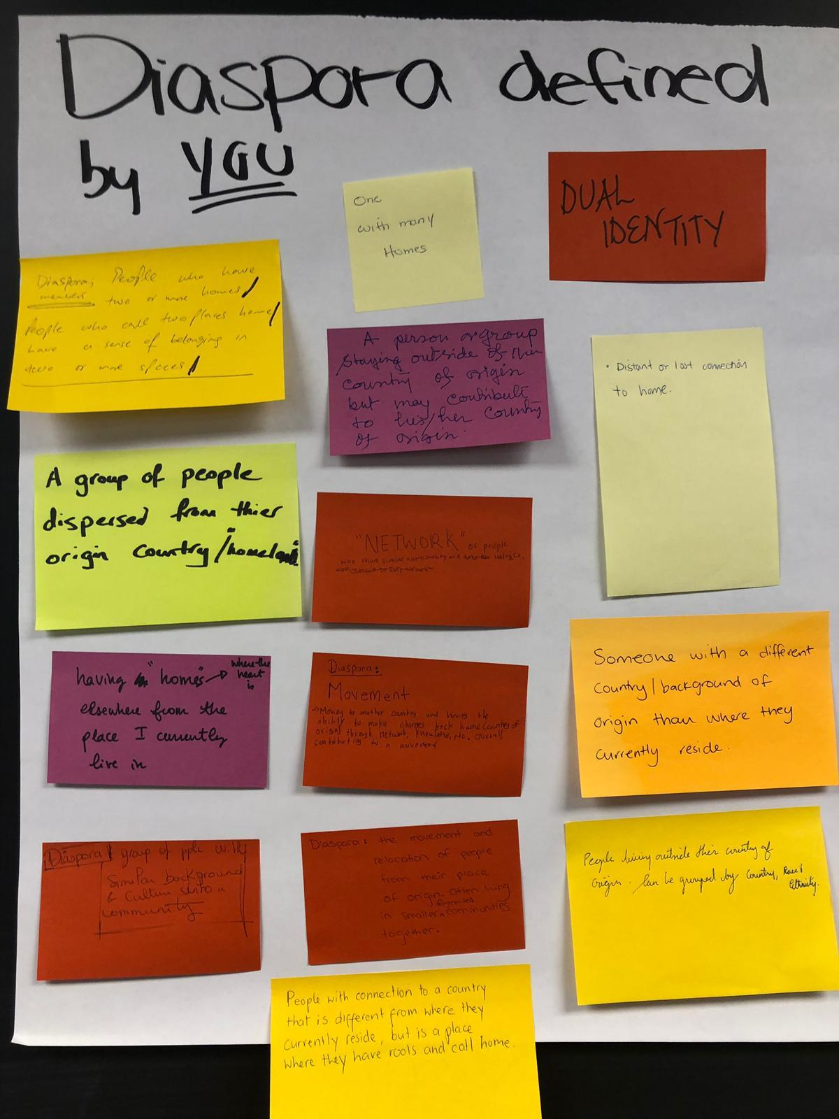
Image 1: Participants’ interpretation of ‘Diaspora’
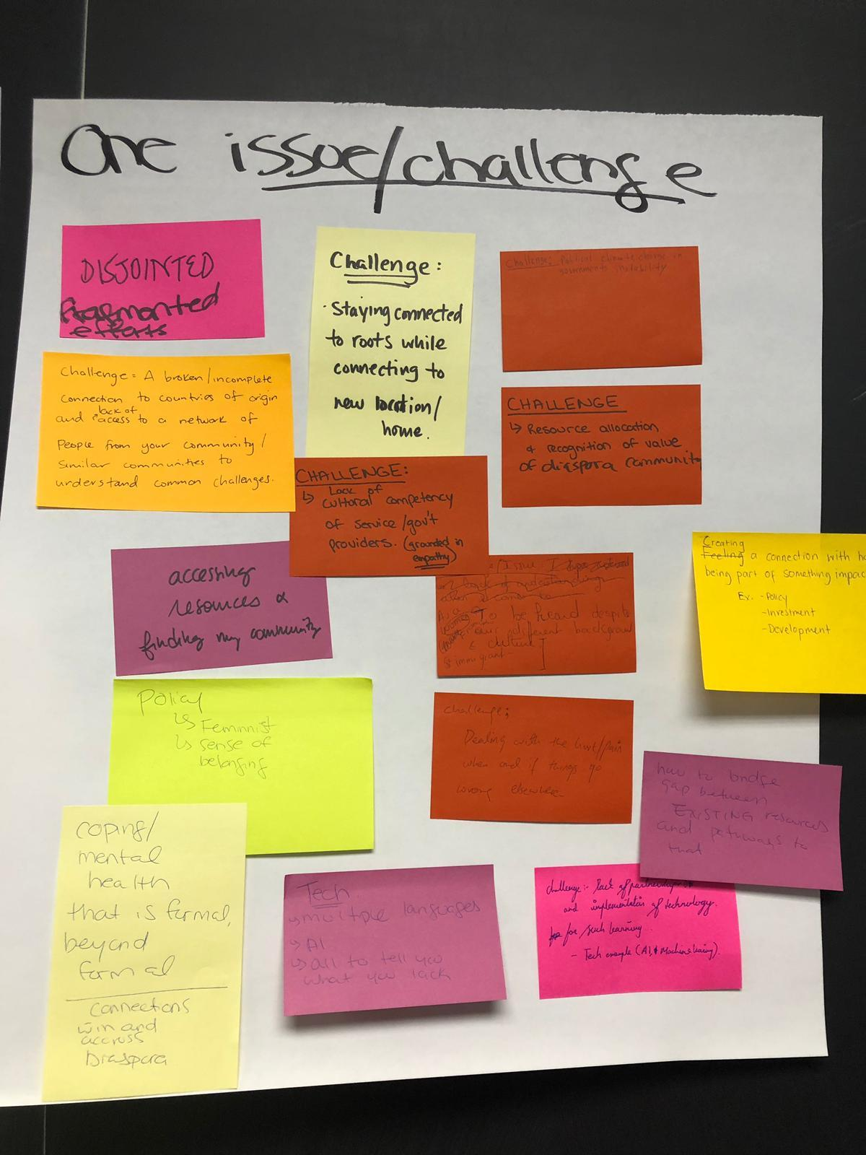
Image 2: Issues and challenges faced by participants’ communities
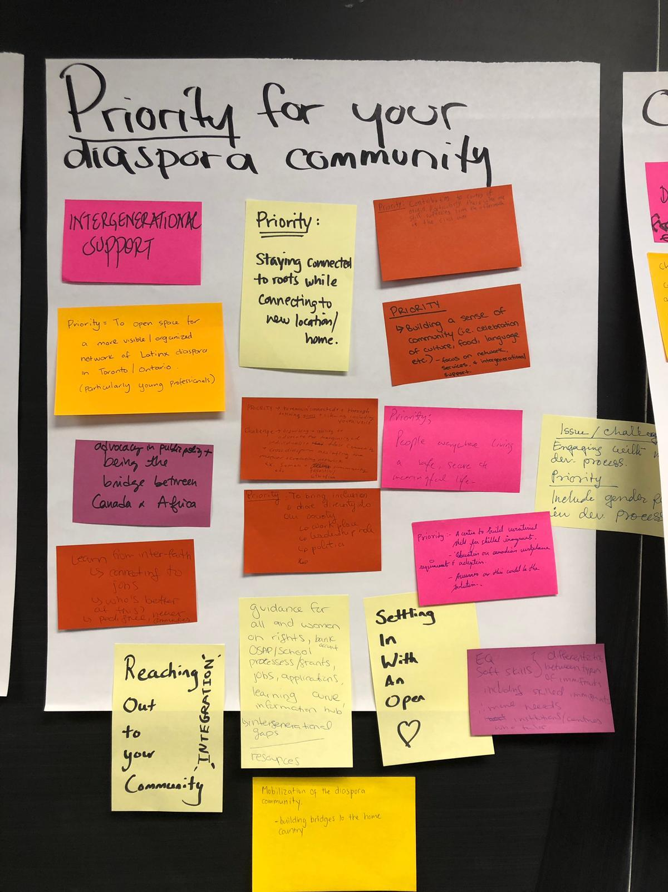
Image 3: Priorities of communities

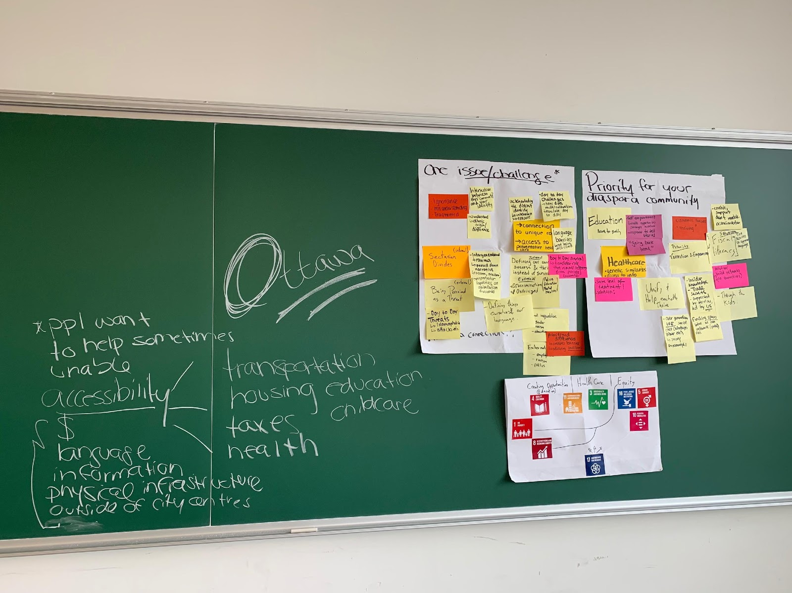
Image 4: Issues/priorities mapped to most relevant SDGs

Appendix 5: Participant responses for ‘leaving no one behind’
The responses emphasized a more meaningful application of equity, in theory and practice.
- Conduct a census with disaggregated data, unpacking by country of origin and/or mother tongue
- Providing platforms and opportunities for representation
- National strategy on educating society as a whole on EQUITY
- Better effective outreach
- Create a platform for diverse voices
- Mentorship versus sponsorship
- Creating unique impact in the “now”
- Empathy + care, particularly when listening and responding
- Consultations in pre-existing spaces
- Person to person outreach (allyship)
- Giving a platform for not normally voices heard. Asking who else is in the room that couldn’t make it to the table.

Appendix 6: Select aggregated responses from post-event survey
What are ways to increase your participation, and that of your Diaspora community, in Canada's Agenda 2030 National Strategy?
- Engage more directly with specific stakeholder group in the implementation of any specific actions resulting from these consultations with the diaspora community
- More in-person consultations
- Have aligned goals which contribute to Canada's SDG. Currently people view SDG as mainly linked to developing world (emerging economies). Linking goals which aren't immediately brought to mind, such as gender equality, good health, and decent work. These are aspects of SDG which I believe my community would more likely be engaged with. Ways to increase my participation is different.
- more grassroots participation
- Collaboration with likeminded individuals with my diaspora community to give back to our people. The efforts of one can become diluted very quickly but a strong team can help combat those efforts
How can your Diaspora community's understanding of Canada's 2030 Sustainable Development Strategy be enhanced?
- Public awareness campaigns in community centres and other public spaces frequented by community, partner with prominent figures and businesses within community to deliver message
- More platforms like OCIC organizing events to gather the Diaspora community in discussing and exchanging ideas
- More effective outreach
- Knowledge on more resources available that can be offered, those that want to give back can act like an ambassador for passing on institutional information to those that need it the most
Please share any websites, initiatives or organizations that you recommend being included in OCIC's submission on Canada's Agenda 2030 National Strategy.
- The Société Économique de l’Ontario (SÉO) - as they work on green economy, agriculture and eco-tourism in Ontario)
- University of Toronto Model United Nations
- Atar-AI program designed to help settle refugees
Please share any reflections on ways OCIC could support your efforts towards Agenda 2030 and the SDGs.
- More ongoing engagement of diaspora community
- Encouraging the diaspora to join as members and use the platform to connect with fellow diaspora members
Please feel free to provide any additional/final comments for our consideration.
- The consultation was well run and engaging. Look forward to seeing the report
- It was a fantastic event! Thank you
- I realize this was given to OCIC on a short notice, but perhaps contacts could be established with active diaspora from different communities and maintained for future (and continued) involvement. If this is not already being done.
- More door to door canvassing to achieve effective outreach
- Collaborate with those already doing and giving back to their perspective communities, there are so many people already doing amazing work and would benefit from the OCIC network

Appendix 7: Resources and documents
Below are the resources and documents identified as helpful towards supporting and understanding needs of Diaspora communities in Canada:

Toronto Unity Mosque | A safe space for LGBTQ Muslims reconciling their religious background and sexual orientation. This is significant given challenges to identify as LGTBQ within Diaspora communities and households. There is a significant gap for mental health resources that support self-acceptance of multiple identities. How can this Mosque be tapped into by mental health agencies, and what resources can this Mosque share with Canadians within and beyond Toronto that may be supportive?
The Mowat Centre, Diaspora Nation | The Mowat Centre produced research linking the potential role of Diaspora Canadians in economic growth policies and strategies abroad. The report describes Canada as a ‘Diaspora Nation’ where “Diaspora networks are playing a larger role in the global economy,” and stressing that “Recognizing and acting on this trend should be part of a thoughtful policy response to the shifts in the global economy and immigrants’ declining economic outcomes. The recommendations flowing from this report outline some plausible responses.”
Refugee 613 | This Ottawa-based non-profit is considered a leader in acting as a coordinating information hub for newcomers in Canada. While overstretched, what lessons can it share with respect to successes and challenges of providing Diaspora communities needed ‘survival’ information. How can this model be replicated outside of Ottawa and what opportunities exist to convene similar organizations to leverage lessons learned?
The Centre for Addiction and Mental Health (CAMH) | As mental health support was called out as a key need for Diaspora communities, what linkages and lessons can be made and shared by CAMH regarding relevant, cross-cultural supports? Are there affordable services, both formal and as part of extra-curricular/pro bono efforts, that can be made more visible? Recent decisions to cut financial support for Legal Aid Ontario’s support to newcomers and refugees may highlight a lack of available sources/ funding/ prioritization from government. It will be important to surface any alternative private and non-profit resources that can be elevated.

See Annex 4 for a description of how individuals from Diaspora communities define Diaspora.
See Annex 3 for a full discussion of the participation dynamics in the disability inclusion consultations. Alliance for Equality of Blind Canadians’ experience shows the importance of ensuring that individuals are adequately informed on key issues prior to consultations and on the need to take specific steps to ensure all participants are comfortable and supported to effectively participate.
The diverse community consultation reports annexed to this report provide information on specific initiatives that could be undertaken to monitor progress for specific communities. The Diaspora community consultation noted Indicators of success that could be included while the disability inclusion community consultation identified specific types of analyses and measurement tools. The report from the consultation with leaders and members of Indigenous communities points to alternative indicators related to displacement.
The Diaspora community consultation, Annex 3, identified a number of concrete initiatives that the private sector can undertake to support Diaspora priorities for 2030 Agenda implementation.

