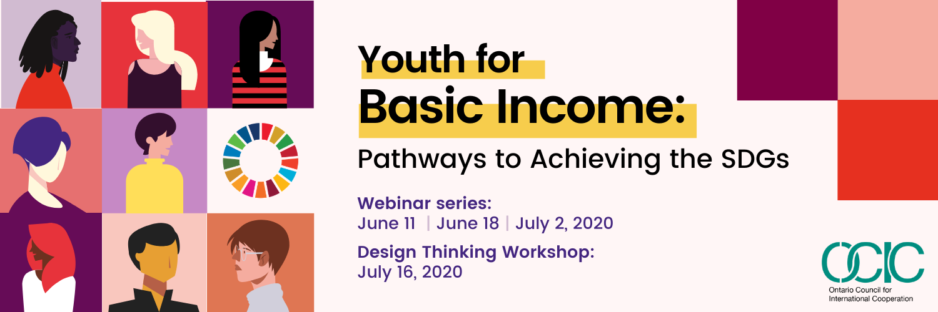
Basic Income Resource List

Introductory Materials

Basic Income Primer - Basic Income Canada Network (BICN)
- BI Policy Options for Canada - BICN
- The (Big!) Difference Between a ‘Basic Income’ and the National Dividend - The Clifford Hugh Douglas Institute for the Study and Promotion of Social Credit
- Three big misconceptions about Yang’s Freedom Dividend - BIEN

Various Online Articles from Various Perspectives:
- The Case Against a Basic Income, Jacobin Magazine, Dec. 2017. This would be if you want to discuss more pros/cons or talking points, although most are covered in resources above.
- Basic Income: A Radical Proposal for a Free Society and a Sane Economy by Philippe Van Parijs and Yannick Vanderborght
- Universal basic income: a way through the storm?, opendemocracy.net, multiple authors. This article contains a discussion about the pros & cons of BI by authors from various fields, including the co-president of BIEN, a social worker from a developing nation, and a political philosopher
- Here's How a Universal Basic Income Can Help Us Mitigate The Climate Emergency, sciencealert.com, Mark Maslin & Simon Lewis. Adding this just for the Kate Raworth graphic in the middle of the article, illustrating how BI & the doughnut economy can work together.
- COVID-19 Supports and Benefits Rapid Analysis - Wellesley Institute

In the News
- The neoliberal era is ending. What’s next? - The Correspondent
- Davos Panel Segment - NowThis News
- Spain introducing BI - BBC

Live Discussions

Lift the Floor: Would a Universal Basic Income guarantee a good life for all Canadians? - Broadbent Institute, Webinar
- Ending Poverty: Making Basic Income Feasible in Canada - The Tamarak Institute, Webinar
- Basic Income and Youth - The Tamarak Institute, Webinar
- Restitching the Social Safety Net - The Recovery Project, Webinar
- Basic Income and the New Golden Age of Capitalism - Floyd Marinescu, TEDx Windsor

Books
- Utopia for Realists: How we can build the ideal world - Mr. Rutger Bregman, Book
- Basic Income for Canadians: The key to a healthier, happier, more secure life for all - Dr. Evelyn L. Forget, Book
- Exploring Universal Basic Income: A guide to navigating concepts, evidence, and Practices - World Bank Organization

Support & Endorsements for Basic Income in Canada
- 120 Canadian CEOs, Private Business Owners, Presidents, and Cofounders - CEOs for Basic Income
- 50 Senators Endorse Basic Income in a letter to Prime Minister - With and on behalf of the Honourable Frances Lanking and Kim Pate, Senators
- Youth Leaders Call for Guaranteed Livable Income: Rally Behind Senators’ Letter to Prime Minister - Canadian Council of Young Feminists - Counseil canadien de juene féminists (CCYF-CCJF)
- Open Letter to Prime Minister Trudeau, Deputy Prime Minister Freeland, Minister Chagger, and Minister Morneau, in support of the Senators’ call for guaranteed livable income - CCYF-CCJF, BICYN, Endorsed by 43 NGOs & CSOs and 29 individuals across Canada
- Tweet to individuals’ local MP in support of a policy entrepreneur to put Basic Income on the Federal Policy Agenda, now - OCIC YPH, endorsed by you!

You Can Take Action #BI4CAN Now!

We encourage you to add your voice to our collective tweet to local MPs, by copying and pasting the following message into your Twitter:

“Following endorsement by 50 senators, 120 CEOs + NGOs, CSOs, Youth, & individuals across the country, the time to act is nigh! Place #BI4CAN on the policy agenda @[local MP] @SenMarilou @JustinTrudeau @theJagmeetSingh @ElizabethMay @ocictweets #cdnpoli”

Find your local MP using this link

Stay Connected and join our Future Events!
- Find out more about future OCIC Hub events on Basic Income
- Find out more about OCIC’s Youth Policy-Makers Hub
- Subscribe to OCIC’s newsletter(s)

Additional Mailing Lists & Future Events to Stay Informed!
- BICYN mailing list
- BICN mailing list
- UBIWorks mailing list
- BIEN mailing list
- Various BI Groups: 13th International Basic Income Week (Future Events)

Thank you,
On behalf of Everyone on the BI Project Team

BI Project Team
Youth Policy-Makers Hub
Ontario Council for International Cooperation

