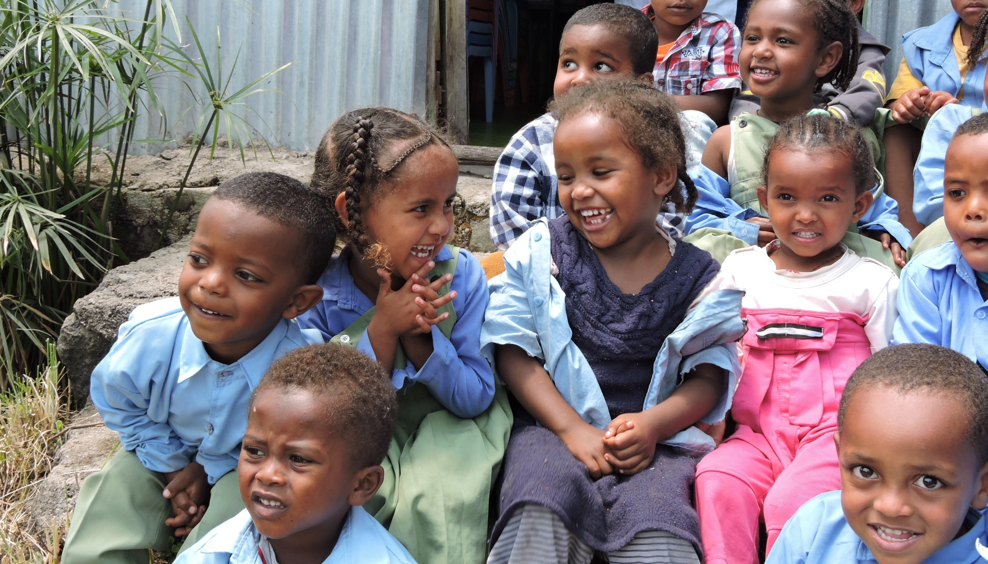
Getting on “Board” to help children thrive
CFTC Fast Facts
- Independent, Canadian secular development agency founded in 1986
- Provided 3 million meals to children through school and community programs in 2019-2020
- Delivers integrated, holistic child and youth-centric programs through community-based partners
- A top 100 Charity in Canada for 2018 – 2020, and a top 10 Impact Charity in Canada with the highest (4-star) rating by Charity Intelligence for its financial transparency, accountability, cost efficiency and social impact
- Recognized for financial reporting transparency by Queen’s University Centre for Governance Voluntary Sector Reporting Awards
- One of first non-profits in Canada to achieve Imagine Canada Standards accreditation
- Selected by The Financial Post as one of top children’s charities in Canada

At Canadian Feed The Children (CFTC), we dedicate ourselves to our mission to unlock children’s potential through community-led action in Canada and around the world. CFTC delivers development programs through local partners that have positive, meaningful, and sustained impact on children’s lives and on the self-sufficiency of their families and communities. Currently operating in five countries (Bolivia, Ethiopia, Ghana, Uganda, and in Indigenous communities in Canada), we are an award-winning, Imagine Canada Standards-accredited agency at the leading edge of practice in the development sector. Our vision is a world in which children thrive free from poverty. We support sustainable, long-term, community-led approaches to make our vision a reality.
We are looking for a skilled and passionate individual to join our Board of Directors. There is an exciting atmosphere of transformation and possibility at CFTC. Joining our Board will provide you with an excellent opportunity to contribute to impactful community-led initiatives, knowing that you are volunteering with others who share similar values. With strong, shared values as touchstones we are able to act with honesty and integrity to deliver our mission. You will also expand your abilities while contributing to strategic leadership dedicated to the best practices in non-profit organizational governance, effectiveness and impact.
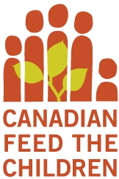
901-2 Lansing Square, Toronto ON M2J 4P8
canadianfeedthechildren.ca
1-800-387-1221 416-757-1220
Charitable Registration No.: 118830983 RR0001

2019 Recruitment Focus

About You
We are recruiting a committed individual to be part of our national Board. We are seeking a pro-active, inspired young leader who will contribute to the diversity of our organization, who believes in a gender equality-based, de-colonized approach and who demonstrates a commitment to our mission and values and strong governance and oversight. We are committed to anti-racist practices which is reflected in the experiences and composition of our leadership.

Accountabilities of the Member
- Commitment to Canadian Feed The Children’s mission and vision and serve at a minimum one, three-year volunteer term, with the possibility of a second term
- Accountability for governance leadership in collaboration with other Board members
- Participation on Board committees
- Attend quarterly Board meetings and Annual General Meeting
- Support a culture of philanthropy and commitment to the CFTC mission

Consider Joining CFTC as Member of the Board
Comprised of 14 Directors, CFTC’s Board is a governance and policy Board that is critical to the continued success of this values-driven, development organization.
The Board are volunteer professionals that contribute directly to the governance of the organization, including but not limited to oversight of strategy and fiscal accountability.
Board Directors also participate in committee work which supports the overall governance of CFTC. Committees include the Finance and Audit Committee and the Nomination and Governance Committee. Other committees may be struck depending on particular priorities as they arise.
Next Steps
To be considered for membership on the CFTC Board of Directors please send your CV and letter of interest to:
Nomination and Governance Committee
To the attention of: MaryAnn Chathanat
Executive Assistant & Board Governance Coordinator to
the President & CEO
mchathanat@canadianfeedthechildren.ca

Applications will be accepted until 7th May, 2021

The Nomination and Governance Committee will conduct interviews starting as early as May in order to select and present appropriate candidates ready for consideration at the CFTC 2021 June Board meeting. To learn more please visit:

CanadianFeedTheChildren.ca
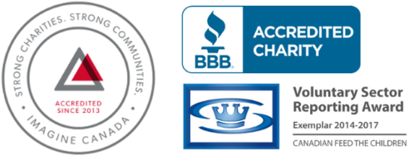
CanadianFeedTheChildren

@cdnfeedchildren

inthefield_cftc
Canadian-Feed-The-Children

The Standards Program Trustmark is a mark of Imagine Canada used under licence by Canadian Feed The Children.

