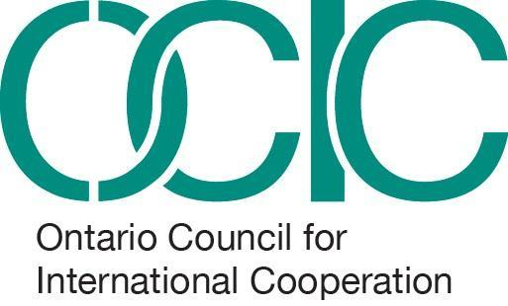

OPPORTUNITY POSTING

OCIC Gender Equality Hub Lead Volunteer

Term: March 2021 – August 2021 | Deadline: February 24, 2021 – 5:00 pm EST
Position type: Volunteer | Interviews: Week of March 8, 2021
Location: Remote – based in/connected to Ontario | Beginning: Late March 2021

Background:

The Ontario Council for International Cooperation (OCIC) is an expanding community of Ontario-based international development and global education organizations and individual associate members working globally for social justice.

Reporting to the Community Engagement & Gender Equality Specialist, the Gender Equality Hub Lead Volunteer will work with OCIC staff, members and other stakeholders in the coordination of OCIC’s Gender Equality Hub. Ideal candidates will have experience facilitating, curating or supporting community engagement activities with diverse stakeholders. They will have creative ideas, enthusiasm, skillful communications and writing abilities, and knowledge of/demonstrated interest in international cooperation issues. As key contributors to a small and dynamic team, OCIC Lead Volunteers must be able to work independently on a variety of tasks, and to motivate others to participate.

Scope of work:

- Assisting in facilitating broad-based participation of OCIC members and key stakeholders in Gender Equality Hub activities
- Providing administrative support, including writing minutes, developing agendas, and coordinating meetings
- Providing logistical and outreach support to maximize reach of public-facing programming across Ontario
- Ensuring gender equality and anti-oppression themes and results are integrated into activities as outlined in our funding agreements and organizational policies;
- Helping to document and report on good practices and lessons learned;
- Supporting the preparation of qualitative, quantitative and financial reporting items, as necessary
- Actively participating in planning meetings and providing input towards the development of public engagement activities
- Committing to 5-7 hours/week

Desired Qualifications:

- Understanding of and passion for gender equality issues
- Individuals with grassroots organizing experiences, lived experiences of intersectionality, alternative educational routes and non-traditional backgrounds
- Interest in supporting professional development for gender equality practitioners
- Knowledge of or interest in global social justice, international cooperation and solidarity work with non-profit and grassroots organizers
- Excellent interpersonal, communication and writing skills, and a demonstrated ability to work effectively with diverse groups
- Detail-oriented, with a demonstrated ability to organize work, set priorities, meet deadlines, and track information, both independently and as part of a team
- Computer proficiency

To learn more: Visit OCIC’s website, and check out our Gender Equality Hub here.

To apply: Qualified, interested applicants are invited to submit:
- a CV and two professional or community references
- a video [2 mins MAX] or statement of interest [500 words MAX] telling us why would you like to take on this role, and why now?

Please submit applications via this Google Form by no later than 5:00 pm EST on February 24, 2021.

As an equity seeking organization, OCIC encourages applications from individuals that represent the full diversity of communities in Canada, including complexities of intersecting identities such as ability, age, class, gender, race and sexual orientation. Individuals who identify as BIPOC, LGBTQ+, women or non-binary, person with a disability, newcomer, visible minority, or from any other systemically underrepresented populations are strongly encouraged to apply.

